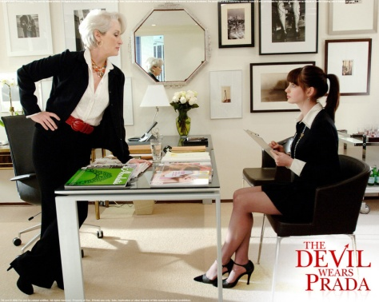
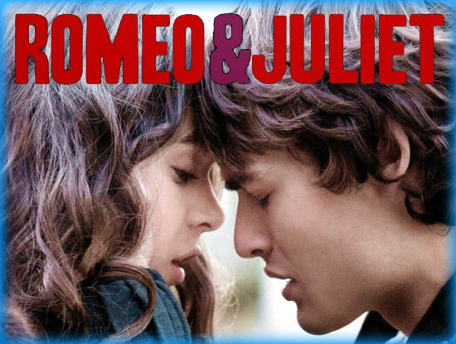
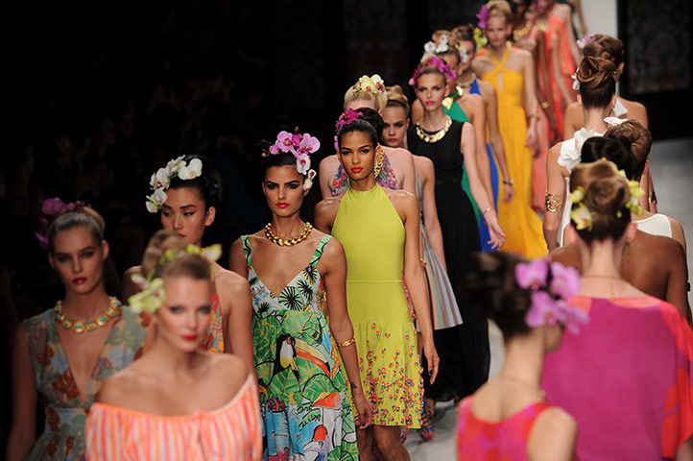

1. Tell about your personal style. Are you a fashion victim? Give reasons. Does fashion influence you when you choose clothes? Is it more important for you than price, style, comfort, colour, etc? What is your attitude to the fashion currently popular in our country?
2. Dwell on the following quotations: “If you are not in fashion you are nobody”, “It’s only the modern that becomes old-fashioned”. Do you agree or disagree? Why (not)?
3. What do you wear to a new disco’s first night/ an open-air rock-concert/ a summer afternoon near the river/ a quiet evening at home/ an entrance examination/ a barbeque in the country/ a formal party etc?
4. Do clothes affect the way you react to other people? What can the clothes tell about a person who wears them? How would you complete the following statements?
People who never clean their shoes are….
People who wear matching clothes…
People who always wear a suit and a tie are…
People who always wear dark clothes are…
People who wear bright colours are…
People who like designing their own clothes are…
People who never experiment with their clothes are…
People who wear crumpled clothes are…
People who closely follow the fashion are…
People who prepare in the evening the clothes they will wear the next day are…
5. How can you describe the 21st century comparing it with the previous ones? In your opinion, which aspects of modern living would a person from a previous century find most difficult to get used to? Why?
6. Do you spend much time watching TV? What types of programmes do you know? What programmes do you mostly/never watch? Why?
7. Which reality shows are you familiar with in your country? Do you enjoy viewing them? Why (not)? In your opinion, why are reality shows popular? Would you ever consider participating in a reality show? Why (not)?
8. If you could create a reality show, what might it be like? Decide on the theme, setting, rules, contestants, prize.
9. How often do you read/buy the newspaper? What types of newspapers do you know? What sections can you find there? What is circulation? What language is used in the newspapers?
10. Do you enjoy watching commercials? What were they like in the past? What are they like today?
11. Describe one of your group mates. Make sure you mention where and how you first met him/her, their physical appearance, facial features and clothes, personal qualities and justifications/examples, hobbies and interests, comments and feelings about the person.
12. How much do you know about pantomime? Is there any similar traditional form of entertainment in your country?
13. What film genres do you know? Which do you fancy? Which films would appeal to the following catagories of people (non-intellectual teenagers, middle-aged housewives, university students, elderly professors, etc)? Describe the last film you viewed in English?
14. Do you have your favourite film? If yes, how many times have you seen it? What makes you see it all over again? Do you have your favourite movie stars? What attracts you in them? Do you like to read about their life in media?
15. What is your attitude to theatre? Do you agree that in the nearest future there will be no theatre? What was the latest play you watched? Did you like it? Why (not)?

