We are not supposed to be friends, you and me,
we are meant to be enemies.

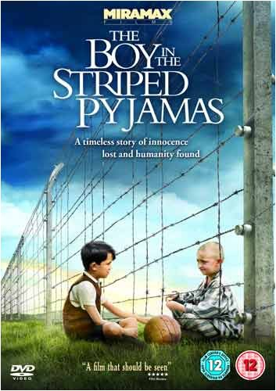
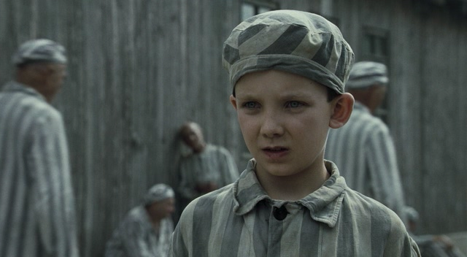
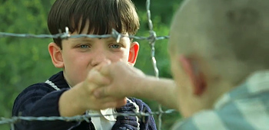

Childhood is measured out by sounds and smells,
and sights, before the dark hour of reason grows
John Betjeman

Before viewing the film
Vocabulary
Spare tyre – запасне колесо
Swap – обмін
Vermin – an unpleasant, obnoxious, or dangerous person⇒шкідник, паразит
Lamb - a person, esp a child, who is innocent, meek, good, etc ⇒ ягнятко, козенятко
To see smb shortly – незабаром з кимось побачитись
To bleed to death – спливати кров’ю
To peel potatoes – чистити картоплю, бараболю
To put a bandage on one’s knee – накласти бинт, пов’язку на коліно
To mend boots – лагодити, ремонтувати черевики
To make a mess of one’s satchel – забруднити ранець, накидати туди сміття
To be sworn to secrecy – присягтися тримати щось у секреті
To take an oath upon one’s life – заприсягнути, поклястися власним життям
To feel up to smth – usually used with a negative or in a question to be fit enough for (something or doing something) ⇒ почуватися добре, мати бажання, щоб щось зробити
To make up for doing smth – компенсувати щось
To take the air – піти надвір, подихати свіжим повітрям, дихнути ковток свіжого повітря
To get punished – отримати покарання, бути покараним
To air one’s views- висловлювати власну думку, погляди
God forbid! – Не доведи Господи! Боже збав!
To land smb in trouble – накликати на когось біду
It smells horrid! – Це так тхне!
Let’s not spoil things – Давайте не будемо псувати настрій (вечірку в даному контексті)

After viewing the film
Discussion
Task 1. Answer the question to the film.
1. How does Bruno call the imprisoned, the clothes they are wearing? Why?
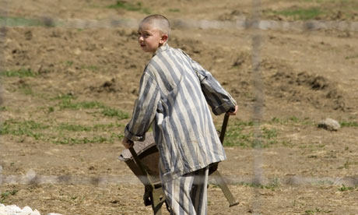
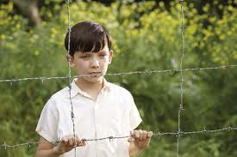
2. Why is Bruno surprised to hear the name Smuel when he first comes across the boy in the striped pyjamas?

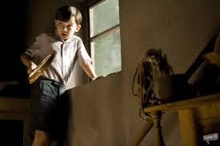
3. What sort of books does the tutor bring one day for the children to read? Do they have any influence on them?
4. How do children see the reality? How do they understand what the war is? What do they play?
5. Is Bruno proud of his father? Does he love him?
6. Does Bruno like exploring new things? How do you understand the quotation ‘Curiosity killed the cat’? Is it true about Bruno?
7. Who hates the Jews according to the film? Why do you think that is? Which characters sympathize with the Jews? Who doesn’t?

Task 2. Read the statements taken from the film. Identify the character each statement belongs to and dwell on it.
- Look, the thing is, Bruno, the thing about being a soldier, is that life is not so much about choice, it’s more about duty.
- Airing your views so publicly could land you in trouble.
- It won’t feel like home until we make it feel like home.
- Home is where the family is.
- Sitting around miserable won’t make things any happier.
- It’s funny how grown-ups can’t make their minds up about what they really want to do.
- I’m afraid, Bruno, in life we often have to do things we don’t want to do.
- The termination of the lesson is for the tutor to decide, not the pupil.
- Some people are not supposed to be friends, they are meant to be enemies.
- Thousands of people have been made poor by the Jews.
Focus on Grammar
What question types do you know? Read the questions taken from the film, identify their types and dwell on the grammar rule that can be applied to them.

1. Children, be angels, will you? Pass me some food around.
2. How long are we losing you for, my boy?
3. Have you got any food on you?
4. You don’t think it’s a farm, do you?
5. Smuel, I’m really sorry for what I’ve done. We are still friends, aren’t we?
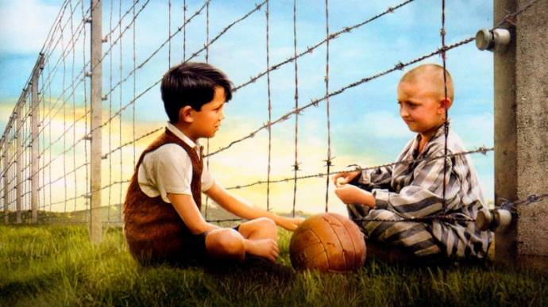
6. I really want to make up for letting you down. That would have done it, wouldn’t it? Helping you find your father?

