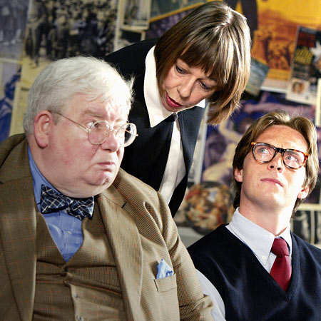
The History Boys
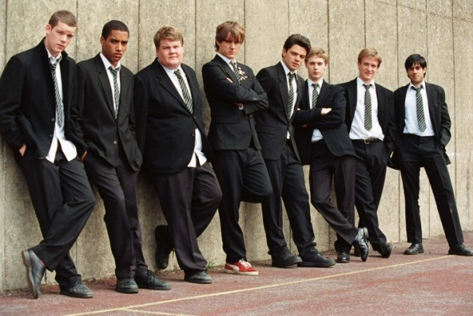
2006, comedy
runtime: 109 min.
language: English
Topic: Education
Playwright: Alan Bennett

Cast: (Headmaster) Thomas Wheatley, (Hector) Gerard Murphy, (Irwin) Ben Lambert, (Mrs. Lintott) Penny Beaumont, (Akthar) Beruce Khan, (Crowther) Tom Reed, etc.
The action of the play takes place in Cutlers' Grammar School, Sheffield, a fictional boys' grammar school in the north of England. The play follows a group of history pupils preparing for the Oxford and Cambridge entrance examinations under the guidance of three teachers (Hector, Irwin and Lintott) with contrasting styles.

PART I: BEFORE WATCHING
What types of schools do you know?Match the following types of school 1-5 to their definitions a)-e)

- boarding school
- grammar school
- crammer
- single-sex school
- co-educational school

- a school that provides living accommodation for some or all its pupils
- mixed type of school, attended by both sexes
- a school for children aged between 11 and 18 who are good at studying
- a school that helps to learn quickly for the exam
- a school that is for either girls or boys, but not both

- View a video about Oxford University and decide if the statements given below are true (F) or False (F):
- Oxford is the oldest university in the world______
- Oxford University is an institution that has been educating world’s leaders for more eight hundred years ______
- Oxford is everything but for research university________
- As a student of Oxford university you become a member of an Oxford college_______
- There are thirty nine different colleges at Oxford University_______
- Oxford is two hours from London_______
Vocabulary
- lad - хлопчина
- temporary contract teacher – викладач, що працює тимчасово на контрактній основі
- dubious (adj) – незрозумілий, підозрілий, що вагається
- sensible – розсудливий, резонний
- mindset – кругозір, спосіб мислення
- to think aloud – думати, роздумувати вголос
- to get changed – переодягнутися
- to say smth in smb's defense- сказати щось на чийсь захист
- change was in the air - повсюди були зміни; здається, що в повітрі відчутний (літає) дух змін
- No hope! – безнадійно
- that's very true! – це справжнісінька правда
- vacancy in .. вільне (вакантне) місце
- on loan - взайм
- smb welcomes you with open arms – хтось чекає на вас з нетерпінням; дуже радий вам
- it stands out – вирізнятися, виділятися
- Dear me! – О Боже!
- сutting edge – сучасно та прогресивно
- Do you have a life? – Ми маєте особисте життя?
- to make smb a rounded human being – виховати когось повноцінною особистістю
- to have smth up smb's sleeves - to have a secret plan or idea that you are going to use later
- to be in the same boat = to be in the same unpleasant situation as someone else
- your head is for the bin! = у тебе в голові зовсім пусто, ти ні на що не годишся
- the world doesn't revolve around you – світ не обертається навколо тебе одного
- pass it on! – передавати далі, продовжувати справу
- a word (with you) – мені потрібно з тобою перекинутись декількома словами
- tragic turn of events – трагічний поворот подій
- educational climate – клімат, що сприяє навчанню та вихованню
- the floor is open – тема для розмови відкрита
- I'm sort of know – я ніби щось про це чув
- to have smth first hand – почути з перших уст
- to step in smb's shoes – іти по чиїмось слідам
- ordinary staff – звичайні речі, нічого особливого

PART II: AFTER WATCHING
Read the statements given below and decide who they belong to. Translate them taking into consideration the context they have been used in.

1. One more try, one more push.
2. Leave this with me!
3. General studies is waste of time. Knowledge is not general, it is specific and has nothing to do with getting on.
4. It's the hard ticket.
5. I don't do notes.
6. He is five minutes older than we are.
7. What truth's got to do with it?
8. There is no better way of forgetting smth than by commemorating it.
9. At an examination truth is not an issue.
10. Learn it now, know it now and you will understand it.
11. The hardest thing for boys to learn is teach who is human.
12. What women know or don't know has always been a mystery for me.
Questions
1. What were the boys preparing for? What type of school did they study at?
2. What teaching methods were used at French/poetry lessons?
3. What was PE teacher like? What was his manner of speaking?
4. Was their library with a difference?
5. Where were the classes with a new teacher, Irwin, held?
6. How did the boys communicate with each other about love and relationships with girls? What language did they use?
7. Was there any artwork in the classrooms?
8. What was the staff room like?
9. What nicknames did the boys give to their teachers?
10. What was the reason Hector was about to be sacked?
11. Did the boys manage to enter Oxford and Cambridge?
12. How did history happen to Hector?

