Pearl Harbour
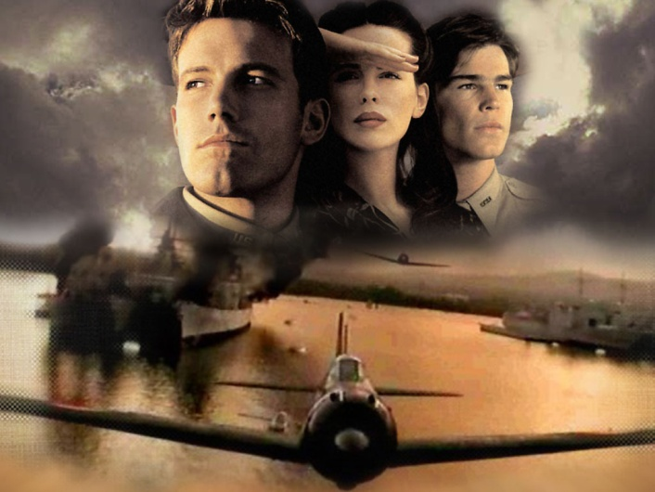

Director: Michael Bay
Writer: Randall Wallace
Running time: 183 minutes
Cast: Ben Affleck
Josh Hartnett
Kate Beckinsale
Cuba Gooding, Jr.
Tom Sizemore
Jon Voight
Colm Feore
Mako
Alec Baldwin
Pearl Harbor * is a dramatic reimagining of the Japanese attack on Pearl Harbor and the subsequent Doolittle Raid.

* Pearl Harbor is a lagoon harbor on the island of Oahu, Hawaii, west of Honolulu. Much of the harbor and surrounding lands is a United States Navy deep-water naval base. It is also the headquarters of the United States Pacific Fleet. The attack on Pearl Harbor by the Empire of Japan on Sunday, December 7, 1941 brought the United States into World War II.
PART I: BEFORE WATCHING
Comment on the quotes from the film:
1. The smart enemy attacks you exactly where you think you are safe (Admiral Kimmel).
2. I joined the army to do MY patriotic duty... AND... to meet guys (Nurse Martha).
3. There's nothing stronger than the heart of a volunteer (Lt. Col. Jimmy Doolittle).
4. A brilliant man would find a way not to fight a war (Admiral Yamamoto)
5. Victory belongs to those who believe in it the most and believe in it the longest. We're gonna believe (Lt. Col. Jimmy Doolittle).
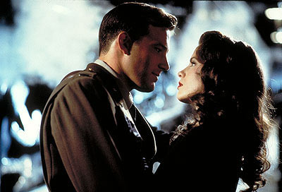
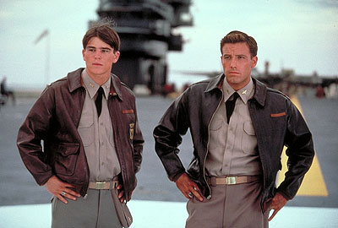
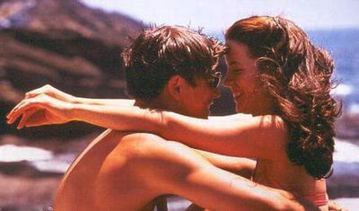

6. When the action is over and we look back, we understand both more and less. This much is certain. Before the Doolittle raid, America knew nothing but defeat. After it, there was hope of victory. Japan realized, for the first time, they could lose and began to pull back. America realized, that she would win and surged forward. It was a war, that changed America and the world. Dorie Miller was the first black American to be awarded the Navy Cross. But he would not be the last. He joined a brotherhood of heroes. World War II, for us, began at Pearl Harbor, and 1.177 men still lie entombed in the battleship Arizona. America suffered, but America grew stronger. It was not inevitable. The times tried our souls, and through the trial, we overcame (Evelyn).
Vocabulary
Before watching the film make sure you are familiar with all lexical units in this section.
- Don’t be a baby – Не поводься я к дитина!
- You are out of your mind! – Ти з’їхав з глузду!
- With your permission – З Вашого дозволу
- I’m hit!* – Мене підбили (ранили)
- I didn’t sleep a wink – Я взагалі не спав, не стулив очей
- Back off! – Йди геть! Відвали!
- I’ll see you around! – Ще побачимось! Скоро побачимось!
- To you! – За тебе!
- I’m just jealous – Я тобі так заздрю
- I’m just curious! – Мені просто так цікаво
- Take a pick! – Вибирай!
- That was not part of ... – Це не входило в плани
- Dry your eyes! – Витри очі!
- Wait your turn – Чекай на свою чергу
- It’s not hard evidence – Цих доказів недостатньо
- It’s like playing chess in the dark** – наосліп
- combat fighter* – боєць
- medical chart – медична картка
- sudden strike* – неочікуваний напад
- bullets* – кулі
- fleet* – флот, флотилія
- navy* – військово-морський флот
- naval intelligence* – розвідка військово-морського флоту
- hanky – носова хустинка
- lousy – вошивий, брудний
- to have eyes like an eagle** – мати чудовий зір, як у орла
- to poke – робити укол
- to volunteer* – добровільно зголошуватися на щось, записуватись добровольцем
- to be anxious to do smth – хвилюватися щодо чогось
- to be at war* – перебувати у стані війни
- to be in the war* – бути задіяним у війні
- to recruit* – наймати когось на службу
- to get killed* – бути вбитим
- to attack with full force* – атакувати всіма силами
- to walk smb home – проводити когось додому
- to make difficult choices – приймати непрості рішення

PART II: AFTER WATCHING
Translate the sentences given below. Who told them? (Rafe, Danny, Evelyn, Dorie Miller, President Franklin D. Roosevelt, Lt. Red Winkle, Admiral Yamamoto, Admiral Kimmel, Lt. Col. Jimmy Doolittle)
1. The best part of my life is still ahead of me___________
2. Ladies cloud the mind___________
3. They will take my wings away_____________
4. We are working on it________________
5. A brilliant man would find a way not to fight a war____________
6. Two years, they never even let me fire a weapon__________
7. I should've died over there. When I was in that water, I made a deal with God. I told him I was sorry, I told him I knew I'd been a fool for leaving you and trying to go over there and be a hero, and I promised I'd never ask for anything again, if I could just see you one more time... And ya know what? It was worth it. You kept me alive Evelyn, you brought me home. So I'm gonna stand by my end of the deal, I'm gonna walk away and I won't ask you for anything... but I just want to know why... Just tell me that will you please? Just tell me why____________
8. Loving you kept me alive ____________
9. How long is America going to pretend, that the world is not at war? From Berlin, Rome and Tokyo, were have been described as a nation of weaklings and playboys who hire British or Russian, or Chinese soldiers, to do our fighting for us. We've been trained to think we're invincible, and our people think Hitler and his Nazi thugs are Europe's problem. We have to do more. Does anyone think that victory is possible without facing danger? At times like these we all need to be reminded who we truly are. That we will not give up or give in___________
10. Can a guy propose? __________
11. Do not tell me it can't be done__________
12. Well guess what? It isn't training over there, it's war. Where losers die and there aren't any winners, just guys who turn into broken-down wrecks like my father. Now if trouble awaits me, I'm ready. But why go looking for it? ________

* - the words related to the topic ‘War&Peace’, ** - similes

