Big Miracle
The film is based on the 1989 book Freeing the Whales by Tom Rose, which covers Operation Breakthrough, the 1988 international effort to rescue gray whales trapped in ice near Point Barrow, Alaska. Drawn into the collaborative rescue work are several normally hostile factions: Inupiatwhale hunters, a Greenpeace environmental activist, an oil executive, ambitious news reporters, the National Guard, the America president and politicians on the state, national and international levels…

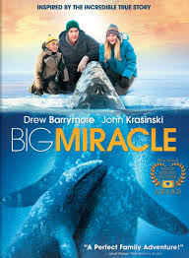
topic: Nature&Environment
2012 family drama
runtime: 107 min.
language: English
director: Ken Kwapis
Based on: Freeing the Whales by Tom Rose
Starring: Drew Barrymore, John Krasinski

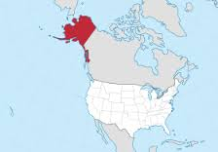
PART I: BEFORE WATCHING

- What is Arctica like? What U.S. state is this*?
- What is Greenpeace**? What do you know about this organization?
- Do you agree with the statement that ‘everybody loves whales’?

VOCABULARY
- environmental story – історія на тему навколишнього середовища
- ice breaker - криголом
- ice barrier – льодовий бар’єр
- shipping - перевезення
- brutal climate – суворий клімат
- oil spill – нафтова плівка
- PR thing - піар
- solid/thick ice – товстий шар криги
- to lead to the open ocean – вести до відкритого океану
- to freeze over – замерзати (про лід)
- to break up – розходитись (про відносини людей)
- to break through the ice – пробиватись через кригу, лід
- to turn smb’s back on smb – відвернутись від когось, відмовитись комусь допомагати
- to put smth at risk – піддати щось ризику, ризикувати чимось, поставити на карту
- to put smb in charge of smth – назначити когось відповідальним за щось
- to be nuts – бути божевільним, схибленим
- to let the whole world in – залучити весь світ до чогось
- to look up to smb – рівнятися на когось
- to freeze to death – замерзнути до смерті, вмирати від холому
- at the edge of the world – на краю світу
- I have very good connections – у мене дуже гарні зв’язки
- I was in the neighbourhood – я тут був неподалік
- It’s the cat in the tree – це як кіт у мішку
- It’s piece of cake – це так просто, на раз-два
- You don’t belong here! – тобі тут не місце, ти чужинець, тобі не зрозуміти
- Is this seat taken? – тут вільно? Тут можна сісти? Тут ніхто не займав?
- I’m on a very strict diet – я притримуюсь дуже суворої дієти
- This is not my first rodeo – мені не вперше, я не новачок в цій справі
- My feet are numb – у мене ноги відібрало від холоду, я ніг не відчуваю від холоду
- What’s the big deal? – Ну що тут такого?
- fatigue – дуже втомлений, заморений, виснажений
- weather conditions get deteriorating – погодні умови погіршуються
- It’s my wake-up call – це дзвіночок для мене (знак, що варто задуматись)
- No matter what it takes! – Чого б це нам (мені) не коштувало!

PART II: AFTER WATCHING
Answer the questions given below:
- Where do the whales breed? How long does it take them to get there?
- Where did the environmental story take place?
- Who was involved into this story?
- What was the governor’s reaction like to this issue?
- What was the locals’ reaction like to saving whales? What do they mean by saying: “If you don’t teach our children to feed themselves, they will starve”? Did they agree to save the whales?
- What are the whales’ names?
- What’s wrong with the baby whale?
- What do people and whales have in common?
- What attempts were made to save the whales?
- Were the whales saved in the long run?
- Comment on each image. What is the attitude to whales in each case?


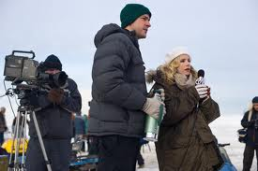
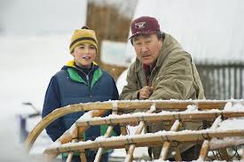
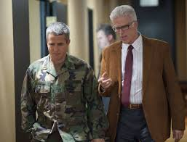
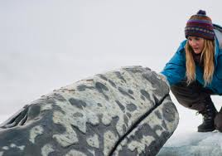

*Alaska is a U.S. state situated in the northwest extremity of the North American continent. Bordering the state is Canada to the east, the Arctic Ocean to the north, and the Pacific Ocean to the west and south, with Russia. It is the largest state in the United States by area, the 4th least populous and the least densely populated of the 50 United States. Approximately half of Alaska's 731,449 residents live within the Anchorage metropolitan area. Alaska's economy is dominated by the oil, natural gas, and fishing industries, resources which it has in abundance. Tourism is also a significant part of the economy.

* *Greenpeace is a non-governmental environmental organization with offices in over forty countries and with an international coordinating body in Amsterdam, the Netherlands. Greenpeace states its goal is to "ensure the ability of the Earth to nurture life in all its diversity” and focuses its campaigning on worldwide issues such as global warming, deforestation, overfishing, commercial whaling, genetic engineering, and anti-nuclear issues.

