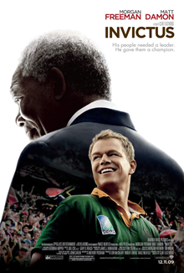
Из-под покрова тьмы ночной,
Из чёрной ямы страшных мук
Благодарю я всех богов
За мой непокорённый дух.
И я, попав в тиски беды,
Не дрогнул и не застонал,
И под ударами судьбы
Я ранен был, но не упал.
Тропа лежит средь зла и слёз,
Дальнейший путь не ясен, пусть,
Но всё же трудностей и бед
Я, как и прежде, не боюсь.
Не важно, что врата узки,
Меня опасность не страшит.
Я — властелин своей судьбы,
Я — капитан своей души.
Out of the night that covers me,
Black as the Pit from pole to pole,
I thank whatever gods may be
For my unconquerable soul.

In the fell clutch of circumstance
I have not winced nor cried aloud.
Under the bludgeonings of chance
My head is bloody, but unbowed.

Beyond this place of wrath and tears
Looms but the Horror of the shade,
And yet the menace of the years
Finds, and shall find, me unafraid.

It matters not how strait the gate,
How charged with punishments the scroll.
I am the master of my fate:
I am the captain of my soul.

William Ernest Henley

Invictus is a 2009 biographical sports drama film directed by Clint Eastwood and starring Morgan Freeman and Matt Damon. The story is based on the John Carlin book Playing the Enemy: Nelson Mandela and the Game That Made a Nation about the events in South Africa before and during the 1995 Rugby World Cup, which was hosted in that country following the dismantling of apartheid. Freeman and Damon play, respectively, South African President Nelson Mandela and François Pienaar, the captain of the South Africa rugby union team, the Springboks.

PART I: BEFORE WATCHING
- Do you know these people? Why are they famous? What do they have in common?
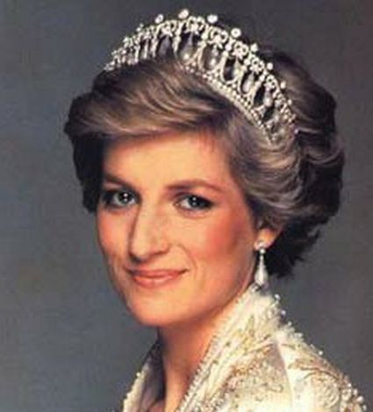
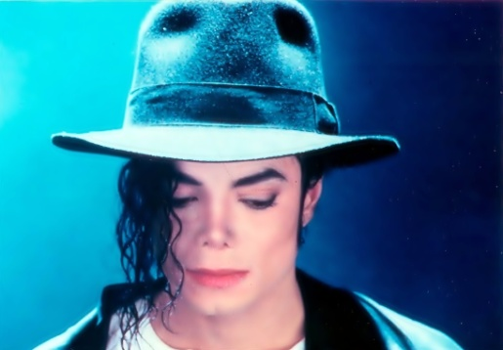
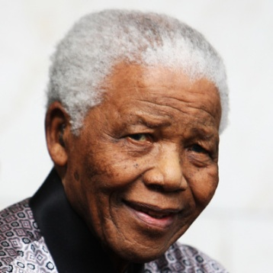

King of Pop
For all Jackson’s life was a strange and often sad one; he deserves to be remembered first and foremost as one of the most spectacular musical talents who’s ever lived, an endlessly gifted singer, dancer and songwriter.
The People’s Princess
Diana showed the way to win the peoples' hearts. She took on unpopular but important causes such as AIDS and the global abolition of landmines. But above all she knew how to relate to people, to make every single person she talked to feel special.
A leader of his people
Nelson Mandela was the first black President of South Africa. He spent 27 years in prison for trying to overthrow the pro-apartheid government. After he left prison, he worked to achieve human rights and a better future for everyone in South Africa.

- What do you know about their last days? How did they pass away?
to die
- pass away
- depart
- buy it (US, slang)
- kick it (slang)
- give up the ghost
- go belly-up (slang)
- peg out (informal)
- kick the bucket (slang)
- breathe your last

This year would have been this person’s 55th birthday. Tragically, of course, s/he didn’t live long enough to see it — s/he died four years ago of a heart attack catalysed by propofol and benzodiazepine intoxication, and the wranglings over his death and legacy continue to this day.

This person died as a result of injuries sustained in a car crash in the Pont de l'Alma road tunnel in Paris, France. Although the media pinned the blame on the paparazzi, the crash was found to be caused by the reckless actions of the chauffeur. Mystery still surround the real cause of this death.

This person died at the age of 95 after a prolonged lung infection.
MAKE SURE YOU ARE FAMILIAR WITH THIS NOTIONS

South Africa – officially the Republic of South Africa, is a country located at the southern tip of Africa.
South African English (SAfrE, SAfrEng, SAE) – is the dialect of English spoken by South Africans, with the first language English varieties spoken by Zimbabweans, Zambians and Namibians, being recognised as offshoots.
Afrikaner – are an ethnic group descended from Dutch and other European settlers in Southern Africa whose native tongue is Afrikaans; a Germanic language developed in Africa which derives primarily from 17th century Dutch. In South Africa, they constitute approximately 5% of the total population.
madiba – Nelson Mandela's clan name; the clan or family name represents a person's ancestry. The meaning is deeper than a surname and is used as a sign of respect and affection. The origin of Madiba comes from a chief who ruled in the 18th century, according to the Nelson Mandela Foundation.
rainbow nation - Rainbow Nation is a term coined by Archbishop Desmond Tutu to describe post-apartheid South Africa, after South Africa's first fully democratic election in 1994. The phrase was elaborated upon by President Nelson Mandela in his first month of office, when he proclaimed: "Each of us is as intimately attached to the soil of this beautiful country as are the famous jacaranda trees of Pretoria and the mimosa trees of the bushveld - a rainbow nation at peace with itself and the world."
apartheid – an Afrikaans word meaning 'the state of being apart'; was a system of racial segregation in South Africa.
the World Cup = The FIFA World Cup - is an international association football competition contested by the senior men's national teams of the members of Fédération Internationale de Football Association (FIFA), the sport's global governing body. The championship is awarded every four years.
Bokke = The South Africa national rugby union team (known as the Springboks) represents South Africa in rugby union. The Springboks play in green and gold jerseys with white shorts, and their emblems are the Springbok and the Protea.

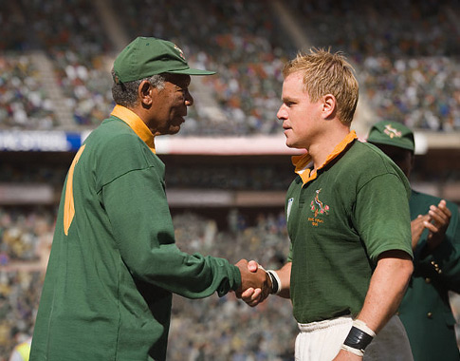
VOCABULARY

-to let smb out=to release – звільняти когось із в’язниці
-to go to the dogs – котитися в прірву, зазнати поразки, вилетіти в трубу
-the top news of the day – новини дня
-on the verge of civil war – на порозі громадянської війни
-panga – великий ніж з широким лезом
-oppression of smb – утиски когось, використання сили проти когось
-be the skunk of the world – об’кт приниження для всіх
-be like clockwork – чіткий як годинник
-to run a country – керувати країною
-it's a legitimate question – це – розумне, обґрунтоване законом запитання
-economic stagnation and unemployment – застій економіки та безробіття
-You got your whole life ahead of you – у тебе ще все життя попереду
-Just you wait! – Зажди-но! Почекай-но!
-on short notice - завчасно
-right away - відразу
-the past is the past – що було, то загуло
-to do smb a service – зробити комусь послугу
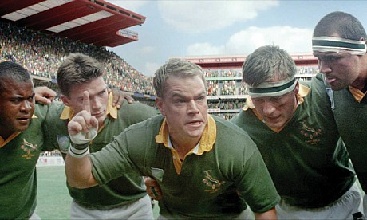
-to do the work to the best of one's abilities – виконати роботу, використовуючи свої вміння повною мірою
-be under arrest – знаходитись під арештом
-reconciliation – примирення, врегулювання
-comrade president – товариш-президент
-agitated - схвильований
-that's a headache! – це – головний біль, морока
-heads will role – полетять голови, будуть покарані
-Don't get your hopes up! – Не дуже сподівайтесь, мрійте!
-like whipped mongrels – як побиті пси
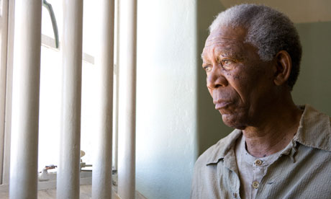
-it will last forever – носитиметься довго (про одяг)
-on agenda – в порядку денному
-foresight – дар передбачення
-unanimous - одноголосний
-to treasure smb/smth = to cherish – дорожити чимось
-compassion - співчуття
-restraint - стриманість
-this is no time to celebrate petty revenge – ще не час святкувати, ще рано святкувати
-overseas trip – закордонна подорож
-not in a million years – нізащо в світі
-to set an example to others – ставати прикладом для інших
-You can't be serious – ти ж не серйозно, ти шуткуєш, правда?
-I heard that one before – десь я це вже чув
-What is your philosophy on ...? – А що ви думаєте про..? А яке ваше ставлення до...?
-the future seemed very bleak – майбутнє видавалось таким похмурим
-it's like talking to a brick wall – як горохом об стіну, як до стіни
-if you will indulge me just for one moment – якщо ви дозволите мені хвилинку вашої уваги, часу
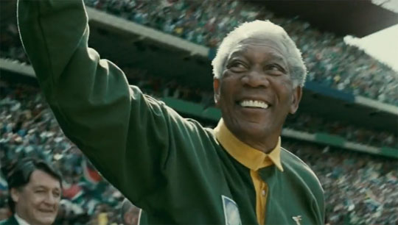
-to put the finishing touches – зробити завершальні штрихи
-in my humble opinion – на мою (скромну) думку
-thugs – головорізи, відморозки
-okes (SAE)- men, blokes, guys, dudes
-wish good luck in person – особисто побажати комусь успіху
-to waste one's time with smth – марно витрачати час на щось
-be hungry for smth – дуже чогось бажати, бути голодним до...
-I don't think I can take it – не думаю, що я це витримаю

PART II: AFTER WATCHING
Read the statements given below. Recall the scenes they were used in. Comment on them.

1. The rainbow nation starts here. Reconciliation starts here. Forgiveness starts here too. Forgiveness liberates the soul. It removes fear. That is why it is such a powerful weapon.
2. For 27 years I studied them. I learned the language, read their books, their poetry. I had to know my enemy before I could prevail against him.
3. If we take what they treasure away, we lose them. We prove that we are what they feared we would be. We have to be better than that. We have to surprise them with the compassion, with restraint and generosity...
4. This is no time to celebrate pretty revenge. This is the time to build our nation, using every single brick available to us.
5. Soccer is a gentlemen's game played by hooligans. On the other hand, rugby is a hooligan's game played by gentlemen.
6. The truth is that you never really play at 100 percent, no matter what. In sports as in life.
7. The English have given us many things...including rugby. But afternoon tea is the greatest.
8. How do you inspire your team to do their best? How to get them to be better than they think they can be? that is very difficult. Inspiration, perhaps. How do we inspire ourselves to greatness, when nothing less will do? How do we inspire everyone around us? …I found inspiration in a poem. A victorian poem. Just words, but they helped me to stand when all I wanted to do was to lie down.
9. I remember when I was invited to the 1992 Olympics in Barcelona, everybody in the stadium greeted me with the song. At the time the future, our future, seemed very bleak. But to hear that song in the voices of people from all over our planet made me proud to be South African. it inspired me to come home and do better. It allowed me to expect more of myself.
10. In order to build our nation, we must all exceed our own expectations.
11. You criticize without understanding. You seek only to address your own personal feelings. That is selfish thinking. It doesn't serve the nation.
12. One Team - One Country (PR campaign)
13. - We need to learn this song. We can't just mouth the words anymore.
- Nobody cares as long as we're winning the matches.
- You're wrong. They do care.

14. If I cannot change when the circumstances demand it, how can I expect others to?

