THE DEVIL WEARS PRADA
The Devil Wears Prada is a 2006 comedy-drama film based on Lauren Weisberger's 2003 novel of the same name. This screen adaptation stars Anne Hathaway as Andrea Sachs, a college graduate who goes to New York City and lands a job as a co-assistant to powerful fashion magazine editor Miranda Priestly, played by Meryl Streep. Emily Blunt and Stanley Tucci co-star, as co-assistant Emily Charlton, and Art Director Nigel, respectively.

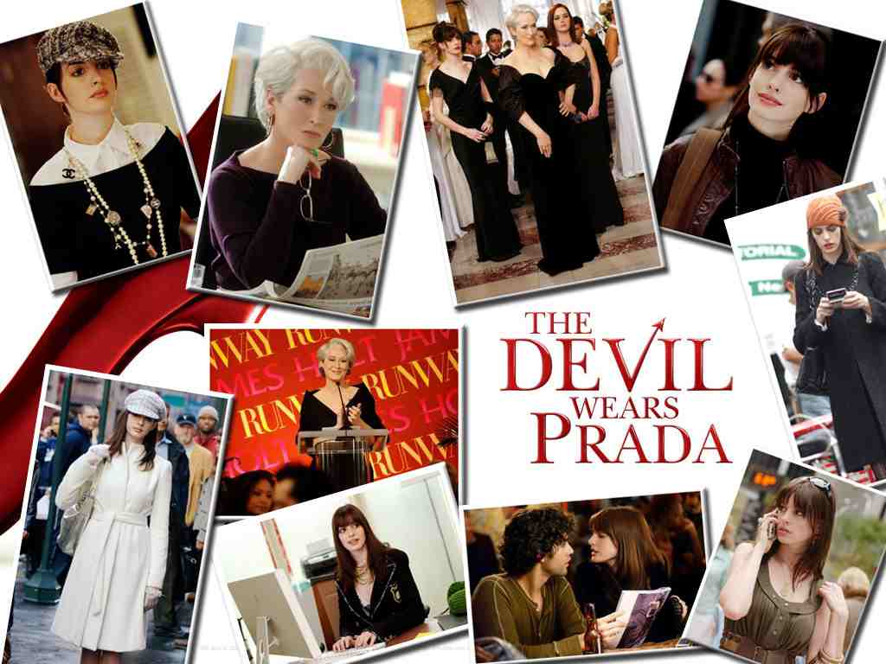

BEFORE WATCHING
1. Look through the song ‘Suddenly I See’ and say how you understand the phrases given in bold.
2. Who is that 'beautiful girl'? What is she like? What influence does she have on people?
3. Do people understand why being beautiful and stylish means so much to them?
4. What kind of power(s) can this 'beautiful girl' give us? How can she do it?
5. How does this 'beautiful girl' make people calm?
LISTENING
"Suddenly I See"
Her face is a map of the world
Is a map of the world
You can see she's a beautiful girl
She's a beautiful girl
And everything around her is a silver pool of light
The people who surround her feel the benefit of it
It makes you calm
She holds you captivated in her palm
Suddenly I see (suddenly I see)
This is what I wanna be
Suddenly I see (suddenly I see)
Why the hell it means so much to me?
Suddenly I see (suddenly I see)
This is what I wanna be
Suddenly I see (suddenly I see)
Why the hell it means so much to me?
I feel like walking the world
Like walking the world
You can hear she's a beautiful girl
She's a beautiful girl
She fills up every corner like she's born in black and white
Makes you feel warmer when you're trying to remember
What you heard
She likes to leave you hanging on her word
Suddenly I see (suddenly I see)
This is what I wanna be
Suddenly I see (suddenly I see)
Why the hell it means so much to me?
Suddenly I see (suddenly I see)
This is what I wanna be
Suddenly I see (suddenly I see)
Why the hell it means so much to me?
And she's taller than most
And she's looking at me
I can see her eyes looking from the page of a magazine
She makes me feel like I could be a tower
A big strong tower
The power to be
The power to give
The power to see, yeah, yeah (suddenly I see)
She got the power to be
The power to give
The power to see, yeah, yeah (suddenly I see)
She got the power to be
The power to give
The power to see, yeah, yeah, yeah (suddenly I see)
She got the power to be
The power to give
The power to see, yeah, yeah (suddenly I see)
She got the power to be
The power to give
The power to see, yeah, yeah
Suddenly I see (suddenly I see)
This is what I wanna be
Suddenly I see (suddenly I see)
Why the hell it means so much to me?
Suddenly I see (suddenly I see)
This is what I wanna be
Suddenly I see (suddenly I see)
Why the hell it means so much to me, oh, oh, oh, yeah, yeah? (suddenly I see)
Suddenly I see (suddenly I see)
Why the hell it means so much to me? (suddenly I see)
Suddenly I see (suddenly I see)
Why the hell it means so much to me?

AFTER LISTENING

1. Watch the video about the effects of mass media on people and say how people get influenced by media? (How do the results of media destort the perception of our bodies, mind and spirits?/ What must girls/boys/teens be according to media?)
2. Do you agree with the statement that 'everything created by media is an illusion'? How do you undestand this issue?
3. How can the perceoption of beauty destored by media push people to extremes? What may the consequences of attempting 'perfection' be?
4. What the video about the Body Image and the way it is created and say what young people think of their perception of a perfect body. Who do you agree with the most? What is your personal opinion on the issue?
5. Are people obsessed with their body image? What can you say to prove your answer taking into consideration the facts given in the videos?
VOCABULARY ON THE FILM
Look through the words to the film ‘The Devil Wear Prada’, see if you can translate them from English into Ukrainian taking into consideration the context they were used in the film.
VOCABULARY ON 'WORK'

- HR (Human Resourses)
- editor in chief
- dream job
- to sack smb
- to be totally wrong for the job
- to be hopeless for this job
- to hire smb
- my job sucks
- countless jobs
- work ethic

VOCABULARY ON 'FASHION & STYLE'
- smiley
- cerulean
- lousy
- paratrooper
- mockup
- glamazon
- inner beauty
- ball gown
- to lose weight
- to have style and sense of fashion
- to wear couture
- to do the coat
- to filter down through the department stores
- to fish smth out
- with right accessories
- closet
- fashion industry
- eyelash curler
- good looks
- obi belt
- complete and utter disaster
- you are in a desperate need of a Channel
- it is sold out everywhere
- You look so chic!
- A million girls would kill for this
- Interest in fashion is crucial.
USEFUL VOCABULARY
- to have odd sense of humour
- to drop smb off
- to pick smb up
- to text-message smb
- to give smb a look
- to warship smb
- to get behind on smb's rent
- to grill smb
- to kiss smb on the forehead
- to give smb a gold star
- to jeopardize smb
- to make the impossible possible
- to come up with a plan B
- to have a moment of weakness
- to be prepped on smth
- to cross over the dark side
- to know smth like the back of one's hand
- to turn one's back on smb
- not to mention,
- on one's way
- at 9.45 sharp
- onion bagel
- Gird your loins!
- Move it!
- Easy there!
- R. S.V.P.
- this is foul!
- that would explain so much
- it has nothing to do with you
- shoot!
- it's divine
- a total psycho
- insignificant, minute details
- that opens a lot of doors
- this is a last minute
- it's drizzling (about the rain)
- she's going to murder me
- I'm killing myself trying
- You are whining
- legends have walked these halls
- shining beacon of hope for smb
- the dragon lady
- Duh!
- top-secret stuff
- I'll guard it with my life
- you don't get it, do you?
- whoopee!
- this is of the utmost importance!
- I'm brilliant! Monuments should be erected in my honour!
- that's big og you!
- it is hanging by a threat
- Stop fidgeting!
- You are a vision!
- The decision is yours
- That's a pathetic excuse!
- You are making a great deal out of it!
- Don't be ridiculous!
- You must have done smth right
- hideous
- nauseous
- suicidal
- groundbreaking
- run-through
- flip-flops
- wacko

TRANSLATION

1. I asked for clean, athletic, smiley. She sent dirty and tired.
2. Is it impossible to find a lovely slender female paratrooper?
3. Yeah, you know, okay. You are right. I don't fit in here. I am not skinny or glamorous and I don't know that much about fashion, but I am smart. I learn fast and work very hard.
4. Who is that sad little person?
5. You should see the way these girls dress. I don't have a thing to wear to work.
6. I hope you know this is a very difficult job for which you are totally wrong. If you mess up, my head is on the chopping block.
7. Remember: you and I have totally different jobs. I mean, you get coffee and run errands. I am in charge of her schedule, her appointments and her expenses and most importantly, I get to go with her to Paris for Fashion Week in the fall.
8. Please bore someone else with your questions
9. You think it has nothing to do with you. You go to your closet and you select, I don't know, that lumpy blue sweater, for instance because you are trying to tell the world you take yourself too seriously to care about a you put on you, but what you don' t know is that that sweater is not just blue, it's not turquoise, it's not lapis. It is actually cerulean. And you're also unaware of the fact that in 2002 Oscar de la Renta did a collection of cerulean gowns and then it was Yves Saint Laurent who showed cerulean military jackets and then it filtered down through the department stores and then trickled on down into some tragic casual corner where you, no doubt, fished it out of some clearance bin. However, that blue represents millions of dolars and countless jobs. And it's sort of comical how you think that you've made a choice that exempts you from fashion industry when, in fact, you are wearing a sweater that was selected for you by the people in this room from a pile of 'stuff'.
10. Do you know why I hired you? I always hire the same girl: stylish, slender, of course, who worships the magazine. But so often , they turn out to be disappointing and stupid. So you with that impressive resume and the big speech about your so-called work ethic... I though you would be different. I said to myself: 'Go ahead. Take a chance! Hire the smart fat girl', I had hope. You ended up disappointing me more than any of the other silly girls.
11. Don't you know that you are working at the place that published some the greatest artists: Halston, Lagerfeld, de la Renta? And what they did, what they created was greater than art, because you live your life in it. This is not just a magazine. This is a shining beacon of hope for people.
12. Fashion is not about utility. All accessories is merely a piece of iconography used to express individual identity.

AFTER VIEWING

Read the dialogues from the film, recall the episodes they were shown in. Who do the lines belong to? Comment on the situation and its main idea.
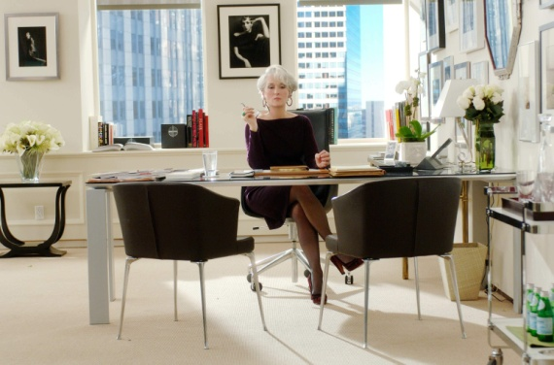
1.
- So, you don't read Runway?
- No
- Before today, you'd never heard of me?
- No
- And you have no style and sense of fashion?
- Well... I think that depends on what you' re...
- No, no. That wasn't a question.
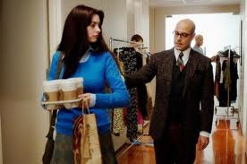
2.
- Shoot!
- Oh, never mind. I am sure you have plenty more poly blend where that come from.
- Okay. You think my clothes are hidious. I get it. But you know, I am not going to be in fashion forever, so I don't see the point of changing myself just because I have this job.
- Yes, that's true. That what this multi-million-dollar industry is all about, anyway, isn't it? Inner beauty.

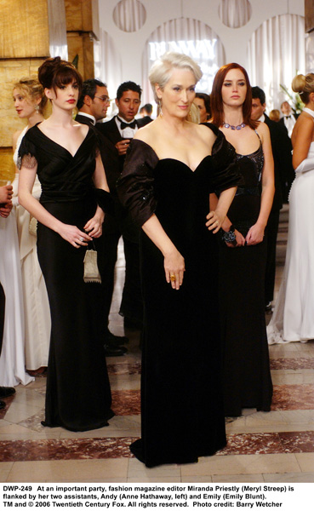
3.
- You look so thin!
- Do I?
- Yeah.
- It's for Paris. I'm on this new diet. It's very effective. I don't eat anything. And then, when I feel like I'm about to faint I eat a cube of cheese.
- It definitely works.
- I know. I'm just one stomach the way from the goal weight.

4.
- I don't think I'm like that. I couldn't do something like that to people.
- You already did...To Emily.
- No, that was different. I didn't have a choice.
- Oh, no you chose. You chose to go ahead. You want this life, those choises are necessary.
- But what this isn't what I want? If I don't want to live the way you live?
- Oh, don't be ridiculous! Everybody wants this. Everybody wants to be us!
