The Twelfth Night or What You Will

Twelfth Night or, What You Will is a comedy by William Shakespeare, believed to have been written around 1601–02 as a Twelfth Night's entertainment* for the close of the Christmas season. The first recorded performance was on 2 February 1602, at Candlemas, the formal end of Christmastide in the year's calendar.

Twelfth Night or What You Will is a 1996 British film adaptation of William Shakespeare's play, directed by Trevor Nunn and featuring an all-star cast. The adaptation is given a northern Central European feel, set in the late 19th century

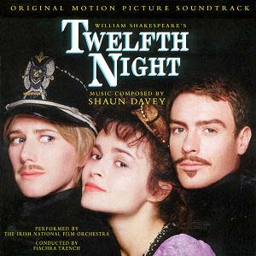

*Twelfth Night is a festival, in some branches of Christianity, marking the coming of the Epiphany and concluding the Twelve Days of Christmas. It is defined by the Shorter Oxford English Dictionary as "the evening of the fifth of January, preceding Twelfth Day, the eve of the Epiphany, formerly the last day of the Christmas festivities and observed as a time of merrymaking". There is some confusion, however, as to which night is Twelfth Night. The older tradition of Twelfth Night being on the eve of 5 January stems from the medieval practice of the day beginning at sunset, rather than at midnight as it does now. Thus Twelfth Night falls on the night of 5 January nowadays.

PART I: BEFORE WATCHING
Comment on the quotes from the play:

1. “Be not afraid of greatness. Some are born great, some achieve greatness, and others have greatness thrust upon them.”

2. “If music be the food of love, play on,
Give me excess of it; that surfeiting,
The appetite may sicken, and so die.”

3. “Some are born great, others achieve greatness.”

4. “Better a witty fool, than a foolish wit.”

5. “But, indeed, words are very rascals, since bonds [vows] disgraced them."
Viola: "Thy reason, man?"
Feste: "Troth [Truthfully], sir, I can yield you none without words, and words are grown so false, I am loathe to prove reason with them.”

6. “Olivia: What's a drunken man like, fool?
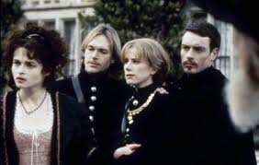
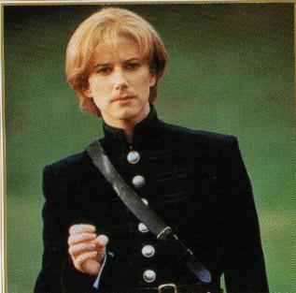
Feste: Like a drowned man, a fool, and a madman: one draught above heat makes him a fool; the second mads him; and a third drowns him.”
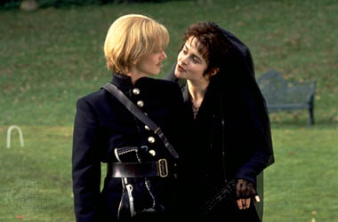

Vocabulary
Before watching the film make sure you are familiar with all lexical units in this section
- to force a vessel from its course – звернути судно від його маршруту
- to unfold the passion of one's love – розкрити пристрасть своїх почуттів, відкрити свої почуття
- to speak three or four languages, word for word – добре володіти трьома чи чотирма мовами
- to hang smb for smth – повісити когось за щось (прибити, придушити)
- Make your proof! – Докажи!
- old enough for a man, young enough for a boy – зрілий чоловік
- Are you a comedian? – Ти що клоун?
- If you be mad, be gone, if you have reason, be brief – Якщо ти не в своєму розумі, то я тебе слухати не буду, а якщо маєш щось доречне сказати - говори!
- Give us this place alone! – залиште нас на одинці!
- It's heresy! – Це – єресь (дурниці, маячня, нісенітниця)
- I'm not for him – Я не для нього, я з ним не буду
- I left no ring with her – Я не залишав у неї жодної каблучки
- to make a good view of smb – скласти про когось гарне враження
- to lose one's tongue – втратити дар мови
- Have you no wit, manners..? – У тебе взагалі клепки (манер) немає? Ти взагалі збожеволів?
- to beat smb like a dog – бити когось як паршивого пса
- to hit smb in the eye – поставити комусь синець під оком
- By my life!– присягаюсь (власним життям), зуб даю, що...
- to live by the music/church – жити на подаяння від церкви, вулиці
- on smb's behalf – від імені
- pang – гострий біль
- as hungry as the sea – ненаситний як море
- to say one's prayers - молитися
- hold one's life at any price – зберегти собі життя за будь-яку ціну
- there's no remedy = nothing can be done to make it better
- do an offence – образити когось
- as dark as hell – темний як ніч
- glorious sun – чудове сонце
- for smb's sake – за ради когось

PART II: AFTER WATCHING
Fill in the gaps with proper names of the main characters of the play to make up the plot of the story.

1)______________ and 2)______________ are young twins who, on Twelfth Night are performing on a ship and use their likeness to tease their audiences. During their journey, they are caught in a storm, shipwrecked and separated. 1)__________and other survivors end up on the shore of 3)_____________. A devastated 1)______________ believes her brother dead. She later takes his appearance to join the court of the local Duke 4)_____________. 1)_____________ becomes a page, using the name "5)____________".
4)_____________ is madly infatuated by Countess 6)______________, who is in mourning due to her brother's recent death. She uses the tragedy as an excuse to avoid seeing the Duke, whom she does not love. He sends "5)________________" to do his wooing and 6)____________ falls in love with the messenger, unaware of "5)_______________"'s real gender. Realising 6)______________'s feelings for her alter ego, 1)________________ is caught in even more of quandary in that she is in love with 4)______________.
Furthermore, 1)___________'s twin, 2)______________, has in fact survived the wreck and has also arrived in 3)_____________, accompanied by 7)________________, who saved him from drowning7)________, who has "many enemies in 4)____________'s court", is forced to flee when he is recognised and comes across "5)______________", whom he mistakes for 2)____________, and is outraged when "5)____________" fails to help him out.
Arriving at her estate, 2)______________ meets 6)_____________, who, mistaking him for "5)_________", talks him into marrying her. When he learns of this, 4)___________ is furious and dismisses his page, whom he had made a friend and confidante. However, the matter is soon cleared up when 2)_______ and "5)____" come face-to-face and the latter reveals her real nature and identity of 1)___________. 4)________ marries 1)__________. The film ends with both couples holding a party to celebrate their marriages.

Characters

Viola – a shipwrecked young lady, the heroine of the play, later disguised as a young man named Cesario.
Duke Orsino – Duke of Illyria
Olivia – a wealthy countess
Sebastian – Viola's twin brother
Malvolio – steward in the household of Olivia
Maria – Olivia's gentlewoman
Sir Toby Belch – Olivia's uncle
Sir Andrew Aguecheek – a rich man who Sir Toby brings to be Olivia's wooer
Feste – the clown, or court jester, of Olivia's household
Fabian – a servant and friend to Sir Toby
Antonio – a captain and friend to Sebastian
Valentine and Curio – gentlemen attending on the Duke
A Captain
First Officer
Second Officer
A Priest
A Servant of Olivia
Musicians, Sailors, Lords, Attendants

Setting

Illyria, the setting of Twelfth Night, is important to the play's romantic atmosphere. Illyria was an ancient region of the Western Balkans whose coast (the eastern coast of the Adriatic Sea which is the only part of ancient Illyria which is relevant to the play) covered (from north to south) the coasts of modern day Slovenia, Croatia, Montenegro and Albania. It included the city state of the Republic of Ragusa which has been proposed as the setting.[2] Illyria may have been suggested by the Roman comedy Menaechmi, the plot of which also involves twins who are mistaken for each other. Illyria is also referred to as a site of pirates in Shakespeare's earlier play, Henry VI, Part 2. The names of most of the characters are Italian but some of the comic characters have English names. Oddly the "Illyrian" lady Olivia has an English uncle, Sir Toby Belch. It has been noted that the play's setting also has other English allusions such as Viola's use of "Westward ho!", a typical cry of 16th-century London boatmen, and also Antonio's recommendation to Sebastian of "The Elephant" as where it is best to lodge in Illyria; The Elephant was a pub not far from the Globe Theatre.

Synopsis

Viola is shipwrecked on the coast of Illyria and she comes ashore with the help of a captain. She loses contact with her twin brother, Sebastian, whom she believes to be dead. Disguising herself as a young man under the name Cesario, she enters the service of Duke Orsino through the help of the sea captain who rescues her. Orsino has convinced himself that he is in love with Olivia, whose father and brother have recently died, and who refuses to see any suitor until seven years have passed, the Duke included. Orsino then uses 'Cesario' as an intermediary to profess his passionate love before Olivia. Olivia however, forgetting about the seven years in his case, falls in love with 'Cesario', as she does not realise 'he' is Viola in disguise. In the meantime, Viola has fallen in love with the Duke.
In the comic subplot, several characters conspire to make Olivia's pompous steward, Malvolio, believe that Olivia has fallen for him. This involves Olivia's uncle, Sir Toby Belch; another would-be suitor, a silly squire named Sir Andrew Aguecheek; her servants Maria and Fabian; and her fool, Feste. Sir Toby and Sir Andrew engage themselves in drinking and revelry, thus disturbing the peace of Olivia's house until late into the night, prompting Malvolio to chastise them. Sir Toby famously retorts, "Dost thou think, because thou art virtuous, there shall be no more cakes and ale?" (Act II, Scene III) Sir Toby, Sir Andrew and Maria are provoked to plan revenge on Malvolio. They convince Malvolio that Olivia is secretly in love with him by planting a love letter, written by Maria in Olivia's hand. It asks Malvolio to wear yellow stockings cross-gartered, to be rude to the rest of the servants, and to smile constantly in the presence of Olivia. Malvolio finds the letter and reacts in surprised delight. He starts acting out the contents of the letter to show Olivia his positive response. Olivia is shocked by the changes in Malvolio and leaves him to the contrivances of his tormentors. Pretending that Malvolio is insane, they lock him up in a dark chamber. Feste visits him to mock his insanity, both disguised as a priest and as himself.
Meanwhile, Sebastian (who had been rescued by a sea captain, Antonio) arrives on the scene, which adds confusion of mistaken identity. Mistaking Sebastian for 'Cesario', Olivia asks him to marry her, and they are secretly married in a church. Finally, when 'Cesario' and Sebastian appear in the presence of both Olivia and Orsino, there is more wonder and confusion at their similarity. At this point Viola reveals she is a female and that Sebastian is her twin brother. The play ends in a declaration of marriage between Duke Orsino and Viola, and it is learned that Sir Toby has married Maria. Malvolio swears revenge on his tormentors but Orsino sends Fabian to console him.

