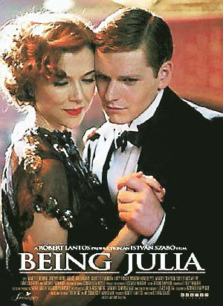
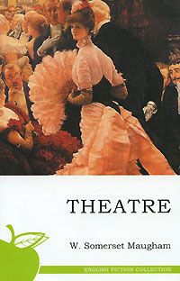
Being Julia
Being Julia is a 2004 drama film with comic undertones directed by István Szabó and starring Annette Bening and Jeremy Irons. The screenplay by Ronald Harwood is based on the 1937 novel Theatre by W. Somerset Maugham.

BEFORE WATCHING
Read the lines by William Shakespeare about his vision of what life is and the role of men in it. How do you understand it? Do you agree with him?

“All the world's a stage,
And all the men and women merely players;
They have their exits and their entrances,
And one man in his time plays many parts,
His acts being seven ages. At first, the infant,
Mewling and puking in the nurse's arms.
Then the whining schoolboy, with his satchel
And shining morning face, creeping like snail
Unwillingly to school. And then the lover,
Sighing like furnace, with a woeful ballad
Made to his mistress' eyebrow. Then a soldier,
Full of strange oaths and bearded like the pard,
Jealous in honor, sudden and quick in quarrel,
Seeking the bubble reputation
Even in the cannon's mouth. And then the justice,
In fair round belly with good capon lined,
With eyes severe and beard of formal cut,
Full of wise saws and modern instances;
And so he plays his part. The sixth age shifts
Into the lean and slippered pantaloon,
With spectacles on nose and pouch on side;
His youthful hose, well saved, a world too wide
For his shrunk shank, and his big manly voice,
Turning again toward childish treble, pipes
And whistles in his sound. Last scene of all,
That ends this strange eventful history,
Is second childishness and mere oblivion,
Sans teeth, sans eyes, sans taste, sans everything.”

― William Shakespeare, As You Like It

VOCABULARY
Look through the suggested vocabulary list to the film, see if you are familiar with the words and phrases given. Highlight the ones that are related to ‘theatre’.

- to have magnetism – ти дієш як магніт на людей
- to grab smb by the throat – схопити когось за горло
- to sweat it out – тяжко працювати, до сьомого поту
- to admire smb tremendously – обожнювати когось
- to sound frightfully intelligent – звучати дуже розумно
- to be as poor as a church mouse – бути бідним як церковна миша
- to give a spot of lunch – пригостити когось невеликим обідом (перекусити)
- to be interested in the business side – цікавитись лише бізнесом
- to lay a place for smb at the table – накривати на когось за столом
- to sit quiet as a lamb - quietly and without any argument - буду сидіти тихенько як мишка
- to feel twice one's age – почуватися вдвічі старшим
- to be near a break-down – перебувати у стані, наближеному до нервового зриву
- to be in an odd state – бути в дивному стані
- to be entirely myself – бути собою у повній мірі
- to be low – почуватися пригнічено
- to settle an argument – розсудити, сказати, хто правий
- to see smb out – проводити когось, показувати дорогу назад, виводити
- to come straight to the point – переходити безпосередньо до суті, до головного
- to get smb out of the hole – допомогли комусь вибратись зі скрутного становища
- to make a fuss about smth – перейматися із-за чогось, бити на сполох
- to put a good word for smb – замовити за когось слівце
- to have the guts to tell smb the truth – мати мужність сказати правду
- to let sentiment interfere with business – дозволити почуттям втручатися в справи, бізнес
- to be a find – бути знахідкою
- to give a lousy performance – ганебно зіграти, повний провал
- to have a fling with smb – закрутити з кимось недовготривалу інтрижку
- to be too angelic – бути занадто добрим
- vile - extremely unpleasant or bad [= horrible]
- slut - a very offensive word for a woman who has sex with a lot of different people. Do not use this word
- bubbly - champagne
- matinee - a performance of a play or film in the afternoon
- tart - an insulting word for a woman who you think is too willing to have sex. Do not use this word
- balls - something that is stupid or wrong [= nonsense]
- vanity - too much pride in yourself, so that you are always thinking about yourself and your appearance
- bugger - an offensive word for someone who is very annoying or unpleasant
- civilians – громадяни, населення
- tedious - something that is tedious continues for a long time and is not interesting[= boring]
- vain - someone who is vain is too proud of their good looks, abilities, or position - used to show disapproval [= conceited]
- brute - a man who is cruel, violent, and not sensitive
- ravenous - very hungry [↪ starving]
- vaguely - slightly [≠ clearly]
- comfy - comfortable
- fagged - also fagged out [not before noun] extremely tired
- humiliated - принижений
- erratic - нестійкий
- foul-mouthed – «чорноротий», сварливий
- a rotten actor – поганий актор, нездара
- afternoon nap – післяобідній сон
- dirty-minded – з поганими помислами
- fatal beauty – фатальна краса
- gold-digger – корислива людина
- grudge - образа
- I'm an incurable romantic – я невиліковний романтик
- with every fiber of my being – кожною клітинкою свого тіла
- I give up – ну все, я здаюсь (я не знаю)
- a perfectly natural thing - природньо
- I am utterly exhausted – я абсолютно виснажений
- It's a greаt lark - used to describe an activity that you think is silly or difficult
- I'm near the breaking point – у мене скоро буде нервовий зрив, я на межі зриву
- What has this to do with me? – Яке це має до мене відношення?
- Last one is a sissy – Хто останній, той і програв!
- the audience always gasps – глядачі завжди затамовують подих, дивуються
- you never know – ніколи не знаєш...
- Don't torture yourself like this! – не знущайся так над собою!
- on a business matter – у справах
- Show her in! – Нехай зайде!
- Ignore me! – Не зважай на мене
- at my time of life – у моєму віці
- This is becoming a ritual – це вже стає звичною справою, переходить у звичку
- I don't see why not – не маю жодних заперечень
- What's so funny? – Що такого смішного?
- You reminded of something? – Ти щось пригадав?
- as if your bones are melting inside your body – ніби в тебе всередині щось перевертається
- How divine! – Як гарно! Божественно!
- Well spotted – гарно підмічено
- Don't be so pedantic! – Не придирайся так до всього!
- This is total insanity – Це якесь божевілля!
- my tummy needs tightening – потрібно підтягнути животика
- It will only end in tears – це завершиться розчаруванням, будеш плакати гіркими сльозами
- smth doesn't mean a thing to smb – це нічого не означає для когось
- How shall I put it? – Як мені сказати, пояснити?
- I'm worried sick – Я вмираю від хвилювання
- Geez = jeez- used to express feelings such as surprise, anger, annoyance etc – Чорт забирай!
- I heard on the grapevine – сорока на хвості принесла
- She eats out of my hand – вона зробить усе, що я їй скажу, вона у мене на побігеньках
- Don't be daft! – Не будь ідіотом!
- Keep the pace, don't rush it! Nice and easy! – Помаленьку! Не поспішай! Помаленьку!
- on the contrary - навпаки
- let's face it – давайте подивимося правді у вічі
- assert yourself! – Покажи себе!
- Don't fly into temper – Не гарячкуй!
- The public are jackasses – глядачі нічого не петрають
- How madly generous of you! – Ой, як же люб’язно з вашого боку!
- I play for the other side – я нетрадиційної орієнтації
- ta (informal)- thank you
- ta-ta - goodbye
AFTER-WATCHING
Look through the statements taken from the film. Define the character they belong to. Recall the episode in the film they were used in.

1. Remember this, when you are on the stage acting,
the theatre is the only reality. Everything else, the world outside, what civilians call the real world, is nothing but fantasy.

2. I'm in such an odd state at the moment. It's as if the curtains come down on act 1, and I have no idea what happens in act 2. I'm in a sort of limbo. Waiting for something to happen. But what?

3. Life is just a bowl of cherries. Don't take it serious, life is too mysterious.
The sweet things in life to you were just loaned, so how gonna you lose what you've never owned?
Life is just a bowl of cherries, so live and laugh at it all.

4. - You know something? You ought to be in movies.
-Real actresses don't make films.
-But beautiful actresses do.

5. Age cannot wither her, nor custom stale her infinite variety.

6.Don't let the world outside cheapen your gifts

7. Nowadays we're only interested in appearances. And he did have the most beautiful appearance.

8. I want to stop living in an atmosphere of make-believe. That's your world, not mine. And it stifles me.

9. I was acting. If I truly felt all the emotions I was representing, I'd be a wreck.

10. All who love are blind.

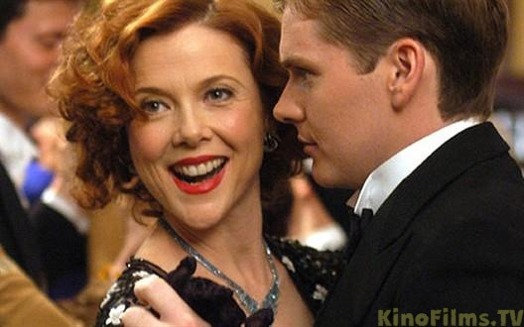
11. I've decided to retire and let myself go. I'll have potatoes for lunch and potatoes for dinner and beer. God, I love beer! And treacle pudding and cherry tart and cream, cream, cream, cream, cream, cream... as god is my judge, I'll never eat a lettuce leaf again.

12. If you're thinking what I think you're thinking, stop thinking!


