Balto
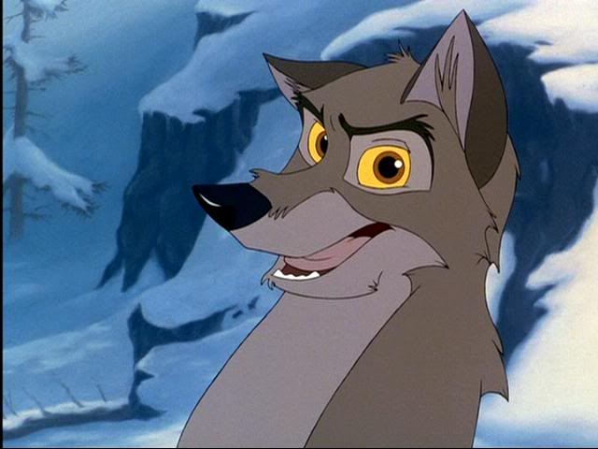
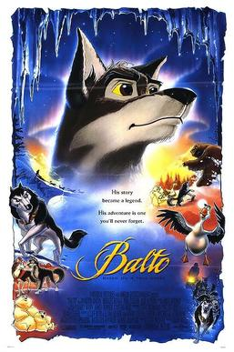
Before Watching
Answer the questions given below:
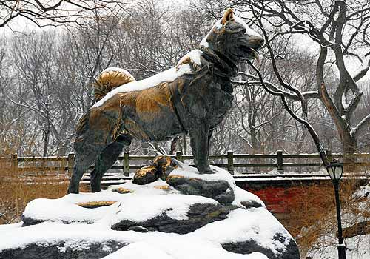

What is a memorial*?
Are there any in your town/city?
Do think it is important to remember the history of any place? Why? Why not?

VOCABULARY
Look through the words and expressions given below and highlight the ones that are new for you.
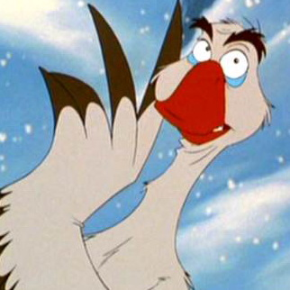
- fragile – тендітний, ламкий
- a polar bear – полярний ведмідь
- freezing cold – сильний мороз
- bitter cold – сильний мороз
- the most beautiful spot – найкрасивіше місце
- the Northen lights – полярне сяйво
- bearly alive – ледве живий
- a reliable source – надійне джерело
- fever – лихоманка, гарячка
- to be speechless – не мати, що сказати (від здивування)
- to make a journey – мати подорож
- to slow down - гальмувати
- to take smb in circles – водити когось колами
- to be out of medicine – залишитись без ліків
- to make it through – пройти через складний шлях
- to make an impression – складати враження
- to be in the middle of nowhere – бути невідомо де, хто-зна-де
- to snow hard/heavily – сильно сніжити
- to get around – діставатись по місцевості
- to hold races - проводити перегони
- to lose one's appetite - втрачати апетит
- to feel warm – бути зігрітим
- to stay warm – бути (залишатися) в теплі
- by sea/air – морем (кораблем)/повітряним шляхом (літаком)
- Stay close! – Не відставай! Тримайся мене!
- Come to life! Breath! – Оживай! Дихай!
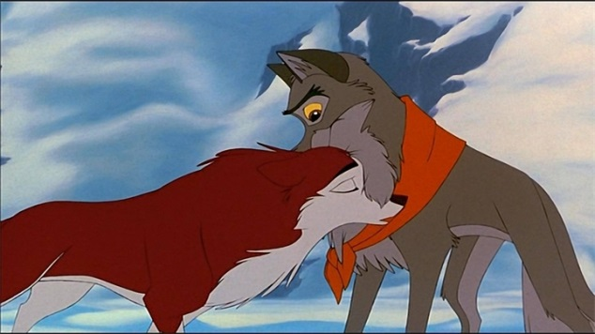
*a memorial
is a reminder of a wonderful story
at a place. (according to the film)

After Watching
Answer the questions given below:

1. Where did the story take place?
2. Who is Rosy? What happened to her? How did she feel?
3. Why was it impossible to ship the medicine by sea and air? What was the way out?
4. Who is Balto?
5. What is Balto’s favourite spot?
6. What happened to Balto at the end of the story?
7. What other characters do you remember? Who do you like best? Why?

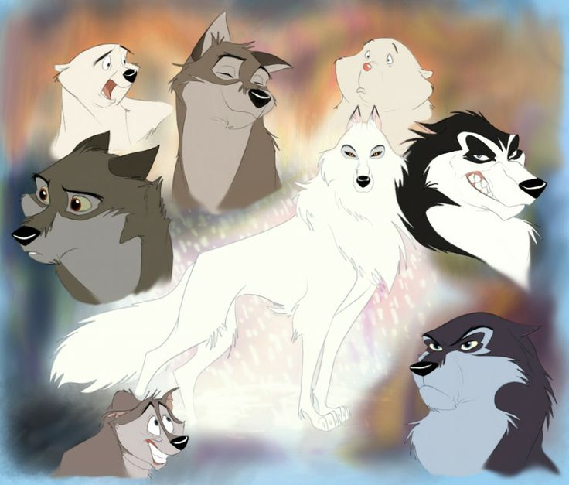

8. What are your favourite quotations from ‘Balto’? What do you think of these ones?
