The Beauty and the Beast

Task 1. Read the beginning of the story and say what you think of it by answering the questions that go after it.
One upon a time in a far away land, a young prince lived in a shining castle. Although he had everything his heart desired, the prince was spoiled, selfish and unkind. But one winter’s night an old beggar woman came to the castle and offered him a single rose in return for the shelter from bitter cold. Repulsed from her unpleasant appearance the prince refused from the gift and turned the old woman away, but she warned him not to be deceived by appearances for beauty lives within and when he dismissed her again the old woman’s ugliness melted away to reveal beautiful enchantress, the prince tried to apologize, but it was too late for she had seen that there was no love in his heart and as punishment she transformed him into a beast… If he could learn to love in return by the time the last petal fell, then the spell will be broken. If not, he will be doomed to remain a beast for all time.
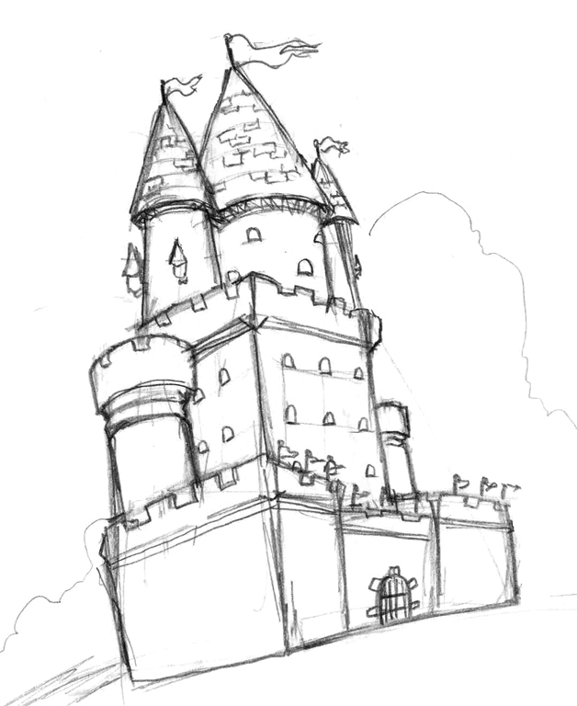
- Do you think it was a right punishment for a spoilt prince? Why? Why not?
- Do you agree that true beauty lives within each person?
- Would you like to have everything your heart desires?

BEFORE WATCHING:
Vocabulary

Task 2. Look through the vocabulary to the film, it will help you to understand the story better. Highlight the ones that are new for you.

a fair – ярмарок
a bitter cold – сильний холод
a beggar woman – жінка, що просить милостині
a spell – закляття
***
gorgeous – неймовірної краси, неперевершений
splendid – чудовий
hospitable – гостинний
mean – нечесний, грубий, жадібний
enchanted – зачарований
***
to borrow a book – брати на користування книгу
to insist on smth – наполягати на чомусь
to discover smth – відкривати щось, з’ясовувати
to get through – діставатись через, прокладати шлях крізь, проходити
to pay attention to smth/smb – звертати увагу на щось чи когось
to turn around – повертатись назад
to stay for night – залишатись на ночівлю
to demand – вимагати
to warm up – зігріватись, розігріватись
to stare at smb/smth – пильно дивись на щось чи когось
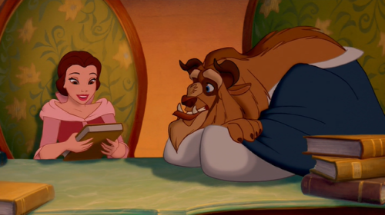
to be in smb’s shoes – бути на чийомусь місці
to deserve smth – заслуговувати на щось
to let smb out – випускати когось
to promise to do smth – обіцяти щось зробити
to say good-bye – прощатися
to break a spell – розбивати закляття
to starve – вмирати з голоду, дуже хотіти їсти
to watch smth/smb – наглядати за чимось чи комусь
to find out about smth – з’ясовувати щось, дізнаватися про щось
to go to bed – іти спати
to look around – оглядати щось довкола, ходити і роздивлятися
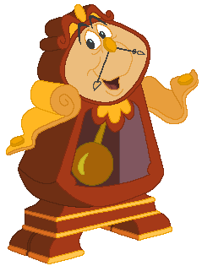
AFTER WATCHING

Task 3. Watch the film carefully and answer the questions given below:

- Does Belle like adventures?
- Why do you think people from Belle’s village believe that she is strange and funny?
- How do you find Guston? How do people find him? What do you think of his desire to marry Belle without her agreement? Why did he want to marry her?
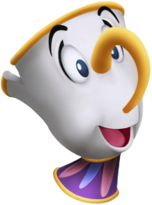
- What is belle’s father name? Who is Belle’s father? What do people say about him?
- What is the name of their horse?
- Who attacked Belle’s father in the forest?
- Was a Beast pleased to see a stranger in his castle?
- What is the castle like? Are there any enchanted things?
- Is there a library in the castle?
- Where was the rose kept? Why?
- How did Belle get to the castle? Where was she staying and how was she treated there? Was the Beast kind to her?
- Was there a dog in the castle? What was it like?
- What surprise did the Beast prepare for Belle one day?
- What could the magic mirror do?
- Why do you think the Beast give up at the end of the story?
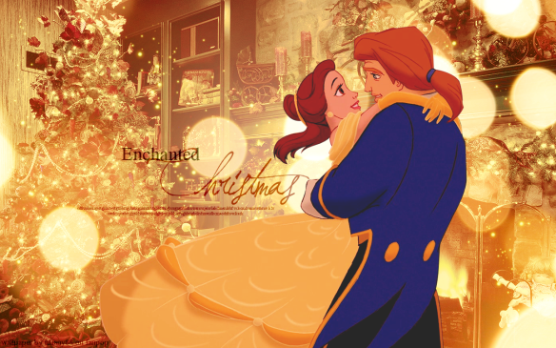
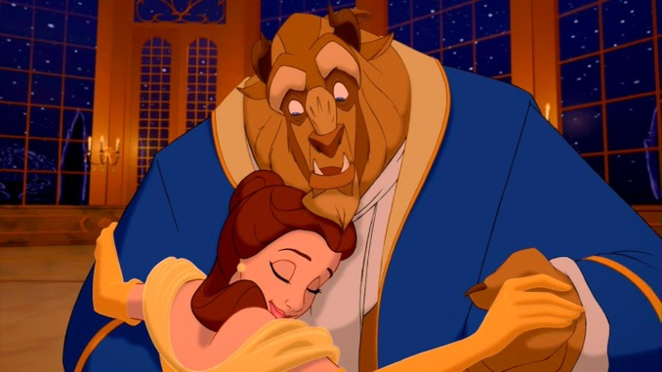

Don’t you worry! – Не хвилюйся!
Let’s give it a try! – Спробуй!
Take care! – Бережи себе!
Let’s go this way! – Ходімо сюди!
Look out! – Стережись!
Over here! – Сюди!
I beg your pardon! – Перепрошую! Прошу вибачення!
This is your luck day! – Тобі пощастило! Сьогодні твій щасливий день!
I’m speechless – Немає (бракує) слів
I’m looking for… - Я шукаю…
Your hands are like ice – У тебе руки холодні як лід
You have my word – Обіцяю!
Let me out! – Відпустіть мене!
What’s for? – Навіщо?
Cheer up! - Вище ніс!
Be our guest! – Будь як вдома!

Nice expressions from the film

