My Fair Lady/Pygmalion

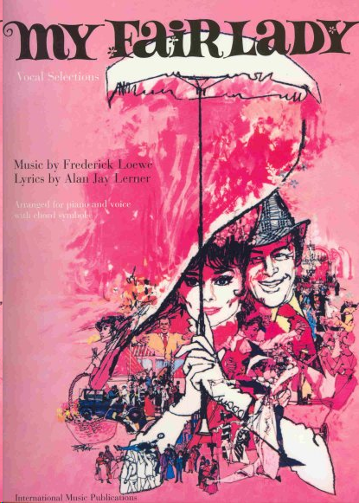
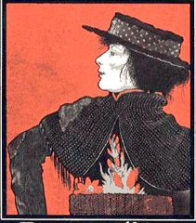

Follow the links and view the film and read the book:
My Fai Lady:
Part 1. http://www.youtube.com/watch?v=c9fI_EpTXtA
Part 2. http://www.youtube.com/watch?v=uhe0VpjkpW4

Pygmalion: http://www2.hn.psu.edu/faculty/jmanis/gbshaw/pygmalion.pdf

Activity 1. My Fair Lady

Task 1.
Watch the 1st video clip (04:30-06:32), listen to different accents in English. What is the relationship between accents and social status in English culture?
_______________________________________________________________________________________________________________________________________________________________________________________________________________________________________________________________________________________________________________________________________________________________________________________________________________________________________________________________________________________________________________________________________________________________________________________________________________________________________________________________________________________________________________________________________________________________________________________________________________

Task 2. Read the script of the video clip you have viewed. Underline the words that come from non-RP, figure out the meaning and pronunciation of those words.
Script
Lady: Freddy, go and find a cab. Do you want me to catch pneumonia?
Don’t just stand there, Freddy. Go and find a cab.
Freddy: All right, I’ll get one. I’ll get it.
(Eliza bumped into Freddy and fell down on the street.)
Eliza: Look where you’re goin’, dear. Look where you’re goin’!
Freddy: I’m so sorry.
Eliza: Two bunches o’ violets trod in the mud. A full day’s wages.
Lady: Freddy, go and find a cab.
Freddy: Yes, Mother.
Eliza: He’s your son, is he? If you’d done your duty by him as a mother should, you
wouldn’t let ‘im spoil a poor girl’s flow’rs and then run away without payin’.
Lady: Oh, go about your business, my girl.
Eliza: And you wouldn’t go off without payin’, either. Two bunches o’ violets trod in
the mud.
(Pickering appeared.)
Lady: Oh, sir, is there any sign of it stopping?
Pickering: I’m afraid not. It’s worse than before.
Eliza: If it’s worse, it’s a sign it’s nearly over.
Cheer up, Capt’n, buy a flow’r off a poor girl.
Pickering: I’m sorry, I haven’t any change.
Eliza: I can change ‘alf a crown. Here, take this for tuppence.
Pickering: I told you, I’m awfully sorry. Wait a minute. Oh yes. Here three hapence,
if that’s any use to you.
Eliza: Thank you, sir

non-RP equivalent | transcription | RP equivalent | transcription

Task 3. What are the differences between Eliza and the other 3 characters from the point of view of their accents, the words they use and their appearance? Dwell on grammar, diction, pronunciation, formality, etc.
_________________________________________________________________________________________________________________________________________________________________________________________________________________________________________________________________________________________________________________________________________________________________________________________________________________________________________________________________________________________________________________________________________________________________________________________________________________________________
______________________________________________________________________________________________________________________________________________________________________________

Activity 2. My Fair Lady
Task 1. Watch the 2nd video clip (06:33-10:16), pay attention to Eliza and find out more examples of the informality and grammatical mistakes she makes.
non-RP equivalent | transcription | RP equivalent | transcription

Task 2. Answer the questions given below:
1. What is Henry Higgins?
______________________________________________________________________________________________________________________________________________________________________________
2. What is he good at?
______________________________________________________________________________________________________________________________________________________________________________
3. What do you think about the personalities of Henry and Eliza?
____________________________________________________________________________________________________________________________________________________________________________________________________________________________________________________________________________________________________________________________________________________________
Activity 3. My Fair Lady. Song ‘Why can’t the English’
Task 1. Listen to the song ‘Why can’t the English?’ and fill in the gaps with the missing words.

Look at her, a prisoner of the ___________,
Condemned by every syllable she ever _________.
By law she should be taken out and _________,
For the cold-blooded murder of the English ________.
(Eliza Aaoooww! Henry imitating her Aaoooww!)
Heaven's! What a noise!
This is what the British _________,
Calls an elementary__________.
Pickering: Come, sir, I think you’ve picked a poor example. Henry: Did I?
Hear them down in Soho _________,
Dropping "Hs"__________.
Speaking English anyway they _________.
You sir, did you go to __________?
Man: What ya tike me for, a _________?
Henry: No one taught him 'take' instead of '________'!
Hear a Yorkshireman, or __________,
Hear a Cornishman __________,
I'd rather hear a choir singing __________.
Chickens cackling in a barn just like this one!
Eliza: Garn! Henry: I ask you, sir, what sort of word is _________?
It's "Aoooow" and "Garn" that keep her in her _________.
Not her wretched clothes and dirty __________.
Why can't the English teach their children how to __________?
This verbal class distinction by now should be ___________.
If you spoke as she does, sir, instead of the way you _________,
Why, you might be selling flowers, __________.
An Englishman's way of speaking absolutely classifies him,
The moment he talks he makes some other
Englishman despise him.
One common language I'm afraid we'll never __________.
Oh, why can't the English learn to _________
A good example to people whose
English is painful to your _________?
The Scotch and the Irish leave you close to _________.
There even are places where English completely ____________.
In America, they haven't used it for __________!
Why can't the English teach their children how to ________?
Norwegians learn Norwegian; the Greeks have taught their __________.
In France every Frenchman knows
his language from "A" to "Z"
The French never care what they do, ___________,
as long as they pronounce it ____________.
Arabians learn Arabian with the speed of summer ___________.
And Hebrews learn it backwards,
which is absolutely ___________.
But use proper English you're regarded as a ___________.
Why can't the English,
Why can't the English learn to __________
Activity 4. Summary on the film
View the film and write the summary to it.
____________________________________________________________________________________________________________________________________________________________________________________________________________________________________________________________________________________________________________________________________________________________
_____________________________________________________________________________________________________________________________________________________________________________________________________________________________________________________________________
_____________________________________________________________________________________________________________________________________________________________________________________________________________________________________________________________________
_____________________________________________________________________________________________________________________________________________________________________________________________________________________________________________________________________
_____________________________________________________________________________________________________________________________________________________________________________________________________________________________________________________________________
_____________________________________________________________________________________________________________________________________________________________________________________________________________________________________________________________________
______________________________________________________________________________________________________________________________________________________________________________
_____________________________________________________________________________________________________________________________________________________________________________________________________________________________________________________________________
_______________________________________________________________________________________

Activity 5. Pygmalion
Task 1. Read George Bernard Shaw’s biography. Take notes. Be ready to retell the biography in the class.

THE AUTHOR

George Bernard Shaw 1856 - 1950
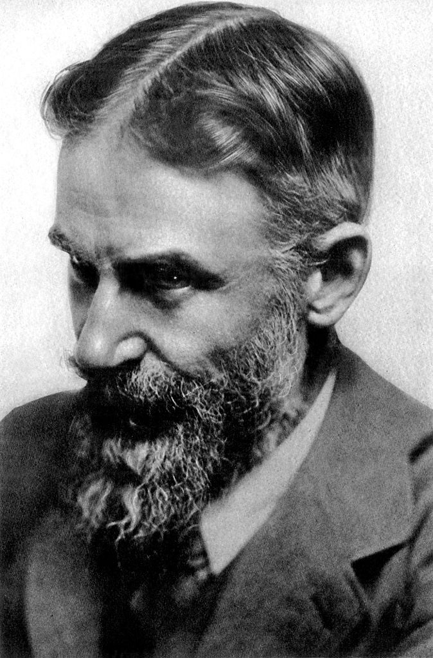
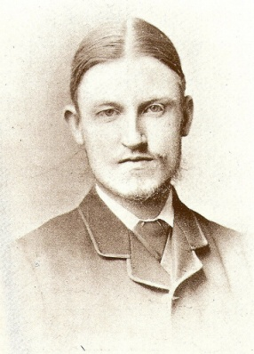
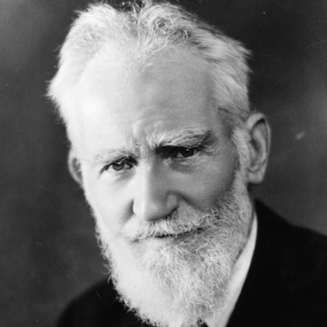

George Bernard Shaw, born in Dublin in 1856, began his writing career as a novelist and journalist, but gained his great fame as a playwright. Most people consider Shaw the secondgreatest playwright in the English language, after only Shakespeare.
Growing up in Dublin, Shaw developed a wide knowledge of music, art and literature under the influence of his mother, a singer and vocal music teacher. At age 20 he moved to London, where he spent his afternoons in the British Museum and his evenings pursuing his informal education by attending lectures and debates. He declared himself a socialist in 1882 and joined the new “Fabian Society” in 1884. Soon he distinguished himself as an effective public speaker, and an incisive and irreverent critic of music, art and drama.
As a critic, he grew weary of the fashionable but intellectually barren melodramas of the 19th century. His admiration for the Norwegian playwright Henrik Ibsen (about whom he wrote influential essays) encouraged Shaw to reshape the English stage with sophisticated comedies that presented what he considered important social issues.
Shaw’s first play, Widowers’ Houses, was produced at a private theatre club in 1892. It was followed by The Philanderer and Mrs Warren’s Profession. These three plays were published as Plays Unpleasant (1898). More palatable, though still rich with challenges to conventional middle-class values, were his Plays
Pleasant published the same year: this volume included the plays Arms and The Man, Candida, The Man of Destiny and You Never Can Tell. In 1897 Shaw attained his first commercial success with the American premiere of The Devil’s Disciple, the income from which enabled him to quit his job as a drama critic and to make his living solely as a playwright.
In 1898 he married Charlotte PayneTownshend, an Irish heiress whom he had met through his Fabian
friends Beatrice and Sidney Webb. Although Shaw’s plays were not popular initially, in the period 1904-
07 he began to reach a larger audience through an influential series of productions at London’s Royal Court
Theatre. His plays became known for their brilliant arguments, their wit, and their unrelenting challenges to
the conventional morality of his time.
His best-known play, Pygmalion, was first performed in 1913. Two generations later, it attained even greater fame as the musical My Fair Lady. During World War I, Shaw’s anti-war speeches and a controversial pamphlet entitled Common Sense About the War made him very unpopular as a public figure. In Heartbreak House (performed 1920) Shaw exposed, in a countryhouse setting, the spiritual bankruptcy of the generation responsible for the carnage. Next came Back to Methuselah (1922) and Saint Joan (1923), acclaim for which led to his receiving the Nobel Prize for Literature for 1925.
Shaw continued to write plays and essays until his death in 1950 at the age of 94.

Task 2. Read Pygmalion by George Bernard Shaw and make up summary of the story. Write out new words (up to 100 words) and learn them by heart.
_______________________________________________________________________________________________________________________________________________________________________________________________________________________________________________________________________________________________________________________________________________________________________________________________________________________________________________________________________________________________________________________________________________________________________________________________________________________________________________________________________________________________________________________________________________________________________________________________________________
_________________________________________________________________________________________________________________________________________________________________________________________________________________________________________________________________________________________________________________________________________________________________________________________________________________________________________________________________________________________________________________________________________________________________________________________________________________________________

Vocabulary List on Pygmalion

English Equivalent | Ukrainian Equivalent
Activity 6.
The story of Eliza Doolittle in Pygmalion shares certain aspects of various themes: the Cinderella fairy tale, the myth of Pygmalion and the study of phonetics. Read each theme and find some common ground between the Pygmalion and the themes.
Theme 1
THE MYTH OF PYGMALION

This story was told by the Roman poet Ovid in a book called Metamorphoses.
Pygmalion was a prince of Cyprus, a hater of women, and a very talented sculptor. Resolving that he would never marry, Pygmalion created a marble statue of a woman so beautiful that no living woman approached her allure.
Pygmalion called his statue Galatea, which means “sleeping love”. Infatuated with his own creation, he clothed the statue and gave it gifts of jewels and flowers. He kept it on a bed of the softest blankets and pillows, where it looked so alive that he could hardly believe it wasn’t human.
The festival of Aphrodite, goddess of love, was approaching. This festival was highly celebrated in Cyprus, and Pygmalion decided to visit the altar of the goddess and make a request. He brought gifts to please Aphrodite and asked her to give him a wife who was just like his statue. In response, Aphrodite caused the flame on the altar to flare up three times into the air.
After Pygmalion left the altar, Aphrodite decided to visit Galatea. She went to Pygmalion’s home, and was very please to discover that Galatea resembled herself. To reward Pygmalion for his creation, she brought Galatea to life. When Pygmalion discovered that Galatea was alive, he decided to marry her. Their marriage was blessed with a daughter, Paphos. Pygmalion and Galatea brought gifts to the altar of Aphrodite every year. They were rewarded with a long and happy marriage.

Theme 2
THE FAIRY TALE OF CINDERELLA

Once upon a time there lived an unhappy young girl. Her mother was dead and her father had married a widow with two daughters. Her stepmother didn't like her one little bit. All her kind thoughts and loving touches were for her own daughters. Nothing was too good for them - dresses, shoes, delicious food, soft beds, and every home comfort.
But, for the poor unhappy girl, there was nothing at all. No dresses, only her stepsisters’ hand-me-downs. No lovely dishes, nothing but scraps. No rest and no comfort. She had to work hard all day. Only when evening came was she allowed to sit for a while by the fire, near the cinders. That’s why everybody called her Cinderella.
Cinderella, even dressed in old rags, was a lovely girl. While her stepsisters, no matter how splendid and elegant their clothes, were still clumsy, lumpy and ugly and always would be.
One day, beautiful new dresses arrived at the house. A ball was to be held at the palace and the stepsisters were getting ready to go. Cinderella didn't even dare ask if she could go too. She knew very well what the answer would be: You? You're staying at home to wash the dishes, scrub the floors and turn down the beds for your stepsisters. They will come home tired and very sleepy. Cinderella sighed. Oh dear, I'm so unhappy!
Suddenly something amazing happened. As Cinderella was sitting all alone, there was a burst of light and a fairy appeared. . Don't be alarmed, Cinderella, said the fairy. I know you would love to go to the ball. And so you shall!. . How can I, dressed in rags?. Cinderella replied. The servants will turn me away!.
The fairy smiled. With a flick of her magic wand Cinderella found herself wearing the most beautiful dress she had ever seen. Now for your coach, said the fairy; "A real lady would never go to a ball on foot! Quick! Get me a pumpkin! Oh of course, said Cinderella, rushing away. Then the fairy turned to the cat: You, bring me seven mice, and, remember they must be alive!
Cinderella soon returned with the pumpkin and the cat with seven mice he had caught in the cellar. With a flick of the magic wand the pumpkin turned into a sparkling coach and the mice became six white horses, while the seventh mouse turned into a coachman in a smart uniform and carrying a whip. Cinderella could hardly believe her eyes.
Cinderella had a wonderful time at the ball until she heard the first stroke of midnight! She remembered what the fairy had said, and without a word of goodbye she slipped from the Prince. s arms and ran down the steps. As she ran she lost one of her slippers, but not for a moment did she dream of stopping to pick it up! If the last stroke of midnight were to sound... oh... what a disaster that would be! Out she fled and vanished into the night. The Prince, who was now madly in love with her, picked up the slipper and said to his ministers, “Go and search everywhere for the girl whose foot this slipper fits. I will never be content until I find her!” So the ministers tried the slipper on the foot of every girl in the land until only Cinderella was left.
That awful untidy girl simply cannot have been at the ball, snapped the stepmother. . Tell the Prince he ought to marry one of my two daughters! Can't you see how ugly Cinderella is? But, to everyone’s amazement, the shoe fitted perfectly.
Suddenly the fairy appeared and waved her magic wand. In a flash, Cinderella appeared in a splendid dress, shining with youth and beauty. Her stepmother and stepsisters gaped at her in amazement, and the ministers said, "Come with us Cinderella! The Prince is waiting for you." So Cinderella married the Prince and lived happily ever.
Theme 3
THE STUDY OF PHONETICS

In a preface to Pygmalion, Bernard Shaw wrote: “The English have no respect for their language and will not teach their children to speak it...The reformer we need most today is an energetic phonetic enthusiast: that is why I have made such a one the hero of a popular play.” This hero, Professor Higgins, devotes his life to the study and training of human dialects and speech patterns. The story of Pygmalion is based on a bet made by Professor Higgins to pass off a lower-class woman as a duchess after a few months of speech training.

_____________________________________________________________________________________________________________________________________________________________________________________________________________________________________________________________________
_____________________________________________________________________________________________________________________________________________________________________________________________________________________________________________________________________
_____________________________________________________________________________________________________________________________________________________________________________________________________________________________________________________________________
_____________________________________________________________________________________________________________________________________________________________________________________________________________________________________________________________________
_____________________________________________________________________________________________________________________________________________________________________________________________________________________________________________________________________
_______________________________________________________________________________________

Activity 7. Film vs Text
Having viewed the film ‘My Fair Lady’ and read the book Pygmalion by Bernard Shaw, analyze the film vs text version of the story. Fill in the table with as many similarities and differences as you can.

similarities/differences | My Fair Lady | Pygmalion

Activity 8.
Answer the questions given below:
- What value do we place in today’s society on proper grammar and pronunciation?
- Professor Higgins claimed that Eliza would never be able to “leave the gutter” unless she learned to speak properly. Does improper speech have the same effect in modern times?
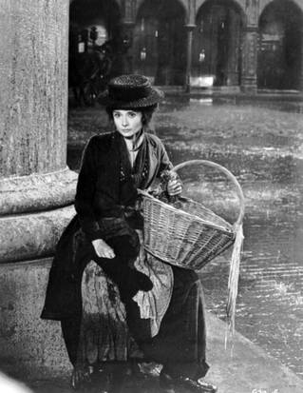
- In addition to speech, what further alterations would be necessary to convince people that a common street vendor was a duchess?
- Compare Eliza’s treatment by Clara and the taxi drivers at the beginning and then later in the play. Do you agree with her statement about the difference between a lady and a flower girl?

- Do people today make assumptions about strangers based on appearance and manner of speaking?

From the beginning of the play, Professor Higgins bullies Eliza quite aggressively. After he insults her on their first meeting, she appears at his house to ask for elocution lessons. When he agrees to teach her, he threatens physical abuse if she refuses to obey him. Whenever she is in the room, he talks about her to others as if she weren’t there.
- Why is Higgins abusive to Eliza?
- Why does Eliza stay with him?
- Is the threat of physical harm an act of abuse even if it is never acted upon?
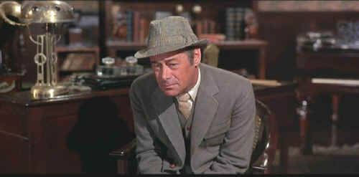
Pretend you are the actor playing Higgins.
- How would you interpret his attitude so that you might understand his character?
- Is it possible for characters to behave a certain way and not see the behaviour in themselves?
- Does this contradiction ever occur in real life?
- Did you find Higgins a likeable character in the play? Why or why not?
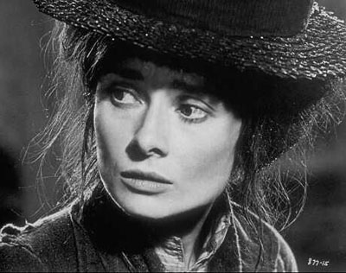
- Is Higgins an effective teacher? Why or why not?

Imagine that Liza brought a charge of abuse against Higgins at the end of the play.
- What evidence would she list in the charge?

- When Higgins transforms Eliza from “a flower girl to a duchess” what changes does she undergo? What stays the same?
- Why does she enter the grand ballroom feeling as if she’s “in a dream,” and leave saying: “I don’t think I can bear much more… Nothing can make me the same as these people.”? Why does she feel that now, she belongs nowhere?
- The relationship between Higgins and Eliza is complex. Although it appears throughout most of the play that Higgins is in control, the end reveals that Eliza has power as well. What is her power over Higgins?
- Bernard Shaw wrote an afterword to Pygmalion, in which Eliza marries Freddy but keeps close contact with Higgins and Pickering. In 1956, Pygmalion was recreated as a musical, My Fair Lady, starring Julie Andrews and Rex Harrison. The film version appeared in 1964, starring Audrey Hepburn and Rex Harrison. The end of this adaptation has Eliza returning to Higgins, with the hint that she will marry him and not Freddy. This version also ignores Shaw’s depiction of Higgins as physically awkward. Why do you think these changes were made? Do modern writers have the right to change the ending of the story?
