Shakespeare in Love

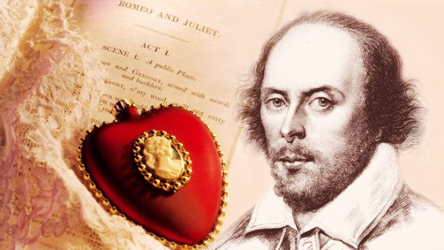
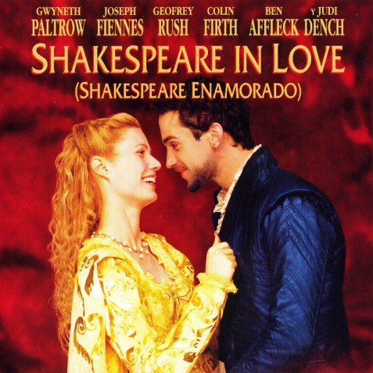

Pre-viewing activities
Vocabulary List
To be in love/to out of love – бути (не)закоханим
To be about to do smth – збиратися щось робити
To be good to smb – бути добрим до когось
To be killed in duel – бути вбитим на дуелі (у двобої)
To be a desperate want of smth/smb - бути вкрай необхідним для чогось (когось)
To be put in the clink = to be put into the prison - бути запротореним до в’язниці
To be put to death – бути приговореним до смерті
To be buggered to boot = to be penniless - very poor; almost totally without money-бути дуже бідним
To be humbled - confused, embarrassed, low-spirited – бути спантеличеним
To banish – виганяти, засилати
to borrow money from smb- позичити у когось гроші
to breed smth in smb – виховувати щось у комусь
to covet one’s property – зазіхати на чуже майно
to capture one’s heart – заполонити серце
to cut one’s strings –обірвати щось всередині (коли боляче на душі)
to do one’s duty – виконувати свій обов’язок
to embark on a great voyage - вирушати в довгу подорож
to favour smth/smb – надавати комусь (чомусь) перевагу
to get into a fight – встрягати в бійку
To howl – вити, викрикувати, завивати
To hang round the house – вештатись по будинку
To have smb rolling in the aisles – змусити когось надривати живіт від сміху
To have a natural ear – мати від природи хороший слух
To keep smb informed – тримати когось у курсі справ, проінформованим
To lean one’s cheek upon one’s head – схилятися головою на руку
to make smb immortal – зробити когось безсмертним, увіковічнити когось
to meet the love of one’s life – зустріти кохання всього життя
To talk prose- говорити прозою (не віршами)
To tour – гастролювати, подорожувати, здійснювати театральне турне
to lend smb money- позичати комусь гроші
to love/like smb for smth (looks, speaking, etc) – любити когось за щось
to own smb money- заборгувати комусь гроші
to have a gift – мати талант, дар
to lose one’s gift – втратити талант, дар
to restore one’s gift – відновити талант, дар
to cause a riot in a nunnery – здійняти галас
to shed blood – проливати кров
to show one’s pleasure – виражати своє задоволення
to speak well of smb - гарно про когось озиватись
to stand tiptoe – стояти на кінчиках пальців
to stab - заколоти

apothecary – аптекар, фармацепт
audition - прослуховування
Banishment – вигнання, заслання
Bangle – браслет
Bombast – пихатість, бундючність
Blessing – благословення, спасіння
Beaker of brandy – келих бренді
Backsides – задня сторона, позаду
Confession - сповідь
Calf love - temporary infatuation or love of an adolescent for a member of the opposite sex, аlso called: puppy love
Dagger - кинжал
Drunkard – п’яниця, випивайло
Dregs – покидьки
Friar – чорнець
Foe - ворог
Groundlings – невибагливі глядачі
Lewdness- хтивість, непристойність
Interest - відсоток (гроші)
Muse- муза
Lad – хлопець
Rehearsal- репетиція (в театрі)
Handmaiden- служниця
Plague- чума
Pipsqueak - a person or thing that is insignificant or contemptible – простолюдин, абихто
Petticoat – спідниця, під’юпник
Pickpocket – кишеньковий злодій
Prattle – лепет, базікання
Seamstress – швачка
Sedition – метіж, бунт
Shipwreck- корабельна аварія
Skirmish of words and swords – Словесна та збройна перестрілка/перепалка
Stews - тушковане м’ясо
Sovereign - a former British gold coin worth one pound sterling
Vanity - марнославство
Wager – ставка, заклад
Wickedness- злість, гріховність, порок, нечестивість
crowd-tickler – що визиває живий інтерес у глядача
submissive – покірний
While-viewing activities
Task 1. Read the phrases you will come across when viewing the film and identify their meanings.
A thousands apologies! –
A broad river divides us –
A black day for us all! -
As occasion arises -
Anon! = in a moment –
Alas! –
A goodly length in the times past-
At the most-
At my risk-
At your service -
At this very moment –
By order of… -
By all the stars in heaven –
Break a leg/shake a leg = hurry up!-
Come hellfire and brimstone = come ruin or rapture–
Dream on, boy! –
Do me a speech! Do me a line! -
For the length of the Bible! -
God save you and good night!-
Get me to drink mandragora –
God be praised! –
How goes it? -
I’m a fortunate’s fool -
In truth /to be honest/to be blunt –
In secret -
It’s all locked safe in here
It won’t cost you a penny –
It’s all long-faced –
It’s hateful to me!-
It will do/it won’t do –
It’ll turn out well -
It does no harm –
If you wouldn’t mind -
Luck be with you! -
My sleeve wants for a button-
My heavens! -
Now and again –
Not for the world -
Oh, for pity’s sake!-
Old boot -
Piety is for Sunday! –
Palm to palm -
Sit / be still! –
Suffering cats! -
To the penny-
Tell me in your own words –
There are rubies in the saddlebag -
We are lost! –
What of it? –
Who asks for him? –
What business here? -
What is my part?
You have no soul –
You flatter –
You will go far –
You are on my ground now -
Focus on Translation
Task 2. Translate the sentences into Ukrainian and comment on the ones that are given in bold.
1. Oh, cut out my heart, throw my liver to the dogs!
2. Will Shakespeare has a play. Let’s go and cough through it.
3. Playhouses are not for wellborn ladies. Well-monied is the same as wellborn and well-married is more so.
4. All the men of court are without poetry.
5. The natural condition is one of insurmountable obstacles on the road to imminent disaster.
6. Strangly enough, it all turns out well, it’s a mystery.
7. It’s customary to make a little speech on the first day.
8. You will see how genius creates a legend.
9. Am I to suffer this constant stream of interruption?
10. Be submissive, modest, grateful and brief!
11. A plague on both your houses!
12. Oh, she has cut my strings!
13. Love knows nothing of rank or bank. It will spark between a queen and the poor vagabond who plays the king and their love should be mended by each for love denied blights the soul we own to God.
14. For one kiss I will defy a thousand Wessexes.
15. The morning rooster woke me. It’s a broad day. The rooster tells us so. The house is stirring. It’s a new day.
16. Shall I hear more or shall I speak at this?
17. I found something in my sleep.
18. The tide waits for no man.
19. Playwrights teach us nothing about love. They make it pretty, they make it comical or they make it lust. They cannot make it true.
20. It takes a woman to know it.

Focus on Grammar
Task 3. Read and translate the sentences given below. Comment on the usage of ‘Like’/ ‘As’/ ‘As if’/etc in English. The grammar notions to analyze have been underlined for you.

- I could make love out of words as a potter makes cups out of clay, love that overthrows empires, love that binds two hearts together, come hellfire and brimstone
- It’s as if my quill is broken, as if the organ of my imagination has dried up, as if the proud tower of my genius has collapsed. Nothing comes. It’s like trying to pick a lock with a wet herring.
- Words will flow like a river.
- He spoke like a schoolboy at lessons.
- I will have love or will end my days as a nurse.
- He looks well enough for a charlatan.
- She is obedient as any mule in Christendom.
- There’s no one like Marlowe.
- He dies with such passion and poetry as you ever heard.
10) I love her like a sickness and its cure together, like rain and sun, like cold and heat..And her voice, like lark’s song, deeper and softer, none of the twittering larks.
11) If he be married, my grave is like to be my wedding bed.
12) I cannot move in this dress. It makes me look like a pig. I have no neck in this dress.
13) I will have love in my life, love above all, but love that overthrows life, unbiddable, ungovernable, like a riot in the heart and nothing to be done, come ruin or rapture.
14) I’m unmanned, unmended, unmade like a puppet in a box.
15) A broad river divides my lovers: family, duty, fate, as unchangeable as nature.

Focus on Pronunciation

Task 4. Read the passage taken from The Two Gentlemen of Verona that you will hear in the film. Find it in the film and listen to it once again. Prepare good reading of the passage.

The Two Gentlemen of Verona is a comedy by William Shakespeare, believed to have been written in 1590 or 1591. It is considered by some to be Shakespeare's first play, and is often seen as showing his first tentative steps in laying out some of the themes and tropes with which he would later deal in more detail; for example, it is the first of his plays in which a heroine dresses as a boy. The play deals with the themes of friendship and infidelity, the conflict between friendship and love, and the foolish behaviour of people in love. The highlight of the play is considered by some to be Launce, the clownish servant of Proteus, and his dog Crab, to whom "the most scene-stealing non-speaking role in the canon" has been attributed.

SCENE I. Milan. The DUKE's palace.
VALENTINE
What light is light, if Silvia be not seen?
What joy is joy, if Silvia be not by?
Unless it be to think that she is by
And feed upon the shadow of perfection
Except I be by Silvia in the night,
There is no music in the nightingale;
Unless I look on Silvia in the day,
There is no day for me to look upon;
She is my essence, and I leave to be,
If I be not by her fair influence
Foster'd, illumined, cherish'd, kept alive.
I fly not death, to fly his deadly doom:
Tarry I here, I but attend on death:
But, fly I hence, I fly away from life.

