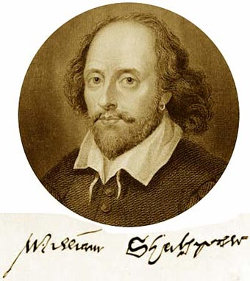
William Shakespeare was baptized on April 26, 1564, in Stratford-upon-Avon, England. From roughly 1594 onward he was an important member of the Lord Chamberlain’s Men company of theatrical players. Written records give little indication of the way in which Shakespeare’s professional life molded his artistry. All that can be deduced is that over the course of 20 years, Shakespeare wrote plays that capture the complete range of human emotion and conflict.
"All the world's a stage, and all the men and women merely players."
– William Shakespeare

Video: Shakespearian Language: http://www.youtube.com/watch?v=BMkuUADWW2A

Mysterious Origins

Known throughout the world, the works of William Shakespeare have been performed in countless hamlets, villages, cities and metropolises for more than 400 years. And yet, the personal history of William Shakespeare is somewhat a mystery. There are two primary sources that provide historians with a basic outline of his life. One source is his work—the plays, poems and sonnets—and the other is official documentation such as church and court records. However, these only provide brief sketches of specific events in his life and provide little on the person who experienced those events.

Early Life

Though no birth records exist, church records indicate that a William Shakespeare was baptized at Holy Trinity Church in Stratford-upon-Avon on April 26, 1564. From this, it is believed he was born on or near April 23, 1564, and this is the date scholars acknowledge as William Shakespeare's birthday.

Located 103 miles west of London, during Shakespeare's time Stratford-upon-Avon was a market town bisected with a country road and the River Avon. William was the third child of John Shakespeare, a leather merchant, and Mary Arden, a local landed heiress. William had two older sisters, Joan and Judith, and three younger brothers, Gilbert, Richard and Edmund. Before William's birth, his father became a successful merchant and held official positions as alderman and bailiff, an office resembling a mayor. However, records indicate John's fortunes declined sometime in the late 1570s.

Scant records exist of William's childhood, and virtually none regarding his education. Scholars have surmised that he most likely attended the King's New School, in Stratford, which taught reading, writing and the classics. Being a public official's child, William would have undoubtedly qualified for free tuition. But this uncertainty regarding his education has led some to raise questions about the authorship of his work and even about whether or not William Shakespeare ever existed.

Married Life
William Shakespeare married Anne Hathaway on November 28, 1582, in Worcester, in Canterbury Province. Hathaway was from Shottery, a small village a mile west of Stratford. William was 18 and Anne was 26, and, as it turns out, pregnant. Their first child, a daughter they named Susanna, was born on May 26, 1583. Two years later, on February 2, 1585, twins Hamnet and Judith were born. Hamnet later died of unknown causes at age 11.
After the birth of the twins, there are seven years of William Shakespeare's life where no records exist.
Scholars call this period the "lost years," and there is wide speculation on what he was doing during this period. One theory is that he might have gone into hiding for poaching game from the local landlord, Sir Thomas Lucy. Another possibility is that he might have been working as an assistant schoolmaster in Lancashire. It is generally believed he arrived in London in the mid- to late 1580s and may have found work as a horse attendant at some of London's finer theaters, a scenario updated centuries later by the countless aspiring actors and playwrights in Hollywood and Broadway.

Theatrical Beginnings
By 1592, there is evidence William Shakespeare earned a living as an actor and a playwright in London and possibly had several plays produced. The September 20, 1592 edition of the Stationers' Register (a guild publication) includes an article by London playwright Robert Greene that takes a few jabs at William Shakespeare: "...There is an upstart Crow, beautified with our feathers, that with his Tiger's heart wrapped in a Player's hide, supposes he is as well able to bombast out a blank verse as the best of you: and being an absolute Johannes factotum, is in his own conceit the only Shake-scene in a country," Greene wrote of Shakespeare.
Scholars differ on the interpretation of this criticism, but most agree that it was Greene's way of saying Shakespeare was reaching above his rank, trying to match better known and educated playwrights likeChristopher Marlowe, Thomas Nashe or Greene himself.
By the early 1590s, documents show William Shakespeare was a managing partner in the Lord Chamberlain's Men, an acting company in London. After the crowning of King James I, in 1603, the company changed its name to the King's Men. From all accounts, the King's Men company was very popular, and records show that Shakespeare had works published and sold as popular literature. The theater culture in 16th century England was not highly admired by people of high rank. However, many of the nobility were good patrons of the performing arts and friends of the actors. Early in his career, Shakespeare was able to attract the attention of Henry Wriothesley, the Earl of Southampton, to whom he dedicated his first- and second-published poems: "Venus and Adonis" (1593) and "The Rape of Lucrece" (1594).

Establishing Himself

By 1597, William Shakespeare had published 15 of the 37 plays attributed to him. Civil records show that at this time he purchased the second largest house in Stratford, called New House, for his family. It was a four-day ride by horse from Stratford to London, so it is believed that Shakespeare spent most of his time in the city writing and acting and came home once a year during the 40-day Lenten period, when the theaters were closed.

By 1599, William Shakespeare and his business partners built their own theater on the south bank of the Thames River, which they called the Globe. In 1605, Shakespeare purchased leases of real estate near Stratford for 440 pounds, which doubled in value and earned him 60 pounds a year.

This made him an entrepreneur as well as an artist, and scholars believe these investments gave him the time to write his plays uninterrupted.

Writing Style

William Shakespeare's early plays were written in the conventional style of the day, with elaborate metaphors and rhetorical phrases that didn't always align naturally with the story's plot or characters. However, Shakespeare was very innovative, adapting the traditional style to his own purposes and creating a freer flow of words. With only small degrees of variation, Shakespeare primarily used a metrical pattern consisting of lines of unrhymed iambic pentameter, or blank verse, to compose his plays. At the same time, there are passages in all the plays that deviate from this and use forms of poetry or simple prose.

Early Works: Histories and Comedies
With the exception of Romeo and Juliet, William Shakespeare's first plays were mostly histories written in the early 1590s. Richard II,Henry VI (parts 1, 2 and 3) and Henry V dramatize the destructive results of weak or corrupt rulers, and have been interpreted by drama historians as Shakespeare's way of justifying the origins of the Tudor Dynasty.
Shakespeare also wrote several comedies during his early period: the witty romance A Midsummer Night's Dream, the romantic Merchant of Venice, the wit and wordplay of Much Ado About Nothing, the charming As You Like It and Twelfth Night. Other plays, possibly written before 1600, include Titus Andronicus, The Comedy of Errors, The Taming of the Shrew and The Two Gentlemen of Verona.

Later Works: Tragedies and Tragicomedies
It was in William Shakespeare's later period, after 1600, that he wrote the tragedies Hamlet, King Lear, Othello and Macbeth. In these, Shakespeare's characters present vivid impressions of human temperament that are timeless and universal. Possibly the best known of these plays is Hamlet, which explores betrayal, retribution, incest and moral failure. These moral failures often drive the twists and turns of Shakespeare's plots, destroying the hero and those he loves.
In William Shakespeare's final period, he wrote several tragicomedies. Among these are Cymbeline, The Winter's Tale andThe Tempest. Though graver in tone than the comedies, they are not the dark tragedies of King Lear or Macbeth because they end with reconciliation and forgiveness.

Death

Tradition has it that William Shakespeare died on his birthday, April 23, 1616, though many scholars believe this is a myth. Church records show he was interred at Trinity Church on April 5, 1616.

In his will, he left the bulk of his possessions to his eldest daughter, Susanna. Though entitled to a third of his estate, little seems to have gone to his wife, Anne, whom he bequeathed his "second-best bed." This has drawn speculation that she had fallen out of favor, or that the couple was not close. However, there is very little evidence the two had a difficult marriage.

Other scholars note that the term "second-best bed" often refers to the bed belonging to the household's master and mistres—the marital bed—and the "first-best bed" was reserved for guests.

Video: http://www.youtube.com/watch?v=M11yhSXdKSw

British Theatre History
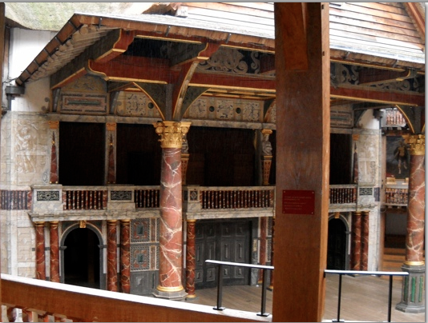
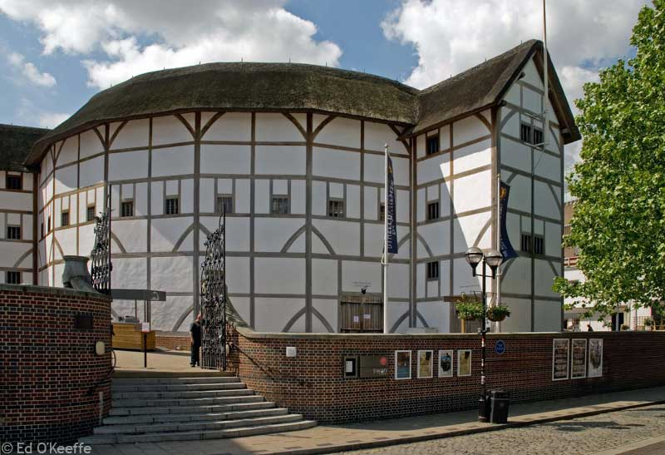

The sixteenth century was the great watershed of British theatre. At the beginning of the century we had Drama: by the end we had Theatre. At the beginning religious drama, although declining, was still dominant: by the end, at least ten of Shakespeare's plays had been produced, including A Midsummer Night's Dream, Romeo and Juliet, The Merchant of Venice, Richard III and parts 1 and 2 of Henry IV.
One of the most significant new developments was the rise of the professional actor. In the liturgical dramas of the preceeding centuries - for instance Katherine de Sutton's Easter ceremony at Barking - monks, nuns and priests were the performers. The development of the Mystery plays then led to the involvement of the laity, but in every case the performers were what we would now describe as amateurs. Only by going back to the bards and minstrels do we find professional performers.
What paved the way for the development of professional theatre was the love of the Tudor monarchs for display. Royal progresses, "disguisings", tournaments and other such spectacles - usually with the king at the centre - had to be organised and presented in a thoroughly professional manner to avoid attracting the king's wrath, and there is no doubt that the very first generation of professional performers sprang from those who organised, took part in or simply watched these spectacular events.
We do know that Henry VIII - not a man to let down! - had his own troupe of actors - four men and a boy - who were skilled in quick costume changes and playing a number of parts.
Political and religious troubles (Henry VIII again!) led to the death of the Mystery plays. In 1548 the Feast of Corpus Christi was suppressed, a warning sign of the waning of religious drama. Performances continued in the north and midlands (remote from the centre of power in London) until around 1580, but by then the secular drama had grown in importance.
As early as the first half of the century, secular plays were being performed for a limited audience. Strongly influenced by the Roman comedy of Plautus and Terence, the earliest successsful English comedy Ralph Roister Doister was written some time between 1534 and 1552 by Nicholas Udall and performed by the schoolboys of Eton (or, possibly, Westminster). Gammer Gurton's Needle, also probably performed by schoolboys, followed some time between 1552 and 1563.
Tragedy was a later development, the first we know of being Gorboduc, written by Thomas Norton and Thomas Sackville for performance before the Queen at the Inner Temple in 1562. It, too, was based on the Roman rather than the Greek model, Norton and Sackville very consciously following the pattern of the work of Seneca.
The Theatres
It was, however, the development of the actual theatre building which was to change the whole course of British theatre. By the last quarter of the century, theatre companies had begun to be formed, usually under the patronage of aristocrats. These were made up of professional actors and played in two totally distinct kinds of venue: the homes of their patrons, where they played to the aristocracy, and inn yards, where they played to the populace. They were paid in two distinct ways, by their patron for their work for him and by collections among the inn yards audiences, the latter not being a very sure way of covering costs, let alone making a profit!
In 1574 the law changed to allow performances on weekdays and this led directly to the building of the very first theatre. The first was simply called The Theatre and was built by master carpenter James Burbage, who had professional acting experience himself as a member of the Earl of Leicester's Men. It was built outside the City of London in Shoreditch because, although the aristocracy and the common people were ardent supporters, the Burgesses of the City of London were less enthusiastic and Burbage wanted to be free of their possible interference.
It seems likely that Burbage was motivated more by financial than artistic considerations, for his theatre had a dual purpose: the stage was not a permanent feature, but could be removed to mount another popular entertainment of the time, cock-fights. And, of course, charging one penny admittance was a far surer method of covering costs and making a profit than passing the hat round in an inn yard!
Other theatres followed remarkably quickly: The Curtain (1577) was followed in less than ten years by the Rose and, in less than twenty, by the Swan.
The Plays
So the playhouses were built, but there were no plays! Or, at least, the repertoire was very small indeed. And then, suddenly, there was an explosion of new writing, as if the building of the Curtain opened the floodgates of creativity. The greatest of these pre-Shakespearean writers was undoubtedly Christopher Marlowe whose hugely influential Tamburlane was written around 1587, three years before Shakespeare's Love's Labour's Lost which modern critics believe to be the first of his plays.
Private Theatres
Although the building of theatres like the Theatre and the Rose was a turning point in the history of theatre in the British Isles, it is not to be supposed that other strands of theatre simply stopped. On the contrary, 1576 also saw another significant development - the indoor theatre. The great Elizabethan playhouses were, of course, open to the elements. There was a roof over the stage and those who sat in the seats had roofs over their heads, but the groundlings, those who stood in the open well in front of the stage, had no such protection.
The indoor theatres, however, were private theatres, in some ways similar to the performances given in aristocratic mansions, but built for the purpose. In 1576 Richard Ferrant, Master of the Children of the Chapel Royal, converted rooms in what had been the Blackfriars monastery into an indoor playhouse, where his pupils performed. Not to be outdone, Sebastian Westcott, Master of the Boys of St Pauls, set up a rival company, and these "boys' companies" achieved a great deal of success, particularly among the aristocracy. Chief among the playwrights who wrote for these companies was John Lyly, whose first plays were performed at Blackfriars in 1584.
These companies had a short life, however, for by 1608 tastes had changed to such an extent that the companies more or less disappeared. It has to be said that their disappearance was hastened by some political mistakes made by those who controlled them, including Lyly.
So by the end of the sixteenth century we have a mature and exciting theatre world which was in essence very similar to what we have today, with purpose-built theatres, professional actors and a stock of writing talent which was unsurpassed until the twentieth century. What a change from the world of liturgical drama, Mystery and Morality plays, and mummers, which was the picture less than a hundred years previously!

Additional Material to Study
(not a must)
Pronunciation in the 16th century: http://www.youtube.com/watch?v=gPlpphT7n9s
The history of English: http://www.youtube.com/watch?feature=endscreen&v=rexKqvgPVuA&NR=1

The Adventure of English. The Biography of a Language-Part 4: This Earth, this Realm, this England: http://www.ex.ua/view/356506 + (on mydaria@ukr.net)

