GENERAL CONVERSATION/INDIVIDUAL LONG TURN/DISCUSSION

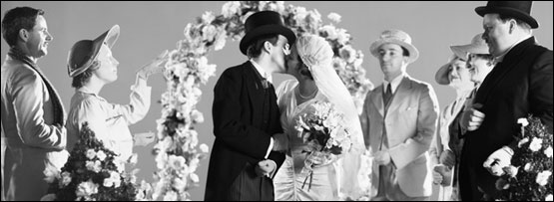

1. Dwell on one of the suggested quotations: 'Success usually comes to those who are too busy to be looking for it', 'You always pass failure on the way to success'.

2. What do believe to be the secret of success? What are the keys to success? How important is talent in achieving success?

3. What factors are important for career success? (background/personal skills, etc) Who do find successful in their career?

4. Do you like celebrating? What special occasions do you usually celebrate? What was the best/worst celebration that you have ever attended?

5. Dwell on an unusual celebration you are familiar with. Why do people/you like it?

6. What is the difference between the following notions: celebration, festival, carnival? Which do you like the most?

7. How do you understand such notions as anniversary, house-warming, engagement, wedding, promotion, retirement, graduation, birth? Which of them have you attended? Were you the person celebrating or were you invited as a guest to the occasion?

8. Are the people from your generation generally happier or unhappier than your parents' generation? What might be the reason for such a difference?

9. What is the secret of happiness? Can money buy happiness? What makes you happy? What is your list of keys to be happy?

10. What do people escape from? Do you feel the need to escape from anything? How do you do it?

11. Dwell on one of the suggested quotations: 'Some people for the sake of getting a living, forget to live', 'A perpetual holiday is a good working definition of hell'?

12. What do you know about 'The Lord of the Rings'? Do you agree with the statement that it's the book of the century? Why? Have you read the book or seen any of the films? What do you think of them?

13. Why do people choose to travel to a remote and lonely place? Would you like to go a lonely place? What would your destination point be?

14. Is Tasmania lonely enough for you? What do you know about it? Describe it from an unusual perspective.

15. What is the value of sleep? How is it connected with the escape from daily problems?

16. How can we wash our worries away? Is it easy to escape from hustle and bustle of everyday life? How do you relax?

17. Can travelling be a perfect way of escape from anything? How do you find travelling? How do you usually travel? What tour would you suggest?

18. Why do we watch escapist movies? What films/ genres do you like? Why? What is your favourite film?

19. Are we ashamed of what we watch? Why should we not be ashamed of what we watch?

20. Is it difficult to be an actor?/Who do you consider to be a successful actor?

SITUATIONAL ROLEPLAY/EXCHANGING INFORMATION




1. Make up a dialogue giving news/responding to good/bad news on the situation related to the topics from Module 1 (units 1-2)

2. Make up a dialogue expressing positive/negative feelings & preferences on the situation related to the topics from Module 1 (units 1-2)

3. Make up a dialogue persuading somebody to do something, making & responding positively/negatively to suggestions, interrupting on the situation related to the topics from Module 1 (units 1-2)

4. Make up a dialogue expressing your thoughts and inviting a response using everyday English on the situation related to the topics from Module 1 (units 1-2)

5. Make up a dialogue asking for/offering clarification/justification, expressing confusion on the situation related to the topics from Module 1 (units 1-2)

