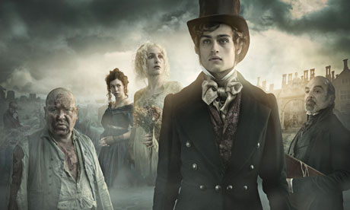

PART I: BEFORE LISTENING AND READING

Task 1. In groups, discuss the following questions and give reasons for your answers:
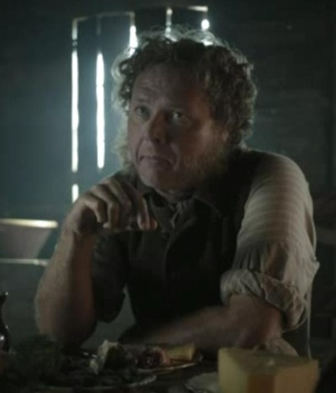
1. Having read the title what do you believe the story would be about?
2. Whom you believe to be the main character of the story?
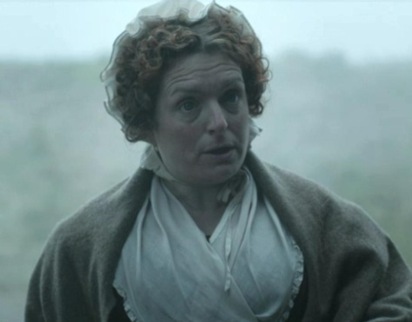
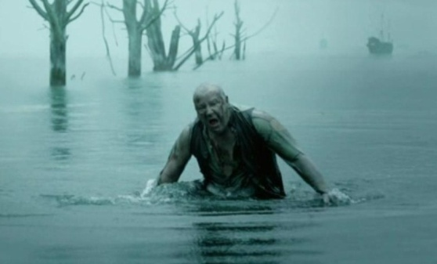

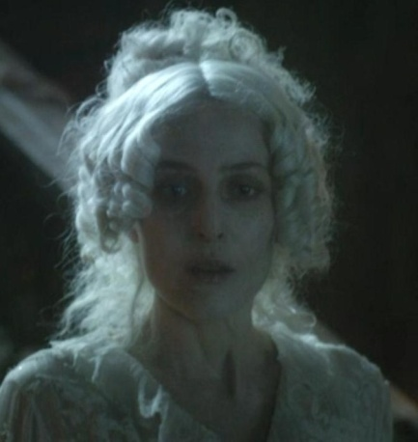
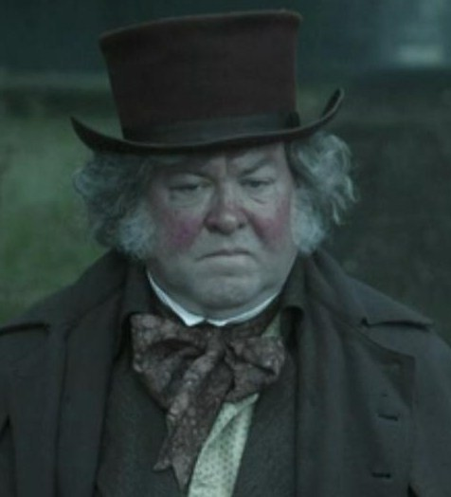
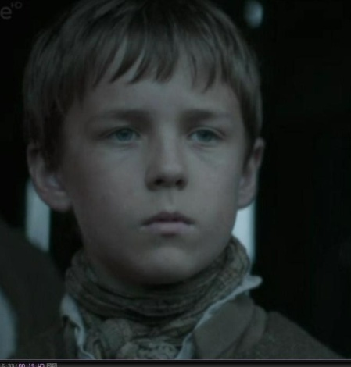
a) b) c)

d) e) f)
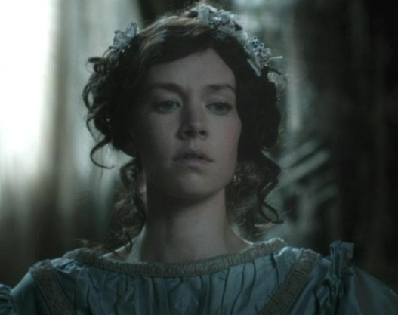
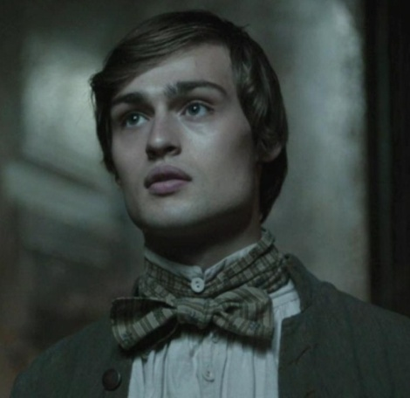
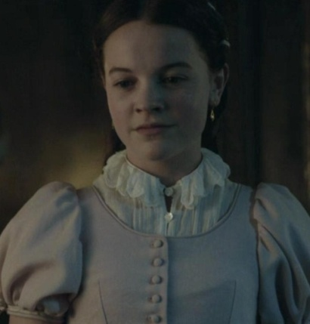

g) h) i)

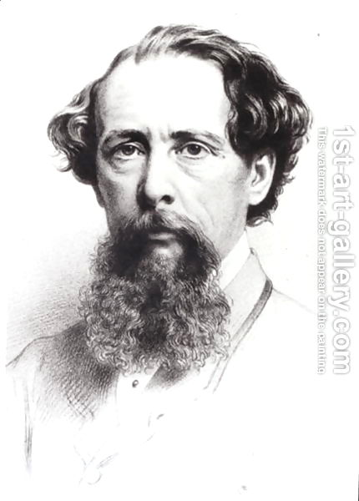
3. What do you know about the author of the story?
What works of his have you read/heard about?

4. The main hero of the story is an orphan. Who is an orphan? Is it
difficult to be one?

PART II. VOCABULARY
Task 1. Before listening to the recording find out the meaning of the following words and
expressions.

timidly(adv) | боязко, полохливо, сором’язливо
hurriedly(adv) | поспішно, квапливо, похапцем, швидко
gravestone(n) | могильний камінь; надгробок
to seat smb | всадити когось
to go head over heels | Іти шкеребертом, з ніг на голову
to empty smb’s pockets | спустошити/вивернути/обчистити чиїсь кишені
to turn smb upside-down | перевернути когось ногами догори
to point to smth | показувати пальцем, вказувати
to stare at smb | пильно дивитися; витріщати очі
to give smb a shake | кивнути кумусь
to beg | 1) просити, благати (когось - of; про щось - for) I beg your pardon — вибачте 2) жебрати, старцювати
in terror(adv) | з жахом, перелякано
to glare | пильно (люто) дивитися
to chatter | цокотіти, клацати (зубами)
to be covered in mud | бути вимащеним в багнюзі
to shake and shiver | тремтіти та дрижати(від холоду)
to be wet to the skin | промокнути до нитки
rag (n) | 1) ганчірка; клапоть 2) лахміття, дрантя
coarse (adj) | грубий
fearful(adj) | жахливий, страшний
to seize | хапати, схопити
to start up | з'являтися
shiver(n) | осколок, уламок
a bundle of smth(n) | 1) клунок; в'язка; пака, пакунок; тюк 2) жмут, пучок 3) пакет
to wind | 1) вертітися, крутитися; витися
marsh (n) | болото
wilderness (n) | 1) пустеля; дика місцевість 2) занедбана частина саду
to stretch | 1) розтягувати(ся); витягувати(ся); подовжувати; тягти(ся)2) натягувати(ся) 3) мати довжину, простягатися
to rush in | 1) кидатися; мчати; рушати; пориватися 2)хлинути, ринути
raw (adj) | вогкий, холодний (про погоду)
grave(n) | 1) могила 2) смерть 3) надгробний камінь
churchyard(n) | 1) цвинтар, кладовище 2) церковне подвір'я
thrill (n) | 1) збудження, глибоке хвилювання, трепет 2) нервове тремтіння
at the time | тоді, в ті часи
to wander | 1) блукати; мандрувати 2) заблукати
tofrighten, frightening(adj) | лякати, налякати, лякаючий

PART III. LISTENING
Task 1. You are going to listen to the first part of the 1st chapter of the story. Fill in the
gaps with the missing words that are given in the table.
frightening thing at the time stretched wet to the skin Point to seated on
thrill of horror glared at in terror coarse wandered
raw marsh out of my skin fearful rag staring at go head over heels
grave bundle started up seized upside-down beast to run away
grown shook and shivered glared timidly rushing

Track 01_01
Chapter One
The Man in the Churchyard
It was, I think, the most _________________________that ever to happened to me. . .
I am a ____________ man now, but I was a small boy _____________________, and I can feel, even yet, the _______________________________________that ran through me on that Christmas Eve, all those years ago.
I had, for some reason, __________________ into the churchyard and found my parent’s ____________. It was a_________afternoon towards evening, I remember; the wind was ____________ in from the sea and beyond the churchyard wall there _______________ the dark flat wilderness of the __________ country, with the river winding across it. I was already a _______________ of shivers, feeling lost and afraid, when a figure ___________from among the gravestones and scared me half-way _________________.
“Hold your noise!” cried a terrible voice. “And keep still, you little devil, or I’ll cut your throat!”
He _________me by the chin; a ____________ man, all in ____________ grey, with a great iron on his leg. A man with no hat, and with broken shoes, and with an old _________tied round his head. A man who was ______________________and covered in mud; who __________________________, and whose teeth chattered in his head as he __________________ into my eyes.
“Oh, don’t cut my throat, sir,” I begged, ______________. “Pray don’t do it, sir.”
“Tell us your name!” said the man, giving me a little shake. “Quick!”
“Pip, sir.”
“What?” said the man_____________________me.
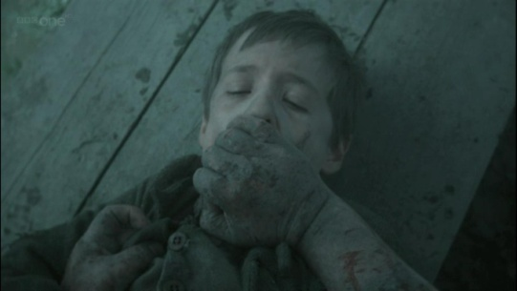
“It’s really Philip, but everyone calls me Pip.”
“Show us where you live,” he ordered. “____________________the place.”
I pointed to where our village lay, among the trees, a mile or more from the church.
The man looked at me for a moment, then turned me ___________________and emptied my pockets. There was nothing in them but a piece of bread. When the church came to itself again—for he was so sudden and strong that he made it __________________________before me—I was ____________________a tall gravestone, trembling, while he ate the bread like a hungry _______________.
“You young dog!” he said suddenly, with a threatening shake of his head. “What fat cheeks you’ve got! I’ve half a mind to eat you!”
I hurriedly expressed my hope that he wouldn’t, and held tighter to the stone to keep myself from crying.
“Now look here,” said the man, “where’s your mother?”
“There, sir,” said I.
He jumped, started _________________, then stopped and _________________me over his shoulder. I pointed.
“There, sir,” I explained, ______________. “She’s dead—and my father, too.”
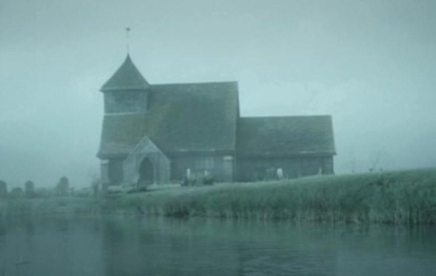

PART IV. AFTER LISTENING AND READING
Task 1. Answer the following questions
1. Who is Pip? Is it his real name? What is he like?
2. When we see Pip for the first time?
3. Why was he scared to death?
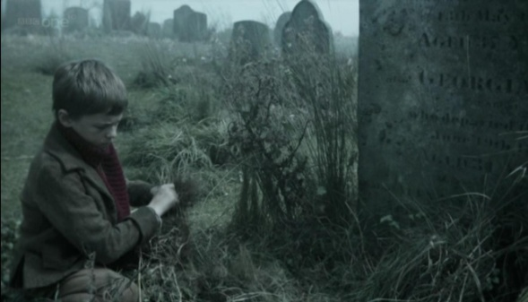
4. What was the weather like that day?
5. What was the stranger like? Describe him. Who was he?
6. What the stranger wanted Pip to do?
7. Was the stranger polite to Pip?
8. What did the stranger ask Pip?

PART V. GRAMMAR AND PHONETICS
Task 1. Translate the sentences and pay attention to the English grammar constructions:
1. The most frightening thing that ever to happened to me..
_____________________________________________________________________
2. The thrill of horror that ran through me on that Christmas Eve
_______________________________________________________________________________________________________________________________________________
3. I was already a bundle of shivers, feeling lost and afraid, when a figure started up from among the gravestones and scared me half-way out of my skin.
_________________________________________________________________________________________________________________________________________________________________________________________________________________________
4. A man who was wet to the skin and covered in mud; who shook and shivered, and whose teeth chattered in his head
________________________________________________________________________________________________________________________________________________
5. “Pray don’t do it, sir.”__________________________________________________
6. The man looked at me for a moment, then turned me upside-down and emptied my pockets. There was nothing in them but a piece of bread.
_________________________________________________________________________________________________________________________________________________________________________________________________________________________
7. When the church came to itself again—for he was so sudden and strong that he made it go head over heels before me—I was seated on a tall gravestone, trembling, while he ate the bread like a hungry beast.
___________________________________________________________________________________________________________________________________________________________________________________________________________________________________________________________________________________________________

Task 2. Write three forms of the following verbs and finish the list of verbs with some
found in the text.
to seat
to go
to empty
to turn
to point
to stare
to give
to beg
to shiver
to glare
to chatter
to be
to shake
to seize
to start up
to wander
to frighten
to wind
to rush
to come

Task 3. Have a look at the way the verbs are pronounced. Formulate the rule that demonstrates the way the ending of the 2nd or 3d form of the verb should be pronounced.

to turn – turned /tɜ:ʳnd/ to rush – rushed /rʌʃt/ to point –pointed /pɔɪntɪd/

_________________________________________________________________________________________________________________________________________________________________________________________________________________________
_________________________________________________________________________________________________________________________________________________________________________________________________________________________
Task 4. Complete the table with the help of verbs taken from the text to illustrate the rule given above.
/ d/ | / t/ | /ɪd/

PART VI. SELF-STUDY WORK

1. Listen to the track at home and record yourself.
2. Find some additional information about Charles Dickens.

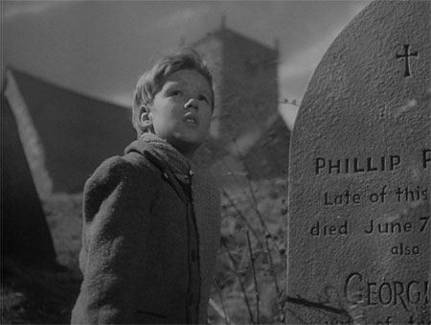

Chapter One
The Man in the Churchyard
It was, I think, the most frightening thing that ever to happened to me. . .
I am a grown man now, but I was a small boy at the time, and I can feel, even yet, the thrill of horror that ran through me on that Christmas Eve, all those years ago.
I had, for some reason, wandered into the churchyard and found the my parent’s grave. It was a raw afternoon towards evening, I remember; the wind was rushing in from the sea and beyond the churchyard wall there stretched the dark flat wilderness of the marsh country, with the river winding across it. I was already a bundle of shivers, feeling lost and afraid, when a figure started up from among the gravestones and scared me half-way out of my skin.
“Hold your noise!” cried a terrible voice. “And keep still, you little devil, or I’ll cut your throat!”
He seized me by the chin; a fearful man, all in coarse grey, with a great iron on his leg. A man with no hat, and with broken shoes, and with an old rag tied round his head. A man who was wet to the skin and covered in mud; who shook and shivered, and whose teeth chattered in his head as he glared into my eyes.
“Oh, don’t cut my throat, sir,” I begged, in terror. “Pray don’t do it, sir.”
“Tell us your name!” said the man, giving me a little shake. “Quick!”
“Pip, sir.”
“What?” said the man, staring at me.
“It’s really Philip, but everyone calls me Pip.”
“Show us where you live,” he ordered. “Point to the place.”
I pointed to where our village lay, among the trees, a mile or more from the church.
The man looked at me for a moment, then turned me upside-down and emptied my pockets. There was nothing in them but a piece of bread. When the church came to itself again—for he was so sudden and strong that he made it go head over heels before me—I was seated on a tall gravestone, trembling, while he ate the bread like a hungry beast.
“You young dog!” he said suddenly, with a threatening shake of his head. “What fat cheeks you’ve got! I’ve half a mind to eat you!”
I hurriedly expressed my hope that he wouldn’t, and held tighter to the stone to keep myself from crying.
“Now look here,” said the man, “where’s your mother?”
“There, sir,” said I.
He jumped, started to run away, then stopped and glared at me over his shoulder. I pointed.
“There, sir,” I explained, timidly. “She’s dead—and my father, too.”
The Man in the Churchyard
It was, I think, the most frightening thing that ever to happened to me. . .
I am a grown man now, but I was a small boy at the time, and I can feel, even yet, the thrill of horror that ran through me on that Christmas Eve, all those years ago.
I had, for some reason, wandered into the churchyard and found the my parent’s grave. It was a raw afternoon towards evening, I remember; the wind was rushing in from the sea and beyond the churchyard wall there stretched the dark flat wilderness of the marsh country, with the river winding across it. I was already a bundle of shivers, feeling lost and afraid, when a figure started up from among the gravestones and scared me half-way out of my skin.
“Hold your noise!” cried a terrible voice. “And keep still, you little devil, or I’ll cut your throat!”
He seized me by the chin; a fearful man, all in coarse grey, with a great iron on his leg. A man with no hat, and with broken shoes, and with an old rag tied round his head. A man who was wet to the skin and covered in mud; who shook and shivered, and whose teeth chattered in his head as he glared into my eyes.
“Oh, don’t cut my throat, sir,” I begged, in terror. “Pray don’t do it, sir.”
“Tell us your name!” said the man, giving me a little shake. “Quick!”
“Pip, sir.”
“What?” said the man, staring at me.
“It’s really Philip, but everyone calls me Pip.”
“Show us where you live,” he ordered. “Point to the place.”
I pointed to where our village lay, among the trees, a mile or more from the church.
The man looked at me for a moment, then turned me upside-down and emptied my pockets. There was nothing in them but a piece of bread. When the church came to itself again—for he was so sudden and strong that he made it go head over heels before me—I was seated on a tall gravestone, trembling, while he ate the bread like a hungry beast.
“You young dog!” he said suddenly, with a threatening shake of his head. “What fat cheeks you’ve got! I’ve half a mind to eat you!”
I hurriedly expressed my hope that he wouldn’t, and held tighter to the stone to keep myself from crying.
“Now look here,” said the man, “where’s your mother?”
“There, sir,” said I.
He jumped, started to run away, then stopped and glared at me over his shoulder. I pointed.
“There, sir,” I explained, timidly. “She’s dead—and my father, too.”

