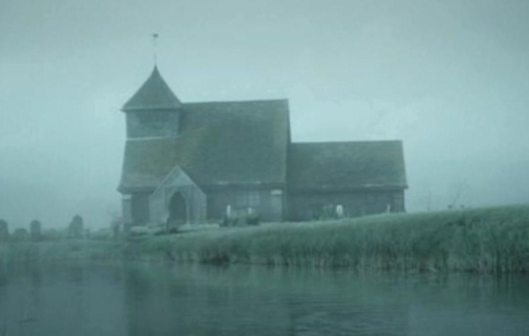
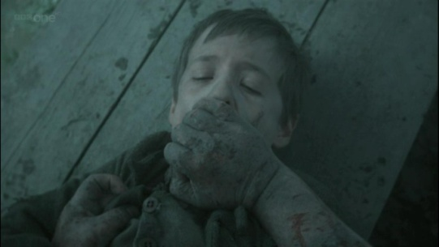
PART I: BEFORE LISTENING AND READING
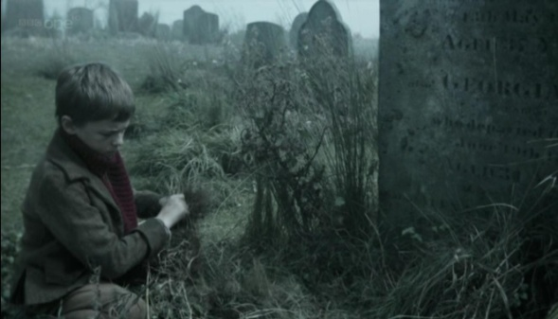
Task 1. Give the gist of the 1st chapter.

___________________________________
_________________________________________________________________________________________________________________________________________________________________________________________________________________________________________________________________________________________________________________________________________________________________________________________________________________________________________________________________________________________________________________________________________
______________________________________________________________________________________________________________________________________________________________________________
PART II. VOCABULARY
Task 1. Before listening to the recording find out the meaning of the following words and
expressions.

good-natured | доброї вдачі, добродушний
sweet-tempered | ласкавий, лагідний, з м'яким характером
to reach home | доїжджати до; добиратися додому
to demand | 1) вимагати, потребувати 2) питати; запитувати
to answer in timid voice | відповідати тихим, сором’язливим голосом
chimney-corner | місце біля каміна
to creep over | перелазити
to set smth | ставити, класти; поміщати; розставляти; установлювати; розташовувати, розміщувати
convict | каторжник; засуджений
impatiently | нетерпляче, нетерпеливо
to fire warning of smb | бити на сполох, попереджати комусь
hulk | велике неповоротке судно
hopefully | сподіваючись, на щастя
dozen | дюжина
to rob | 1) грабувати; обкрадати 2) відбирати; позбавляти (чогось)
to murder | убивати
to be on the way | бути в дорозі
to float | 1) плавати; триматися на поверхні 2) пливти, нестися (за течією, в повітрі - in)
tide | 1) морський приплив і відплив 2) потік, течія, напрям
faint | 1) слабкий; в'ялий, млявий 2) боязкий 3) тьмяний, невиразний; неясний; блідий 4) недостатній, незначний
dawn | світанок, ранкова зоря
upon the way | на шляху
thief | злодій
jar | глек, глечик; кухоль; банка
pickles | солоні (мариновані) огірки
to pour | 1) лити(ся); вливати(ся) 2) наливати (into) 3) розливати (чай тощо)
to contain | містити (мати) в собі; вміщати
forge | кузня
file | напилок; терпуг; пилочка
tool | 1) робочий (ручний) інструмент; різець; знаряддя праці 2) знаряддя (в чиїхось руках)
misty | 1) туманний; затуманений 2) неясний, невиразний
ditch | канава; рів; траншея; кювет
folded | зігнутий
heavy | сонний
to lean | 1) нахиляти(ся) (вперед, над - forward, over) 2) прихилятися, притулятися, спиратися (on, against)
to touch smb on the shoulder | доторкнутися до плеча
instantly | відразу, негайно
swear | лаяти (когось - at) ; лаятися, богохульствувати
to make a hit at smb | вдарити когось
to be in a great fright | бути дуже переляканим
at full speed | щодуху
to limp up and down | повільно рухатися вперед та назад
in a violent hurry | дуже швидко, з жахливим поспіхом

PART III. LISTENING
Task 1. Listen to the recording and put the given excerpts in the correct order
Track 02_01
____a) Joe was sitting in the chimney-corner, and I crept over and sat opposite him while my sister set the tea things. We all jumped and started as there came the sound of a distant explosion.

____b) “Where have you been, you young monkey?” she demanded.

____c) “Hulks are prison-ships, right across the marshes,” said Joe.

____d) “Hah!” said Mrs. Joe, looking angrily from her husband to me. “The pair of you will drive me to the churchyard one of these days!”

____e) “To the churchyard,” I answered in a little, timid voice.

____f) My sister, Mrs. Joe Gargery, was more than twenty years older than I. She was not a good-looking woman. She was too tall and thin, and her skin was very red, and I had an idea that she must have forced Joe to marry her, in much the same way that she forced me to do a good many things I had no wish to do.

____g)“Joe,” I said, “was that great guns?”
____h)“Lord bless the boy!” exclaimed my sister. “It’s from the Hulks!”

____i)“What does that mean?” I asked.

____j)“Escaped! Escaped!” explained my sister impatiently.

____k)“I wonder who’s put into prison-ships, and why they’re put there?” I said, hopefully.

____l)“And please—what’s Hulks?” I asked.

____m)Joe was a big, strong fellow, fairhaired and blue-eyed, always good-natured and sweet-tempered.
They were in the kitchen when I reached home. Mrs. Joe looked at the clock.

____n)“Who’s firing?” said I.

____o)“What’s a convict?” I asked Joe.

____p)“There was one off last night,” said Joe, “after the sunset gun. And they fired warning of him. Now, it seems, they’re firing warning of another.”

____q)“Yes,” said Joe. “There’s another convict off.”

Track 02_02
You are going to listen to the 2nd part of the 2nd chapter of the story. Fill in the gaps with the missing words that are given in the table.
murder on my way in a violent hurry tide downstairs at full speed poured file tools misty heavy swore
rob get along floating thief pickles contained ditch leaning made a hit at me staring
dozen upstairs faint dawn jar forge folded limping up and down touched him on the shoulder

It was too much for my sister.
“That’s the way with this boy!” she said. “Answer him one question, and he’ll ask you a ___________ directly. People are put in the Hulks because they _________, and ___________ , and do all sorts of bad things; and they always begin by asking questions. Now, you _____________________to bed!”
As I went ______________ in the dark I felt sure that I was ___________________to the Hulks. I had begun by asking questions, and I was going to rob Mrs. Joe. If I slept at all that night, it was only to dream that I was ________________ down the river on a strong _____________, to a place where a terrible young man was waiting to cut out my heart.
At the first ________________________of morning, I got up and went _____________________-. Every board upon the way seemed to call after me, “Stop _____________-!” and “Get up, Mrs. Joe!” I stole some bread, a piece of cheese, about half a _______________of _______________, some brandy from a stone bottle (which I ___________________- into a glass bottle that had once _______________ medicine), and a beautiful round meat pie, which I took in the hope that it would not be missed for some time.
There was a door in the kitchen which gave on to Joe’s _______________; I unlocked that door, and got a ____________ from among Joe’s ______________. Then I opened the house door, and ran for the _______________ marshes.
I knew my way to the Battery, for I had been down there on a Sunday with Joe. I had just crossed a _____________ which I knew to be close to the Battery, when I saw the man sitting on the ground. His back was towards me, and he had his arms __________________ and was _____________________ forward, ________________ with sleep.
I moved up quietly and _____________________________________________. He instantly jumped up. It was not the same man, but another!
Yet this man was dressed in coarse grey, too, and had a great iron on his leg, and was everything that the other man was. All this I saw in a moment, for I had only a moment to see it in; he ______________, _____________________________, and then he ran off into the mist and I lost him.
I was in a great fright.
“It’s the young man!” I thought, and made for the Battery _______________________________.
There was the right man, still holding his trembling body with both arms, ________________________________while he waited for me. He was terribly cold, to be sure, and his eyes looked so hungry that when I handed him the file, I thought he might have tried to eat it if he hadn’t seen my bundle.
“What’s in the bottle, boy?” he asked.
“Brandy,” I told him.
He was already pushing food down his throat in a most curious manner—more like a man who was putting it away somewhere ___________________________________than a man who was eating it—but he left off to drink some of the spirit. All the time he kept _______________________ into the mist, often stopping to listen.
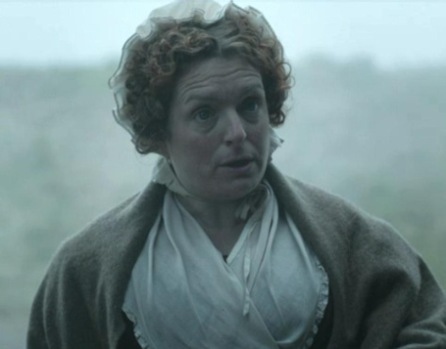
PART IV. AFTER LISTENING AND READING
Task 1. Answer the following questions
1. Describe Mrs Joe Gargery. Who is she?
________________________________________________________________________________________________________________________________________________
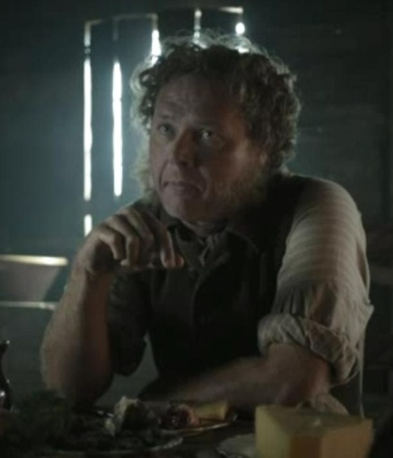
________________________________________________________________________________________________________________________________________________
2. Who is Joe? Describe him.
____________________________________________________
____________________________________________________
____________________________________________________
3. What was Mrs Joe Gargery’s reaction like when Pip returned home?
4. Was Pip surprised to to hear the sound of a distant explosion?
5. What’s Hulks?
6. Does Mrs Joe Gargery believe Pip to be a curious boy?
7. Is Pip a thief? Who was he going to rob?
8. What did Pip take from the Joe’s forgery? What for?
9. Whom did Pip touch on the shoulder having returned to the marsh?
10. Did Pip help a stranger? How?

PART V. GRAMMAR AND TRASLATION
Task 1. What is a compound adjective?
________________________________________________________________________________________________________________________________________________
Task 2. Write examples out of the presentation:
_________________________ ________________________________
_________________________ ________________________________
________________________ _________________________________
Task 3. Write examples out of the text and give synonyms to them:
_____________________________ _______________________________
_____________________________ _______________________________
Task 4. Write words from the box on the left with the words from the box on the right to form 12 compound adjectives.
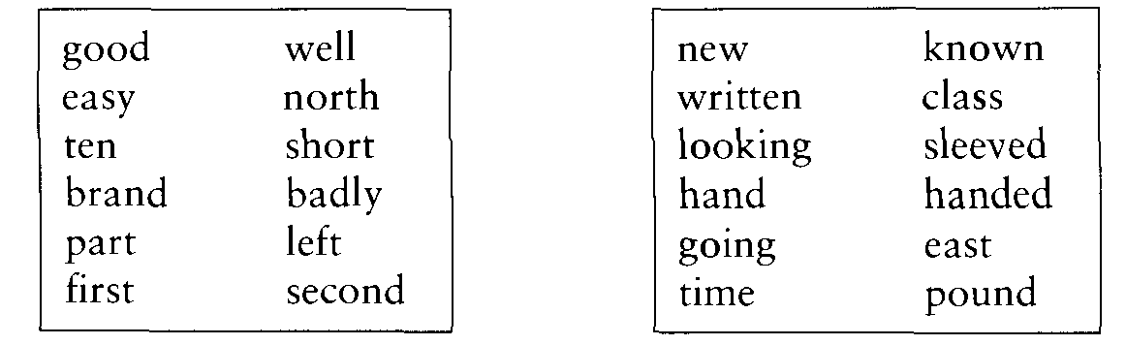
1.________________________________ 7.________________________________
2.________________________________ 8.________________________________
3.________________________________ 9.________________________________
4.________________________________ 10.________________________________
5.________________________________ 11._______________________________
6.________________________________ 12._______________________________
Task 2. Translate the sentences and pay attention to the English grammar constructions:
1. “Hah!” said Mrs. Joe, looking angrily from her husband to me. “The pair of you will drive me to the churchyard one of these days!”
______________________________________________________________________
________________________________________________________________________________________________________________________________________________
2. We all jumped and started as there came the sound of a distant explosion.
______________________________________________________________________
__________________________________________________________________________
3. “There was one off last night,” said Joe, “after the sunset gun. And they fired warning of him. Now, it seems, they’re firing warning of another.”
______________________________________________________________________
________________________________________________________________________________________________________________________________________________
4. “Lord bless the boy!” exclaimed my sister.
______________________________________________________________________
5. “I wonder who’s put into prison-ships, and why they’re put there?” I said, hopefully.
______________________________________________________________________
__________________________________________________________________________
6. If I slept at all that night, it was only to dream that I was floating down the river on a strong tide, to a place where a terrible young man was waiting to cut out my heart.
____________________________________________________________________________________________________________________________________________________
7. Every board upon the way seemed to call after me, “Stop thief!” and “Get up, Mrs. Joe!”
________________________________________________________________________________________________________________________________________________
8. I had just crossed a ditch which I knew to be close to the Battery, when I saw the man sitting on the ground.
____________________________________________________________________________________________________________________________________________________

9. I moved up quietly and touched him on the shoulder. He instantly jumped up. It was not the same man, but another!
____________________________________________________________________________________________________________________________________________________

10. There was the right man, still holding his trembling body with both arms, limping up and down while he waited for me. He was terribly cold, to be sure, and his eyes looked so hungry that when I handed him the file, I thought he might have tried to eat it if he hadn’t seen my bundle.
____________________________________________________________________________________________________________________________________________________
____________________________________________________________________________________________________________________________________________________

PART VI. SELF-STUDY WORK
1. Listen to the track 02_02 and practice reading it.
2. Listen to the track 02_03 and write out all new words.
Тrack 02_03
“You brought no one with you?” he said suddenly. “Or got anyone to follow you?”
“No, sir! No!”
“Well” he said. “ I believe you. You’d be a fierce young wretch at your age, if you’d help to trap a poor convict, hunted as near death as I am!”
I pitied his misery, and watched him settle down with the pie.
“I’m glad you enjoy it,” I said.
“Thank you, my boy. I do.”
I had often watched a large dog of ours eating his food, and I now noticed a decided likeness between the dog’s way of eating and the man’s. The man took sharp, sudden bites just like the dog; and he looked sideways here and there as he ate, as if he thought there was danger of somebody’s coming to take the pie away.
“I’m afraid you won’t leave any of it for him,” I said, after a pause.
“Who’s him?” said my friend, looking at me sharply.
“The young man that you spoke of. The one that was hiding with you.”
He gave a little laugh.
“Oh, him!” he said. “He don’t want food.”
“I thought he looked as if he did,” said I.
The man stopped eating and regarded me in surprise.
“Looked? When?”
“Just now.”
“Where?”
“Over there,” said I, pointing. “I found him half-asleep, and thought it was you.”
He took me by the chin and stared at me so fiercely that I thought his first idea of cutting my throat had returned.
“He was dressed like you,” I explained, “and had an iron on his leg. Didn’t you hear the big gun last night?”
“So there was firing,” he said to himself, then gave me a little shake. “Did you notice anything special about this man?” he demanded.
“Yes—he had a badly bruised face,” said I, remembering something that I hardly knew I knew.
“Not here?” exclaimed the man, striking his left cheek with the flat of his hand.
“Yes, there.”
“Where is he?” he cried. He began putting what little food was left inside his grey jacket. “Show me the way he went. I’ll have him yet! Curse this iron on my sore leg! Give us the file, boy.”
He went down on the wet grass and began to file at his iron like a mad thing, not minding me or minding his leg, which was sore and red with blood. I was very much afraid of him again, now that he had worked himself into this fierce hurry, and I was also afraid of keeping away from home any longer. I told him I must go, but he took no notice of me, so I thought the best thing I could do was to slip away.
The last I saw of him, his head was bent over his knee, and he was working hard at his iron; the last I heard of him, when I stopped in the mist to listen, was the sound of the file still going.

