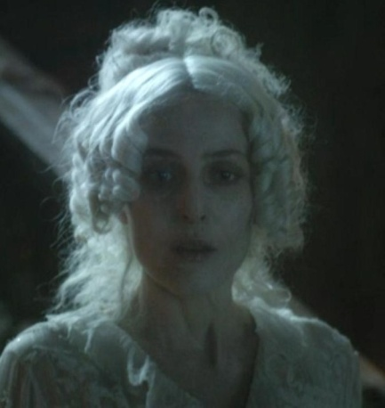
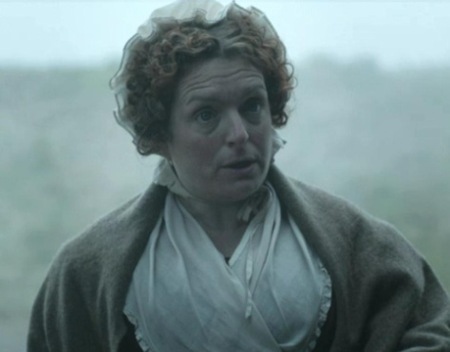
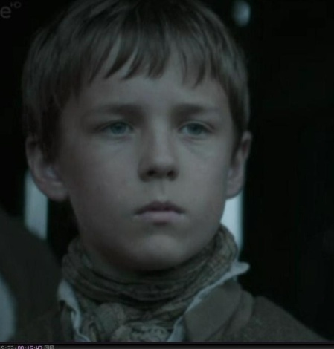

PART I: BEFORE LISTENING AND READING
Task 1. Give the gist of the third chapter.
_________________________________
________________________________________________________________________________________________________________________________________________________________________________________________________________________________________________________________________________________________________________________________________________________________________________________________________________________________________________________________________________________________________________________________________________________________________________________________________________Task 2. Who are these people?
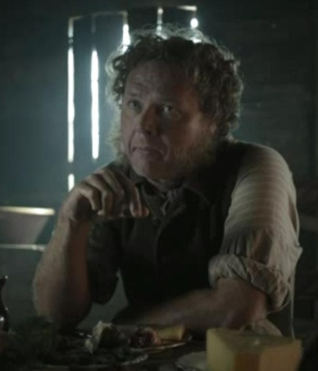
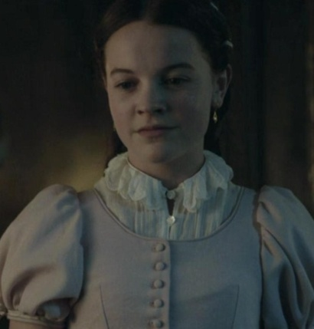
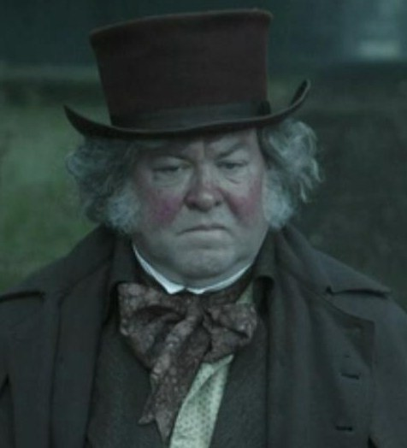
1. 2. 3.

PART II. VOCABULARY
Task 1. Before listening to the recording find out the meaning of the following words and
expressions.
to drive smb quite out of his/her mind
on a market-day
to assist smb in doing smth
to be wrapped to the eyes
in great haste
grateful
puzzled
dismal
to be barred like a prison
to shut oneself away from the world
astonished
sensible
to make a fortune
from head to foot
to spring upon smb
soaped
scrubbed
to rub
on earth
bars
coolly
to lock the gate in smb’s face
with smb’s mouth hanging open
scornful
to knock at the door
glimpse of daylight
within smb’s view
faded
to have a sick fancy
to flicker
to turn up smb’s nose
in wait
to go red in the face
tell me in my ear
to say in a whisper
to insult
to give a laugh at smth
to beat smb
to despise
to push smb out
tap
jewel
to break smb’s heart
to sit down to smth
to be ashamed of smth
to remark
rush of the daylight
to set off
to be filled with a deep regret
to be in a thoroughly bad way

PART III. LISTENING
Task 1. You are going to listen to the first part of the 1st chapter of the story. Fill in the
gaps with the missing words that are given in the table.

forge haste by grateful mind at sensible thick with dirt drove puzzled assist iron shoes market-day judgment convict astonished sprang upon
habit wrapped stuffs scrubbed fixing on dismal on earth
to be sure Stupid soaped put into my best rubbed fortune
rent from head to foot driven off on earth

by
Тrack 04_01
Time went ____, and I thought less and less of my friend, the _________, as the months passed and we heard no more of him. Then there happened something which _______ him quite out of my ___________ for a long time to come....
It was on a ____________it happened. My sister, as was sometimes her _______, had driven into town with Uncle Pumblechook to ________ him in buying such _______ and goods as required a woman’s ___________. They were late coming back to the ______. It was dark before we heard the sound of ________________upon the road, and the two of them drove up, ___________ to the eyes. We were soon all in the kitchen, and my sister began unwrapping herself in great ___________ and excitement.
“Now,” she said, ________ her eyes ____ me, “if this boy isn’t _________ this night, he never will be!”
“Why?” asked Joe, a _______ look on his face.
“Because,” said my sister, “Miss Havisham up town wants this boy to go to her house and play there. And of course he’s going. And he had better play there,” she added, “or I’ll give him something to remember!”
I had heard of Miss Havisham up town— everybody for miles around had heard of Miss Havisham up town—as a wonderfully rich old lady who lived in a large and ________ house that was barred like a prison, and in which she had shut herself away from the world.
“Well, _____________!” cried Joe, __________. “I wonder how she comes to know Pip?”
“_____________!” answered my sister. “Who said she knew him? Uncle Pumblechook has to go there sometimes to pay his ___________, and she asked him if he knew of a boy to go and play there. He, being a ___________ man, unlike some, mentioned this boy here—whose _________ may be made by his going to Miss Havisham’s. Uncle has offered to take him into town tonight and then to Miss Havisham’s in the morning. And here I stand talking, with Uncle waiting, and this boy _________________ ____________________!”
With that, she _______________me, and my face was put under the tap, and I was __________ and ______________ and ____________ with towels until I was quite beside myself. When that was done, I was ________________and tightest suit, delivered over to Uncle Pumblechook, and _______________to town without any idea why ____________I was going to play at Miss Havisham’s, and what _______I was expected to play _______.

Task 2. Listen to the recording 04_02 – 04_04 and answer the following questions:
1. When did Pip and uncle Pumplechook stand before the gate of Miss Havisham’s house? Was the gate locked?______________________________________________________
2. What was the house like (outside and inside)?___________________________________
3. What was the reason Pip came to Miss Havisham’s house?_____________________
4. What was Miss havisham like?___________________________________________
5. What did Miss havisham want Pip to do?___________________________________
6. Who is Estella?_________________________________________________________
7. Was Pip ashamed of something? Why?_____________________________________
8. What was Pip’s attitude to Estella?_________________________________________
9. How do you understand Miss havisham’s phrase told Pip : ‘I know nothing of the days of the week. Come again after six days’?_________________________________________
10. How far was the village Pip lived in?______________________________________
Task 3. View the episode from the film depicting chapter four. Are there any differences between the text version and the film? _______________________________________
______________________________________________________________________
PART IV. TRANSLATION
Task 2. Translate the sentences and pay attention to the English grammar constructions:
1. Time went by, and I thought less and less of my friend, the convict, as the months passed and we heard no more of him.
________________________________________________________________________________________________________________________________________________
2. I had heard of Miss Havisham up town— everybody for miles around had heard of Miss Havisham up town—as a wonderfully rich old lady who lived in a large and dismal house that was barred like a prison, and in which she had shut herself away from the world.
________________________________________________________________________________________________________________________________________________
__________________________________________________________________________________________________________________________________________________________________________________________________________________________
3. With that, she sprang upon me, and my face was put under the tap, and I was soaped and scrubbed and rubbed with towels until I was quite beside myself. _______________________________________________________________________
____________________________________________________________________________________________________________________________________________________
4. I was put into my best and tightest suit, delivered over to Uncle Pumblechook, and driven off to town without any idea why on earth I was going to play at Miss Havisham’s, and what on earth I was expected to play at.
______________________________________________________________________
___________________________________________________________________________________________________________________________________________________
______________________________________________________________________
5. She seemed much older than I, of course, being a girl, and very beautiful and confident; and she was as scornful of me as if she had been one-and-twenty, and a queen.
______________________________________________________________________
___________________________________________________________________________________________________________________________________________________
______________________________________________________________________
6. “What coarse hands this boy has!” said Estella before our first game was done. “And what thick boots!”I had never been ashamed of my hands or boots before, but I was from that moment on.
______________________________________________________________________
________________________________________________________________________________________________________________________________________________
PART V. SELF-STUDY WORK
1. Listen to the track 04_01-04_04 at home and practice reading them. Be ready to record yourself (choose one of four tracks)
2. Learn all new words.

