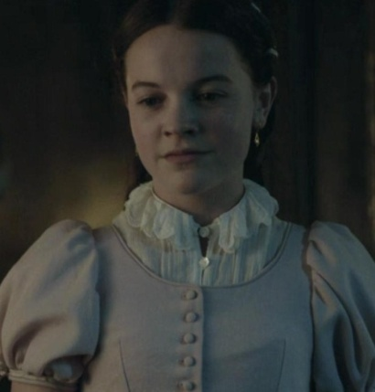
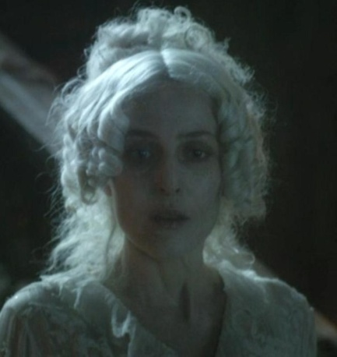
PART I: BEFORE LISTENING AND READING
Task 1. Give the gist of the 4th chapter.

___________________________________
______________________________________________________________________________________________________________________________________________________________________________________________________________________________________________________________________________________________________________________________________________________________________________________________________________________________________________________________________________________________________________________________________
____________________________________________________________________________________________________________________________________________________________________________________________________________________________
PART II. VOCABULARY
Task 1. Before listening to the recording find out the meaning of the following words and expressions.

to treat smb as if smb were no more than a dog in disgrace
to win smb’s favour
exceedingly
bald
sharp
eyebrow
neighbourhood
to send for
behave yourself
bricked up
cobwebs
bride-cake
to wander about
to pull off
bloodthirsty
in a businesslike and bloodthirsty manner
to dance at smb
to hit out at smb
at once
a black eye
to knock smb down
heavily bruised
anxiously
to turn away
to walk off
to be done to smb as a punishment
terrors reach their height
not a word
in any way
sight of smb
greedily
to have no mercy
to be apprenticed
to feel sick at heart
with a laugh

PART III. LISTENING
Task 1. Listen to the recording 05_01 and put the given excerpts in the correct order

____a) He was a big man, with an exceedingly large head that was bald on the top. He took my chin in his hand and turned up my face to have a look at me in the candlelight. His eyes were set very deep in his head, and were sharp and suspicious, and he had thick black eyebrows that wouldn’t lie down.

____b) “What have we here?” asked the gentleman, stopping and looking down at me.
“A boy,” replied Estella.

____c) ““Boy of the neighbourhood, eh?” he said. “How do you come here?”

____d) “Well, behave yourself!” he said. “Do you mind me? Behave yourself!”

____e) Then there came a day, when, as she and I were on our way upstairs, we met a gentleman coming down.
____f) I entered the room she had pointed out. The windows were bricked up so that the daylight could not enter, but there were candles here and there faintly lighting the room. It was a big room and in the centre was a long table with a cloth spread on it, as if a feast had been in preparation when the house and the clocks all stopped together. A great centre-piece of some kind was in the middle of this cloth, so overhung with cobwebs that I could not make out what it was, but I could see spiders running home to it, and others running out from it.

____g)With these words, he went on down the stairs. There was not much time to consider what the man had been doing there, for we were soon in Miss Havisham’s room.

____h)“Are you ready to play?” she asked me. “Or would you rather work?”

____i)I went to Miss Havisham’s often after that; and always Estella treated me as if I were no more than a dog in disgrace; and always, for some reason, I longed to win her favour.

____j)“Miss Havisham sent for me, sir,” I answered.

____k)I said I was quite willing to work, and she took up a stick and came and laid her hand on my shoulder. “Take me into the room opposite,” she said.

____l)“This,” said Miss Havisham, pointing at the table with her stick, “is where I shall be laid when I am dead. What do you think that is?” Again pointing with her stick, “ that—where the cobwebs are?”

____m)“Take Pip down to the garden, Estella. Give him something to eat and let him wander and look about him while he eats. Go, Pip

____n)“I can’t guess what it is, ma’am.”

____o)She glared all round the room, and then said, leaning upon my shoulder: “Come, come, come! Walk me, walk me!”

____p)I made out from this that the work I had to do was to walk Miss Havisham round and round the room. Accordingly, I started at once, and away we went, round and round and round. After a while she said, “Call Estella.” When Estella came, she said:

____q)“It’s a great cake. A bride-cake. Mine.”

Task 2. You are going to listen to the 2nd part of the 5th chapter of the story. Fill in the gaps with the missing words that are given in the table.

leave hit out at businesslike pulled off down came out pouring Come and fight neglected failed
astonished wandered round stared in my own age came at knocked down a piece of money
a black eye dancing at got his breath back heavily bruised walked off at once bloodthirsty

Estella took me ___________ to the yard, left me waiting, and returned with some bread and meat, which she handed to me without looking at me, and left me. I _________________________the corner of the yard, and into a ______________ garden, like a wilderness. Then, never doubting that the house was empty, I ________________at a window and found myself, to my great surprise, looking into the face of a boy with light hair.
This pale young gentleman quickly disappeared, and _________________of a door close by.
“Who let you in?” he asked.
“Miss Estella.”
“Who gave you _______________ to wander about?”
“Miss Estella.”
“_____________________,” said the pale young gentleman.
I was so _____________________ that I followed him to a quiet corner of the garden. There he _____________________not only his jacket, but his shirt too, in a most ____________ and _______________ manner. I judged him to be about ________________, but he was much taller, and my heart _____________ me when he came __________________me with his hands up. I have never been so surprised in my life as I was when I _________________ him and saw him lying on his back, looking up at me with the blood ___________ from his nose.
But he was on his feet ____________and _______________me again. The second greatest surprise I have ever had was seeing him on his back again, looking up at me out of __________________________.
So it went on. He seemed to have no strength, and he never once hit me hard, and he was always ______________. He got ________________________for I am sorry to say that the more I hit him the harder I hit him; but he came up again and again and again, until at last he got a bad fall with the back of his head against the wall.
“All right,” he said, when he had ______________________________. “You’ve won!”
“Are you all right? Can I help you?” I asked anxiously.
“No, thank you,” he replied.
“Good afternoon, then,” I said, turning away. “The same to you,” he answered as I _________________________. When I got back to the yard I found Estella waiting with the keys. She looked very pleased about something. Instead of going straight to the gate, she stepped back into the passage and pulled me in after her. “Come here! You may kiss me if you like.”
I kissed her cheek as she turned it to me. I think I would have gone through a great deal to kiss her cheek; but I felt that the kiss was given to the stupid, common boy as ___________________might have been, and that it was worth nothing at all.

PART IV. AFTER LISTENING AND READING
Task 1. Answer the following questions:
1. Did Pip long to win Miss Havisham’s favour? Why?
2. Read the describtion of Miss Havisham house. Translate it. Do you consider it to be stange? Why/Why not?
I entered the room she had pointed out. The windows were bricked up so that the daylight could not enter, but there were candles here and there faintly lighting the room. It was a big room and in the centre was a long table with a cloth spread on it, as if a feast had been in preparation when the house and the clocks all stopped together. A great centre-piece of some kind was in the middle of this cloth, so overhung with cobwebs that I could not make out what it was, but I could see spiders running home to it, and others running out from it.
3. What did Miss Havisham ask Pip in the room? What for?
4. Was Pip astonished to see a strange young boy of his age at Miss Havisham’s one day? Why was he surprised?
5. Who has won in the fight between Pip and a strange boy?
6. What was the reward for the winner?
7. What did Miss Havisham ask Pip one day? Did she help him?
8. What was Pip’s reaction like to Miss Havisham’s news that Estella was going to go abroad?

PART V. TRANSLATION
Task 2. Translate the sentences from English into Ukrainian:
1. He was a big man, with an exceedingly large head that was bald on the top.
__________________________________________________________________________________________________________________________________________________________________________________________________________________________
2. His eyes were set very deep in his head, and were sharp and suspicious, and he had thick black eyebrows that wouldn’t lie down.
__________________________________________________________________________________________________________________________________________________________________________________________________________________________
3. The windows were bricked up so that the daylight could not enter, but there were candles here and there faintly lighting the room.
__________________________________________________________________________________________________________________________________________________________________________________________________________________________
4. “This,” said Miss Havisham, pointing at the table with her stick, “is where I shall be laid when I am dead. What do you think that is?” Again pointing with her stick, “ that—where the cobwebs are?”
__________________________________________________________________________________________________________________________________________________________________________________________________________________________
___________________________________________________________________
5. Then, never doubting that the house was empty, I stared in at a window and found myself, to my great surprise, looking into the face of a boy with light hair.
________________________________________________________________________________________________________________________________________________
6. I have never been so surprised in my life as I was when I hit out at him and saw him lying on his back, looking up at me with the blood pouring from his nose.
________________________________________________________________________________________________________________________________________________
7. My mind grew very uneasy on the subject of the pale young gentleman.
_________________________________________________________________________________________________________________________________________________
8. Sometimes, indeed, she told me openly that she hated the sight of me.
________________________________________________________________________________________________________________________________________________
9. Miss Havisham would often ask me in a whisper, “Does she grow prettier and prettier, Pip?” And when I said that she did, would seem to enjoy it greedily, and would whisper in the girl’s ear, “Break their hearts, my dear, break their hearts and have no mercy!”
______________________________________________________________________________________________________________________________________________________________________________________________________________________________________________________________________________________________________
10. I was surprised, and, for some reason that I could not determine, I felt sick at heart. In a minute or two I was outside the gate and it was locked behind me.
________________________________________________________________________________________________________________________________________________

PART VI. SELF-STUDY WORK
1. Listen to one of the tracks and practice recording yourself.

