
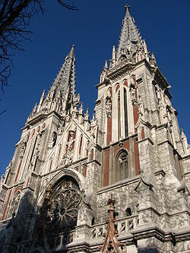
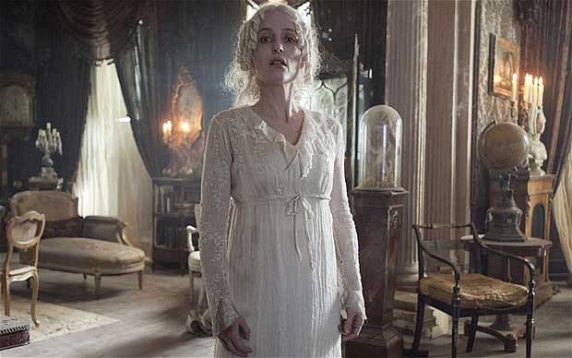

1. Dwell on the following quotations: “A house is no home unless it contains food and fire for the mind as well as for the body”, “A house is made of walls and beams. A home is built with love and dreams”. Which one do you agree with the most? Why?
2. If you could change three things about your home, what would they be? Why?
3. Would you ever consider live underground? What would the advantages and disadvantages be?
4. Could earth-sheltered houses be the homes of the future? Why (not)? What other types of houses might people have in the future?
5. What kind of home do you live in? Where is it located? What makes you feel proud of your home? What is your favourite room in your house?
6. What is the house of your dream?
7. Have you ever done any home improvements? What were they? Where you pleased with the results? Why (not)? Do you like the idea of houseplants in your house? Why (not)?
8. Describe Miss Havisham’s house.
9.What’s Mr Wemmick’s house like?
10. What are the major steps of renting a flat/house?
11. Do you know any house with a difference? What is it like?
12. What is the home and office of the U.S. President? How many rooms are there in the White House? What are they like? What is the Oval Office like?
13. Dwell on one of the architectural styles.
14. Depict the house that is filmed in the computer-animated comedy-adventure movie ‘Up’. What is its role?
15. Tell about your visit to the Nicholas Church – the House of Organ Music in Kiev (follow the link to read about it - http://ukrainetrek.com/blog/photos/nicholas-church-the-house-of-organ-music-in-kiev/ )

