Varieties of English
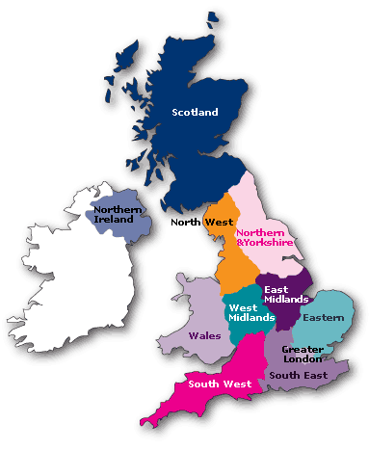
Not all speakers of English pronounce it in the same way. Even between the countries where English is the first language of the majority of population there are considerable differences, and we can distinguish between the pronunciation of ‘British English’, ‘American English’, ‘Australian English’, ‘South African English’, and so on∗.
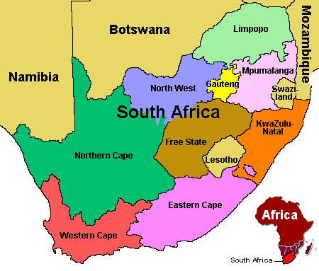
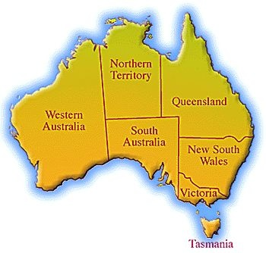
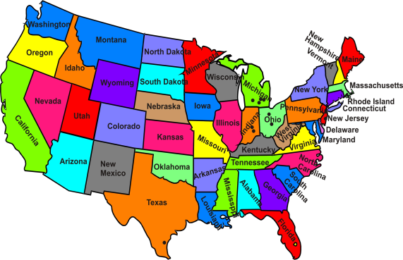

British English (BrE) American English (AmE/US) Australian English South African English
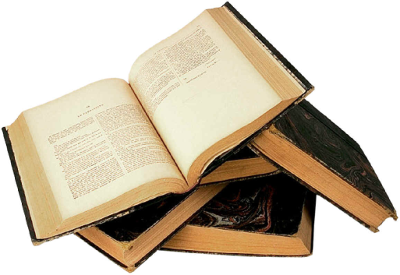
Task1. You will hear speakers from Britain, the USA, Canada, Australia and South Africa talking about what they enjoy doing in their spare time.


1. 2. 3.

______________________ __________________________ __________________



4._____________________ 5.________________________

Which of these accents are you most familiar with? Is there one you find easier to understand than the others?
∗AmE = American English (General American), AuE = Australian English, BrE = British English (RP), CaE = Canadian English, IrE = Irish English, NZE = New Zealand English, SAE = South African English, ScE = Scottish English, WeE = Welsh English

