- Below is an excerpt from “The Physiognomist's Own Book”: an introduction to physiognomy drawn from the writings of Lavater, 1841. Read the text. Study the vocabulary and grammar for further exercises and discussions.

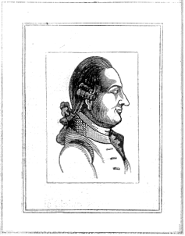
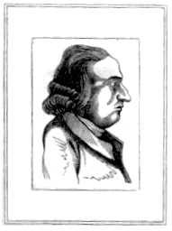
…Most persons are daily in the practice of this art, without a knowledge of the principles upon which it is founded. A man's face displeases them: this is often a sufficient ground for aversion. Prejudices of this nature ought to be exploded, and it should be the man of science and real humanity to remove them. Such was the great design of Lavater, whose profound research, guided by the design of being useful to his species, displayed to him the nature of man, and taught him how far the moral character is capable of being traced upon the face.
II. PRECISION, DILIGENCE
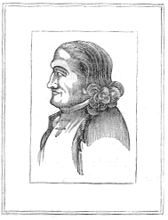
Here is the forehead of a man well calculated for business; the upper part of his head is an unerring characteristic of a calculating, deep-thinking mind; his forte lies in those sciences which demand precision, profundity and unwearied application; he may be a good geometrician, but not a poet. His features, however, do not represent firmness and rigour; a sanguine temperament predominates, and hints at a love of pleasure, so powerful as often to withdraw his attention from serious affairs.
Mr Diligence
III. BENEVOLENCE, HONOUR, ORDERLINESS
We are struck, at the first glance, with the air of honour, which is observable in this face; the moth expresses, at once, kindness, politeness and experience; the chin, marks a mind firm, without obstinacy, and a benevolent heart. Although the forehead and nose give no assurance of greatness, still they denote understanding. The mouth designates a diligent, reliable and orderly man.

Mr Benevolence

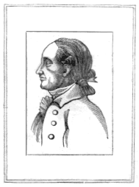
IV. MODESTY, GRAVITY
Here we may observe the characteristics of love of order, and attention to method. In the mouth, closely shut are depicted diligence and accuracy. The lower, part of the face is an indication of a man of discretion, modesty, gravity and reserve. He is not pleased with a book unless it is written clearly and methodically: he never rises to poetic invention, or overleaps the boundaries of scrupulous exactness.

Mr Gravity
VII. FIRMNESS, OCCASIONAL IRRITATION
Mr Firmness
The original of this portrait is one who knows how to enjoy life like a wise man. If he is not nice in his pleasures, he, at least, does not carry them to excess. The cast of his mind presupposes gentleness rather than harshness – dignity, rather than elevation – firmness of character, rather than violence of passion – passing irritation, rather than continued resentment. The whole profile will exhibit a sanguine ground, with a choleric tint.

VIII. REFLECTION, ENERGY, INSENSIBILITY
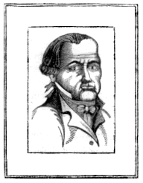
Sternness is engraved upon these features. The wrinkles in the vicinity of the eyes, and particularly those at the root of the nose – all announce harshness and insensibility; the chin designates energy, and the forehead denotes coolness and reflection, but it gives no indication of docility. Melancholy evidently predominates.

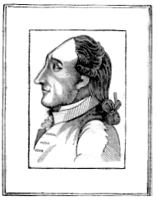
IX. LOVE, SANGUINITY
Mr Romantic
Mr Reflection
The animated eye, the voluptuous mouth, and the eyebrows gently arched, characterise a sanguine man; an expressive countenance, eyes often blue, and always quick, usually indicate this character. He is easily moved; slight circumstances agitate him, but he is soon composed. As his features always express his feelings, it is difficult for him to deceive. He is prone to the emotions of pity; and love rules him with despotic sway, though he may sometimes be accused of inconstancy.

XI. VIOLENT PASSION, HEROISM
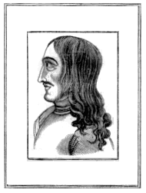
Here we see a countenance that evinces a capacity for great achievements – in which patriotism and heroic virtue, worthy of ancient Rome, are distinguishable. However, it still marks the man prone to the failings of humanity, and is often hurried by violence of passion; and false notions of honour, beyond the bounds of reason. The aquiline nose is indicative of an authoritative and fiery temper. We may predict, that if the person of whom we are speaking takes to improper courses, it will be difficult to restore him to the path of rectitude.
Mr Heroism
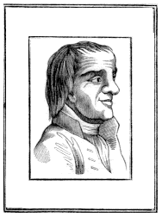
XIV. STRONG MEMORY, GOOD SENSE, DELIBERATIVE PERSEVERANCE
Mr Perseverance
The broad, square forehead points to a strong, memory, and a fund of good sense; but its form denotes a degree of inflexibility, which may degenerate into obstinacy; the slight projection of the lower lip, and the flatness of the chin, are indicative of good nature. This is the face of a prudent, discerning man; of one devoid of poetic genius, but persevering and resolute, he can turn his mind upon every subject, and may render himself conspicuous in a deliberative assembly. He is peculiarly calculated for profound and laborious investigation.

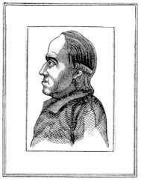
XV. INTEGRITY, SEDATENESS
Mr Integrity
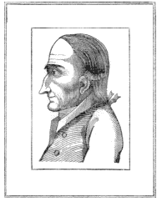This is the physiognomy of one designed by nature to be a man of business; he does not possess the forehead of a poet, nor of one whose impulsive imagination transcends the barriers of cold reason. The elevation and roundness at the summit, are proofs of a sedate, cool, and reflecting mind. The nose announces firmness, benevolence is imprinted on the mouth; but the bold shape of the lips betrays a slight disposition to choler. The chin denotes a man incapable of violating a trust, or betraying the confidence entrusted with him, and it would seem as if he had been formed to be essentially useful: as a man of business, a lawyer, or a merchant, his honesty and integrity will always render him respectable.
XIX. EGOTISM, SUSPICION, TREACHERY, meanness
Mr Miser
The following particulars are combined in the hateful character of the miser: egotistical, hardhearted, and mistrustful, the slightest loss afflicts him; and to confer a benefit upon him, is throwing it away; worry is ever brooding in his heart, and every look is fraught with suspicion. His features cannot lie concealed. He cannot move, he cannot walk a step, without betraying it.
XX. RESOLUTION, ACTIVITY, GENIUS
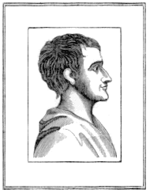
Here are indications of extraordinary genius. The features of this face, the outlines of which are neither too angular nor too rigid, decisively evince great energy; the nose is indicative of a lofty mind, resolution and the forehead displays genius, and designates a character in which reflection and activity are at once combined.

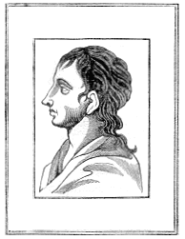
XIX. POETIC GENIUS, FIRMNESS
Mr Activity
Mr Poet
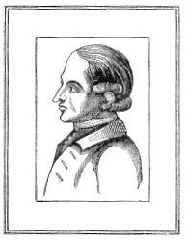
In this physiognomy we distinguish taste, acuteness and sensibility. Should a man of this description become an author, his style will be florid, and he will describe the beauties of nature and the pleasures of friendship: but he will avoid the discussion of scientific subjects, and sometimes turn away from philosophical argument as dry and boring. His features would seem to indicate a genius for poetry and great aptness for mental effort. The chin denotes a character possessed of firmness and energy. We may conclude that a man who bears a physiognomy like this is highly gifted; it distinctly presents the impress of genius.

XXXII. LOVE OF QUIET, daydreaming
Mr Sluggish
Here are collected the features of a character of extraordinary melancholy, discontented and sluggish disposition. The eyes, eyebrows and lips mark the intermixture of a phlegmatic tint. The elongation of the nose, as well as the forehead, declares no want of judgement and gives it its pensive air. The features of this face, taken in connection, exhibit a tranquil mind, fond of accuracy, especially of quiet.

