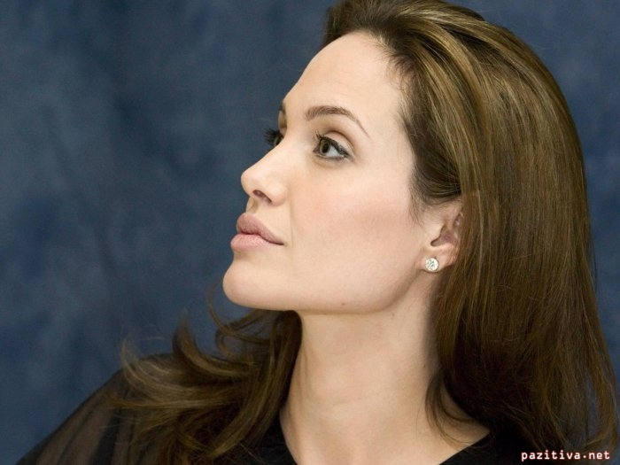 Angelina Jolie( Mrs. Benevolence)
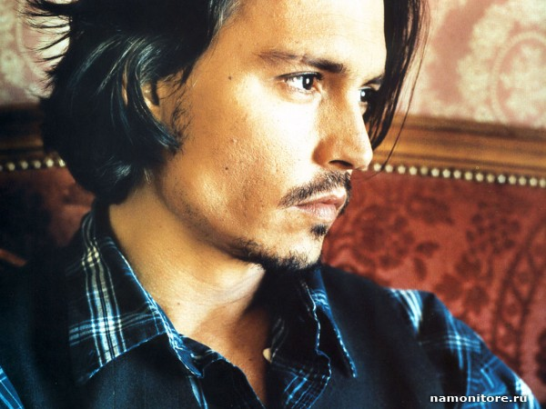 Johnny Depp (Mr. Perseverance)
 Justin Timberlake ( Mr. Firmness)

