"Imagine" is a song written and performed by the English musician John Lennon. The best-selling single of his solo career, its lyrics encourage the listener to imagine a world at peace without the divisiveness and barriers of borders, religions and nationalities, and to consider the possibility that the focus of humanity should be living a life unattached to material possessions.
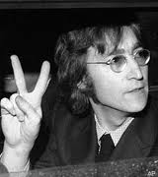
Imagine there is no 1.___________
It's easy if you try
No 2._______ below us
Above us only sky

Imagine all the people
Living for today

Imagine there's no 3._________
It isn't hard to do
Nothing to kill or die for
And no 4.____________, too
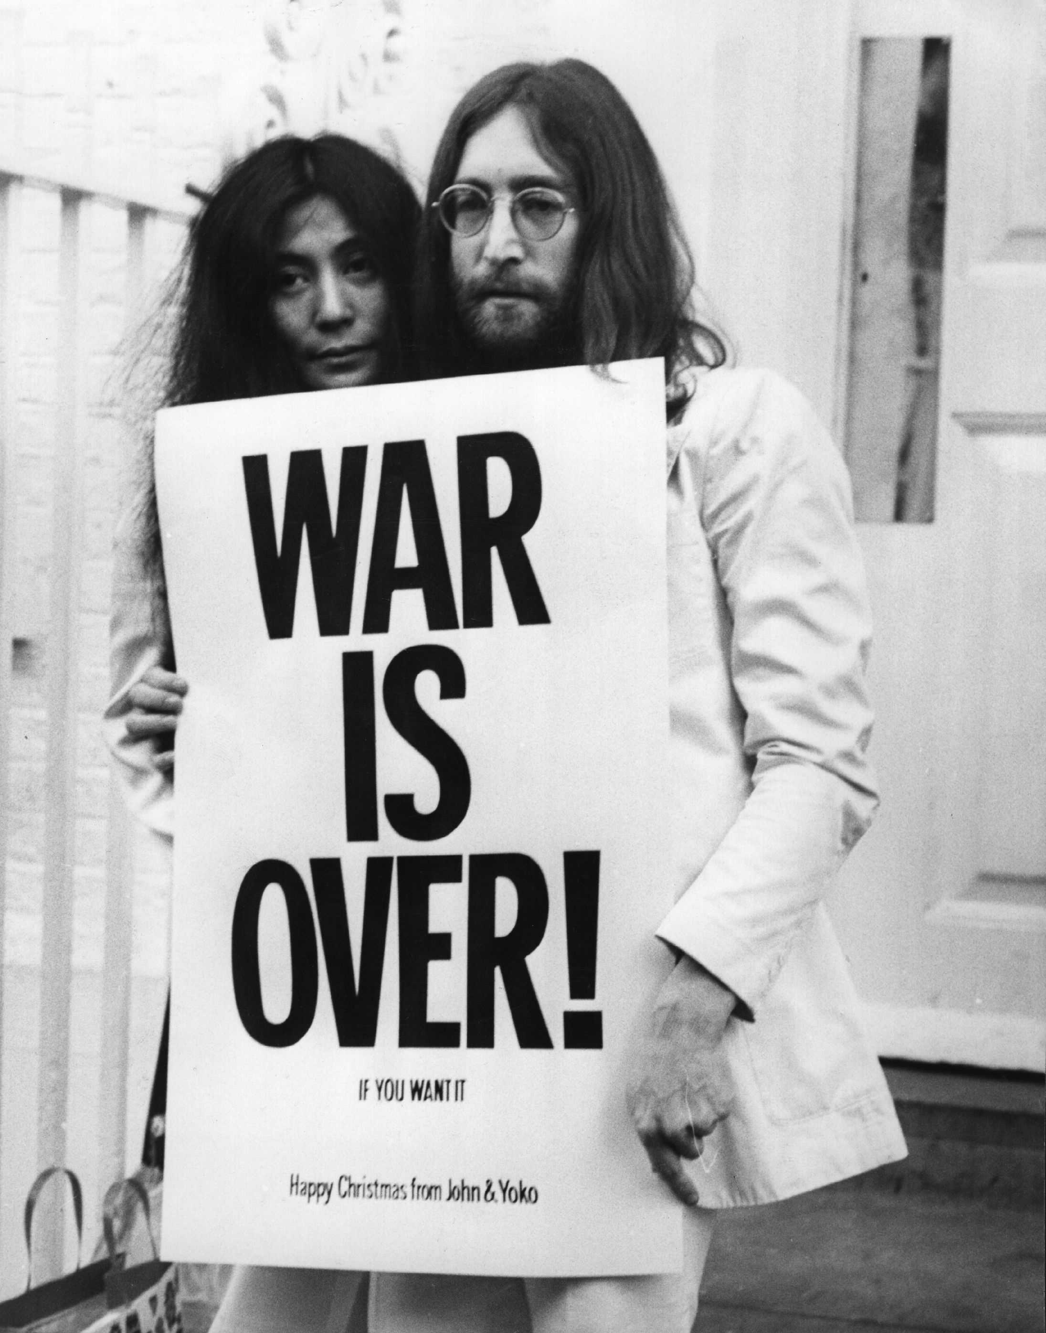
Imagine all the people
Living life in 5.___________

You, you may say I'm a 6._____________
But I'm not the only one
I hope someday you will join us
And the 7.____________ will be as one

Imagine no 8.______________
I wonder if you can
No need for greed or hunger
A brotherhood of man

Imagine all the people
Sharing all the world

You, you may say I'm a 9._______________
But I'm not the only one
I hope someday you will join us
And the 10.______________ will live as one

