"Englishman In New York"
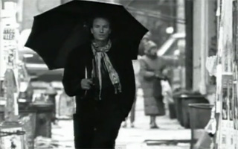

- Listen to the song and observe New York. How do you find it? Why is the video made in black and white? What is the weather like in New York? How does the author feel and see the city?
Write at least 5 word combinations to describe New York.
- Look through the song and underline the3 phrases you like the most.
…………………………..........
I don't drink coffee I take tea my dear
I like my toast done on one side
And you can hear it in my accent when I talk
I'm an Englishman in New York

See me walking down Fifth Avenue
A walking cane here at my side
I take it everywhere I walk
I'm an Englishman in New York

I'm an alien, I'm a legal alien
I'm an Englishman in New York
I'm an alien, I'm a legal alien
I'm an Englishman in New York

If "Manners make the man" as someone said
Then he's the hero of the day
It takes a man to suffer ignorance and smile
Be yourself no matter what they say

I'm an alien, I'm a legal alien
I'm an Englishman in New York
I'm an alien, I'm a legal alien
I'm an Englishman in New York

Modesty, propriety can lead to notoriety
You could end up as the only one
Gentleness, sobriety are rare in this society
At night a candle's brighter than the sun

Takes more than combat gear to make a man
Takes more than a license for a gun
Confront your enemies, avoid them when you can
A gentleman will walk but never run

If "Manners make the man" as someone said
Then he's the hero of the day
It takes a man to suffer ignorance and smile
Be yourself no matter what they say [3x]

I'm an alien, I'm a legal alien
I'm an Englishman in New York
I'm an alien, I'm a legal alien
I'm an Englishman in New York
accent – акцент, говірка
at my side – зі мною
walking cane – тростина
combat gear – військове обладнання
confront smb – протистояти комусь
end up as … - сконати як
legal – легальний, законний
lead to – привести до, спричинити
modesty - скромність
no matter what… - щоб там не сталось
notoriety – скандальна знаменитість
propriety – правильна поведінка
sobriety – стриманість, серйозність

