PHARRELL WILLIAMS – Happy
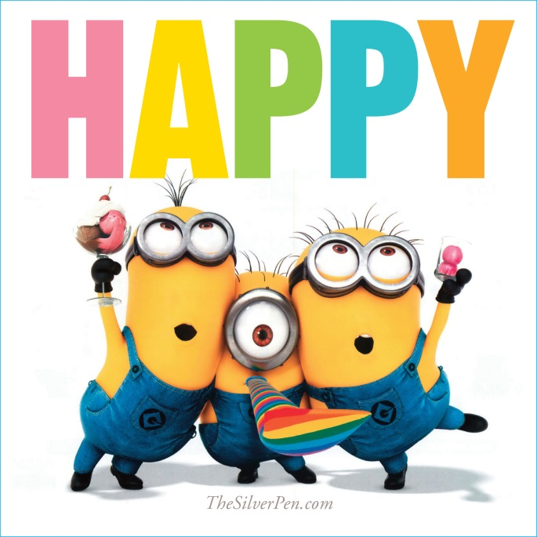

BEFORE LISTENING

1. What is happiness for you? if you could imagine it what would it look like? Describe it.

e.g.: If I could describe what is happiness for me, I would imagine .... It looks like a..., because...

2. What do you usually feel like doing when you feel happy?

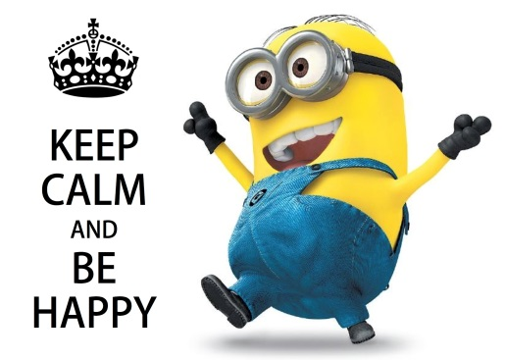
e.g. When I feel happy, I usually feel like singing my favourite songs in English:)

VOCABULARY

Task 1. Read the words and word phrases that may be new for you before listening to the song.

to seem crazy - видаватись божевільним
to take a break - брати перерву, робити перерву
to clap along - плескати з кимось
to warn smb about smth - попереджати когось про щось
to bring smb down - зламати когось
I am about to do smth - я ось-ось щось зроблю
Don't hold it back! - Не тримай це в собі!
I'll be just fine - зі мною буде все в порядку
Don't waste your time - не марнуй свій час
No offense to you = no hard feelings - без образ, не ображайся!
Nothing can bring me down - нічого не може мене зламати

a hot air balloon - повітряна куля

Task 2. Translate the words and word phrases given below.

by the way, space, I don't care, the truth, bad news

Task 3. Find the shortenings and tell how they sound in BBC English.

e.g. gonna - going
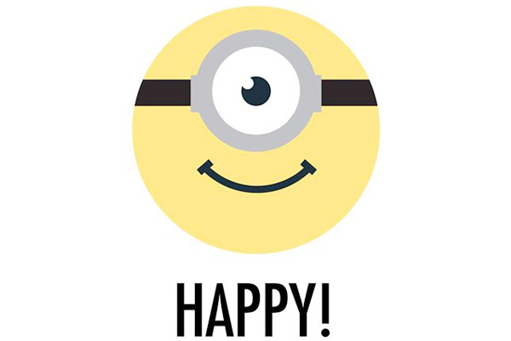

LISTENING

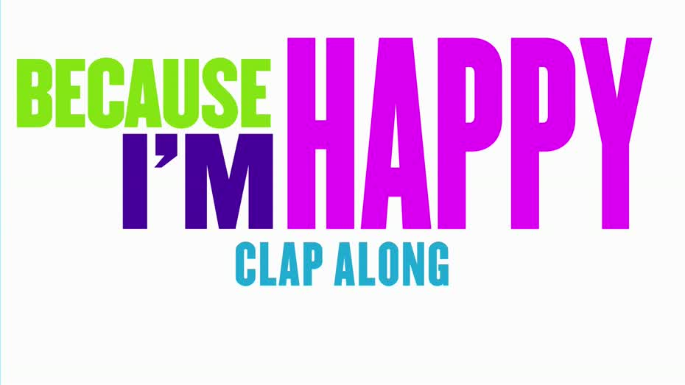

It might seem crazy what I'm about to say
Sunshine she's here, you can take a break
I'm a hot air balloon that could go to space
With the air, like I don't care, baby, by the way

Uh

Because I'm happy
Clap along if you feel like a room without a roof
Because I'm happy
Clap along if you feel like happiness is the truth
Because I'm happy
Clap along if you know what happiness is to you
Because I'm happy
Clap along if you feel like that's what you wanna do

Here come bad news talking this and that, yeah,
Well, give me all you got, and don't hold it back, yeah,
Well, I should probably warn you I'll be just fine, yeah,
No offense to you, don't waste your time
Here's why

Hey
Go
Uh

(Happy)
Bring me down
Can't nothing
Bring me down
My level's too high
Bring me down
Can't nothing
Bring me down
I said (let me tell you now)
Bring me down
Can't nothing
Bring me down
My level's too high
Bring me down
Can't nothing
Bring me down
I said

Hey
Go
Uh

Bring me down... can't nothing...
Bring me down... my level's too high...
Bring me down... can't nothing...
Bring me down, I said (let me tell you now)

Hey
C'mon

