- in somebody's life
Life
- save one’s life
- risk one’s life
- lose one’s life
- take somebody's life =kill someone
Life
- be fighting for your life =be so ill or injured that you might die
- give your life/lay down your life =die in order to save other people or because of a strong belief
- take your life in your (own) hands =put yourself in a very dangerous situation
- lead/live/have a ..... life
- city/country/village etc life
- daily/everyday life
- be somebody's (whole) life = to be the most important thing or person to someone
- life and death also life or death used for emphasizing that a situation, decision etc is extremely urgent and important, especially because someone is at risk of dying
- come to life/roar into life/splutter into life etc =to suddenly start working

make life difficult/easier etc =to make it difficult, easier etc to do something

the life and soul of the party, British English the life of the party American English someone who enjoys social occasions and is fun and exciting to be with
Life

life and limb, formal - your life and physical health - used especially when this is threatened in some way

get a life! - spoken used to tell someone that you think they are boring and should find more exciting things to do

that's life, also such is life spoken - used to say that something is disappointing but you have to accept it

this is the life, spoken - used when you are relaxing and doing something you enjoy

how's life? - spoken used to ask someone if they are well, what they have been doing etc

life goes on - spoken used to say that you must continue to live a normal life even when something sad or disappointing has happened

a life of its own - if something has a life of its own, it seems to move or work by itself

cannot for the life of me - spoken used to say that you cannot remember or understand something even when you try hard

life's too short - spoken - used to say that you should not waste time doing something or worrying about something

not on your life - spoken - used as a reply to a question or suggestion to say that you definitely will not do something

frighten/scare the life out of somebody - informal - to make someone feel very frightened

there's life in the old dog yet – spoken- used to say that although someone or something is old, they are still able to do something - used humorously

(as) large as life - British English -spoken -used when someone has appeared or is present in a place where you did not expect to see them

true to life - also true-to-life a book, play, description etc that is true to life seems very real and natural [= realistic]

for dear life - written if you run, fight, hold on etc for dear life, you do it as fast or as well as you can because you are afraid

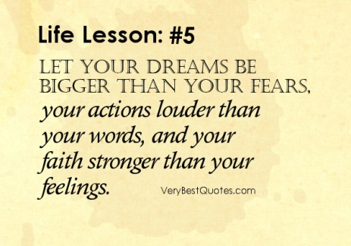
life assurance

life belt

life buoy

life choice

life guard

life jacket

life raft

life sentence

life-size - a picture or model of something or someone that is life-size is the same size as they really are
- life-threatening - a life-threatening situation, illness, or injury could cause a person to die[↪ fatal]

a live-in - job is one in which you live with the family you work for
- real-life - actually happening in life, not invented in a book:

shelf life - the length of time that a product, especially food, can be kept in a shop before it becomes too old to sell
- still life plural still lifes - a picture of an arrangement of objects, for example flowers or fruit

walk of life - the position in society someone has, especially the type of job they have

way of life - the behaviour, habits, customs etc that are typical of a particular society or person

work-life balance - the ability to give a sensible amount of time and effort to your work and to your life outside work, for example to your family or to other interests
Life

